FORREST OUT OF SCHOOL HOURS CARE
2022 APRIL SCHOOL HOLIDAY PROGRAM
Monday 11th April  $95 | Tuesday 12th April  $110 | Wednesday 13th April  $95 | Thursday 14th April  $115 | Friday 15th April
Master Chef Sandwich  Challenge  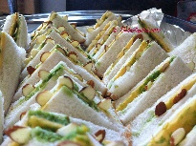  External Workshop: Oval Games with Aaron from Dreamtime Connections | EXCURSION:  Weston Park and Bike Ride  Lunch Provided  9:15 – 3:30 | Showbiz Day!  External Workshop:  Hip Hop Dance  Workshop: Drama with some FOOSHC fav’s | Create your own Button Bowls  EXCURSION:  Tuff Nutterz  Inflatable Course  12pm – 3:45 | CLOSED  PUBLIC HOLIDAY
Screen Time: 3:30-5:30 | Screen Time: 3:30-5:30 | Screen Time: 3:30-5:30 | Screen Time: 3:30 – 5:30
Monday 18th April | Tuesday 19th April  $90 | Wednesday 20th April  $115 | Thursday 21st April  $90 | Friday 22nd April  $110
CLOSED  PUBLIC HOLIDAY | April Around the World   | EXCURSION:  Pied Piper’s production of Seussical the Musical and Eddison Skate Park  10:00am -3:45pm | Science Day   | EXCURSION:  Kambah Playground and Survivor Challenge  Lunch Provided  9:00am – 3:45pm
 | Screen Time: 3:30 – 5:30 | Screen Time: 3:30-5:30 | Screen Time: 3:30-5:30 | Screen Time: 3:30 – 5:30

About the Program
Forrest Out Of School Hours Care (FOOSHC) provides a safe and welcoming environment for the children and their families. We believe children are capable, competent and creative learners that are entitled to participate in a program that facilitates their engagement in risk-taking, experimentation and exploration of indoor and outdoor spaces.
Our program is child led with a play-focused environment which is reflective of the children’s needs and interests. Children will have the opportunity for rest and relaxation and can move freely between activities and inside and outside environments. In addition to the experiences detailed on the cover page, all the fabulous FOOSHC resources will be available daily.

Our Philosophy
Everything we do is in the best interests of the child. We advocate for children’s voices to be heard and we honour and respect their rights, views and ‘being’, as the foundation of our program.
Relationships:
We seek to build and nurture trusting, reciprocal relationships with children, families and each other. We believe this enables children to form secure attachments to each other, the educators and our environments, whilst honouring those with their families. We recognise the diverse backgrounds and cultures of each member of our FOOSHC community and how their presence greatly enriches our service. We acknowledge everyone as an individual who is capable and competent, and we strive to operate without bias. For children, this will provide a sense of belonging and ownership of their environments, whilst also enabling them to become empowered decision makers. FOOSHC believes children who have known kindness, trust and respect will value themselves and others.
Play:
FOOSHC is a place in which play takes priority because all children have the right to play, as such; our program is to plan for the possibilities of play. Our pedagogical practice is based on a Playwork approach which sees children as the constructors of their own experience in an environment which children are supported and encouraged to flourish and fail. A Playwork approach sees our educators facilitate and maintain the physical and psychological conditions that encourage and allow for children to play as ‘a process that is freely chosen, personally directed and intrinsically motivated.’
Professional Development:
High expectations and standards are held of all of our educators at FOOSHC. We embrace opportunities for innovative practice, critical reflection and embed professional development into our everyday practice. FOOSHC strives to create a culture of professional inquiry in which our educators are encouraged to engage in robust discussion and challenge themselves and others. Educators embody integrity, compassion, respect and motivation.
Advocacy and Leadership:
We are committed to advocating for the children of FOOSHC and for their right to have a childhood; the time, space and freedom to play, to take risks and to navigate life. We believe that by sharing what we do with the community and inspiring innovation in others that we are also advocating for all children to have these opportunities.

General Information
Open 8am – 6pm Monday 11th April 2022 – Friday 22^{md} April 2022
CLOSED Friday 15th and Monday 18th April 2022 - PUBLIC HOLIDAYS

Enrolment
Step 1 – All families must complete a 2022 enrolment form which can be found on our website www.forrestpandc.com.au
Step 2 - Complete the attendance/booking sheet for this holiday period & permission notes attached for the relevant days

Enrolments close Sunday 3rd April 2022 Bookings received after this date will incur a $25 surcharge per family.

Fees and Childcare Subsidy (CCS)
- Cancellation must be in writing, TWO weeks in advance for no charges to apply.
- To obtain CCS you must have registered your details with Centrelink or Mygov and have provided us with your child’s date of birth and Customer Reference Number for the parent registered for CCS and each child on the enrolment form.
Arrival and Departure
- Always access the service via Children’s Services Office entrance (FOOSHC Office).
- Children MUST be signed in and out of the program each day by a parent or guardian.
- With Covid restrictions easing the roll will be located for signing in the Junior Hall (next to the door) during the holidays.
Food
- Children are required to provide their own lunch and snacks each day. Children often get hungry in the holidays, please consider this when packing their daily food.
- Afternoon tea will be provided each day around 3:30pm.
- We encourage snacks with healthy high nutritional content to meet the growing needs of children.
- Breakfast is NOT provided during holiday care. We apologise for any inconvenience this may cause.
- Children should also bring a refillable water bottle. PLEASE NOTE ON EXCURSION DAYS, CHILDREN WITHOUT DRINK BOTTLES WILL BE GIVEN A WATER BOTTLE TO KEEP AND A CHARGE OF $5 WILL BE ADDED TO YOUR ACCOUNT.
- We promote healthy eating at FOOSHC so No soft-drinks or juices are permitted. We encourage the children to drink water which will be readily available.
- As we are an allergy aware centre please no nuts/nut products or eggs.
Clothing
Please label / name all your child’s clothing
- Closed in shoes are required on Excursion days
- No singlets or sleeveless tops please as these are not sunsafe
- Children MUST have a rash shirt for ALL water based excursions
- As children engage in all sorts of adventurous play a change of clothes is recommended
- Children are required to bring a sun smart hat that protects the face, back of the neck, eyes and ears. Broad-brimmed, bucket or legionnaire hats offer the best protection. NO CAPS PLEASE.
- PLEASE NOTE ON EXCURSION DAYS, CHILDREN WITHOUT A SUNSAFE HAT WILL BE GIVEN A HAT AND A CHARGE OF $15 WILL BE ADDED TO YOUR ACCOUNT.

Sun Safety
We actively promote children to be sunsafe and as the UV index rating will be high, we encourage children to be proactive in their approach to sun safe practices. Please encourage your child to apply sunscreen prior to their arrival. Sunscreen will be available throughout the day but please feel free to bring your own if you prefer. Please ensure your children wear sunsafe clothing.
Lost property
After the holiday period, all lost property will be donated to charity or recycled as appropriate.
Screen Time
Children will have access our electronic devices for 2-hour periods during the program. This means there will be NO BYO Device day. This decision was reached after lengthy consultation with families, children, and educators.
We hope that the way screen time has been structured these holidays will assist families in regulating screen time at home.

The FOOSHC laptop may be utilised for active and non-competitive group games, such as the “Just Dance” videos that were extremely popular in previous holidays. In unfavourable weather conditions, such as extreme heat or storms, a movie may be used depending on the needs of the children.

Wheels
- Children are welcome to bring their bikes, scooters, skateboards, rollerblades etc. to the program.
- Children MUST have their own fitted helmet to participate.
- Children are not allowed to share wheels. Each child will use their own wheels.
- Wheels may be left at FOOSHC overnight, however all wheels must be taken home at the end of the holiday period unless Ali will try and sell them on ebay 😊.

Day Specific Information
Monday 11th April 2022 – Master Chef Competition & Games with Aaron from Dreamtime Connections
Grab your chef’s hats and your spatulas! Today we open the Holidays with a bang as the children face off in an epic sandwich making competition. Choose from a range of different ingredients and styles to create your own unique masterpiece to be shown off to the crowd and presented to our Master Chef Judges. Everyone will also be able to decorate their own aprons to bring home with them, to become a true FOOSHC Master Chef.
Then in the afternoon we welcome back FOOSHC favourite, our indigenous guide Aaron Chatfield from Dreamtime Connections to teach a range of games down on the oval that have been played by Aboriginal and Torres Strait Islander children for thousands of years, including Marngrook, a game with origins to the AFL, and “Jump Stick”, a hopscotch like game.
Tuesday 12th April 2022 – Weston Park and Bike Ride
In recent holidays interest in Bike riding has reached a fever pitch so don’t miss out on this exciting excursion to Western Park where we will brave their Bike tracks. When visiting Weston Park children will have a range of experiences on offer including a bike ride, ball and group games, and the iconic water playground. The excursion offers the chance for children to move at their own pace in finding what they most enjoy about this traditional Canberra fun spot. Lunch will be provided but please ensure you pack a few energy fuelling snacks.

Children Must come with a fully operational bike and helmet (In line with Australian standards) to participate in the bike ride. Please note this excursion is for bikes only and no other wheeled equipment. We will be transporting the bikes to Weston park ourselves.
Please ensure your child/ren come prepared for a day of adventure and play with the following items:
- Closed in shoes
- Sunsmart Hat
- Water bottle
- A Bicycle
- A Helmet
Wednesday 13th April 2022 – Showbiz Day!
Calling all performers, dancers, and fans of the limelight, FOOSHC is holding its’ very first show biz day! We start off the day with an visiting external Hip-Hop dance workshop from Cube sports that has the children learn to pop and lock as they take over the dancefloor. Then throughout the day we will embrace the flair of carnival performers by making our own juggling balls and decorating mini donuts.
In the afternoon become a master of the dramatic arts as a member of our wonderful FOOSHC team take the children through a Drama workshop filled with games and opportunities to become new and interesting characters. This workshop will also include making masks and costumes to allow the children to be fully immersed into their new identities.
Thursday 14th April 2022 – Button Bowl Making and Excursion to Tuff Nutterz Inflatable Course
This morning will give children the perfect chance to get stuck into some craft by making their very own Button Bowls.
In the afternoon we will be bussing down to Tuff Nutterz and taking on the challenges of Canberra’s favourite land based inflatable obstacle course. Tuff Nutterz is 1,200 square metres of endless inflatable fun! Soccer pitch, climbing wall, giant slides, leap of faith, gauntlet and the list goes on All children will need to wear socks to participate

Friday 15th April 2022 – Closed for Public Holiday

Monday 18th April 2022 – Closed for Public Holiday

Tuesday 19th April 2022 – April Around the World
From our family survey collected in 2022 we received many suggestions of cultural celebrations and festivals that are recognised by families in the FOOSHC community. The April Holidays are a time when many of our families come together with their loved ones to mark some special occasions. These holidays we are celebrating the families of FOOSHC with a day that seeks to honour the many cultures that make up our beautiful community. We will enjoy recipes shared by FOOSHC families, play games that are played by children around the world, and make craft inspired by the different cultures represented at FOOSHC. Some of the celebrations we will be consulting with families to recognise include Greek Orthodox Easter, Passover, and Ramadan, as well as Earth Day.

Wednesday 20th April 2022 – Pied Piper’s Seussical the Musical and Excursion to Eddison Skate Park
Grab a plate of green eggs and ham as we sing and dance our way over to the Pied Piper’s production of Seussical the Musical at the Canberra College Theatre. Watch as beloved Dr Seuss characters collide in this grand musical adventure about friendship, loyalty, and love.

We will then make our way across the road to explore Eddison Skate Park! Children are invited to bring their scooters or skateboards on this exciting excursion to Eddison Skate Park. Please note bikes will not be permitted on this excursion. In addition to the skate ramps, Eddison Park offers a variety of play equipment, fitness equipment, a climbing wall and sprawling natural spaces for exploration so if skating isn’t your thing, there will still be lots to do!
Children Must come with a fully operational scooter or skate board and helmet (fit to Australian standards) to participate in the skate park.
Please ensure your child/ren come prepared for a day of adventure and play with the following items:
- Closed in shoes
- Sunsmart Hat
- Water bottle
- A Scooter or Skate Board
- A Helmet
Thursday 21st April 2022 – Science Day
Today we bring back a FOOSHC favourite experience, Science Day! The day will be jam packed with science experiments, ever wondered why some foods fizz? Or why bubbles keep from popping? Would you like to make a picture dance on a plate? Ever wanted to actually be a mad scientist? Children will be able to move from one experiment to another as they wish and have access to various materials to conduct their own throughout the day.

Friday 22nd April 2022 – Excursion: Kambah ‘Adventure’ Playground and Survivor Challenge
Join us for the exciting final excursion of the April holidays as we go to explore the Kambah Playground. Children will be able to make use of the many unique fixed equipment areas, from the newly upgraded sensory playground to the challenges of the climbing frames and flying fox. We will then sit down together for a picnic lunch before the children run, jump, and seek their way through our gauntlet of survivor group games. Survivor will have the children exploring the full space that Kambah Playground has to offer while competing in challenges big and small. This day has something for everyone and is the perfect way to finish off the April Holidays.
Lunch is Provided however please ensure you pack a few energy fuelling snacks.
Please ensure your child/ren come prepared for a day of adventure and play with the following items:
- Closed in shoes
- Sunsmart Hat
- Water bottle

FORREST OUT OF SCHOOL HOURS CARE
2022 APRIL SCHOOL HOLIDAY PROGRAM:
BOOKING FORM
Please complete the details below to enrol your child.

Account Name: Current Email Address:

Child’s name | Mon11/4  $95 | Tue 12/4  $110 | Wed 13/4  $95 | Thu 14/4  $115 |  |  |  | Tue  19/4 $90 | Wed  20/4 $115 | Thu  21/4 $90 | Fri 22/4 $110

Important Information | Please sign below to acknowledge that you have read and understood this important information
I understand that children need to bring lunch, snacks and a refillable drink bottle each day. We are an Allergy Aware Centre – no nuts/nut products or eggs.
These holidays we may be using both still and movie cameras to record the children’s adventures. Please advise in writing if you do not want your child to participate in this part of the program. We may use the photos/footage to promote our program and to screen with families/friends of the service. I understand that this will include photos of my children in their swimmers during water excursions and water play at the service.
I understand that children need to be signed in and out of the program each day. This will occur by entering through the Children’s Services Office
If I wish to cancel days’ requests must be made in writing and for no charge to apply and must be received at least TWO WEEKS prior to the cancelled day.

Outstanding fees will incur a late payment fee unless arrangements are made on enrolment. Payment plans are available. Bookings after 3rd April will incur a $25 late booking fee per child.
I give permission for my child to view suitable PG movies and play some electronic games that are also rated PG (older games originally rated G that today are rated PG but deemed suitable by Educators) during the program.
I understand that FOOSHC uses a charter bus without seatbelts for excursions and if my child is not signed in prior to the advertised departure time that I will need to drop my child at the excursion.
I understand that if I do not bring a sunsafe hat or drink bottle for my child then my child will be given a new hat or drink bottle at the cost of $10 (hat) or $5(bottle) which will then be charged to my account.
I give permission for my child to use their own wheels and I understand they are required wear to a well fitted helmet that meets Australian Standards that could used in multiple play spaces with various pieces of equipment.
PLEASE SIGN THE BOX FOR EACH DAY YOUR CHILD WILL ATTEND
Date/Time | Experience | Sign
I acknowledge that the proposed routes to all excursions my child is attending are inserted as images over the page.
I understand that these are proposed routes and the final route will be determined on the day by the driver due to a range of contributing factors.
12/04/2021 | Western Park and Bike Ride:  I give permission for my child/ren to travel by charter bus to Western Park  I give my permission for my child to participate in a bike ride around a pre-planned bike track that includes the crossing of one road.  I give permission for my child to use the fixed equipment at Western Park.  I understand that my child might get wet and/or dirty  I understand that my child will need appropriate clothing and foot ware to participate.  I understand FOOSHC is not responsible for lost or damaged equipment and that my child’s equipment will be transported to the park via trailers  I understand that my child may be allowed to participate in tree climbing, as determined by a Dynamic Risk Benefit Assessment conducted on the day.  I understand that the bike equipment and helmet I provide must be in proper working condition that meet Australian Standards  Departing: 9:45 am  Returning: 3:15 pm  Estimated number of children in attendance: 44  Ratio and estimated number of educators: 8 Educators Ratio 1:8  (Raised by 3 educators for supervision of split destination)
14/04/2021 | Tuff Nutterz Inflatables:  I give permission for my child/ren to travel by charter bus (no seatbelts) to Tuff Nutterz – parliamentary Triangle and walk with educators to designated space that may involve crossing a road.  I give my permission for my child to participate on all inflatables included in ticket  I understand that my child will need appropriate clothing and foot ware to participate. – THIS INCLUDES SOCKS  Departing: 12:00pm  Returning: 3:30pm  Estimated number of children in attendance: 44  Ratio and estimated number of educators: 8 Educators Ratio 1:8
20/4/2021 | Canberra College Theatre/Eddison Park Skate Park:  I give permission for my child/ren to travel by charter bus to Canberra College Theatre, walk to Eddison Park and then return to FOOSHC from Eddison Park via charter bus  I give permission for my child to attend a 1:15hr theatre production of Suessical the Musical at Canberra College Theatre.  I give permission for my child/ren to use the play equipment, fitness equipment, climbing wall and skate park.  I give permission for my child/ren to use their scooter or skateboard on the skate park and understand I must provide a helmet for them to participate. I understand that bikes will be not permitted.  I understand FOOSHC is not responsible for lost or damaged equipment and that the equipment will be transported via vehicle to park.  I understand that my child may be allowed to participate in tree climbing, as determined by a Dynamic Risk Benefit Assessment conducted on the day.  I understand that the scooter or skate equipment and helmet I provide must be in proper working condition that meet Australian Standards  Departing: 10:30am  Returning: 3:30pm  Estimated number of children in attendance: 50  Estimated number of educators: 8  Ratio: 1:8 with 2 additional educators required for supervision of skate park
22/4/2021 | Kambah Playground  I give permission for my child/ren to travel by charter bus to Kambah Adventure Playground.  I give permission for my child to use the various fixed equipment at the Kambah Playground including flying foxes.  I understand that my child may be allowed to participate in tree climbing, as determined by a Dynamic Risk Benefit Assessment conducted on the day.  Departing: 9:35am  Returning: 3:30pm  Estimated number of children in attendance: 44  Ratio and estimated number of educators: 8 Educators Ratio 1:8 (raised ratio with an additional 3x educators)

MINIMUM EDUCATOR: CHILD RATIOS WILL BE
1:11 at the centre, 1:8 for excursions, 1:5 for excursions in/around the water
Please see proposed routines for Excursions on the next page

Proposed routes for excursions- route may vary on the day. Our regulations state we need to show proposed routes on excursions
Western Park
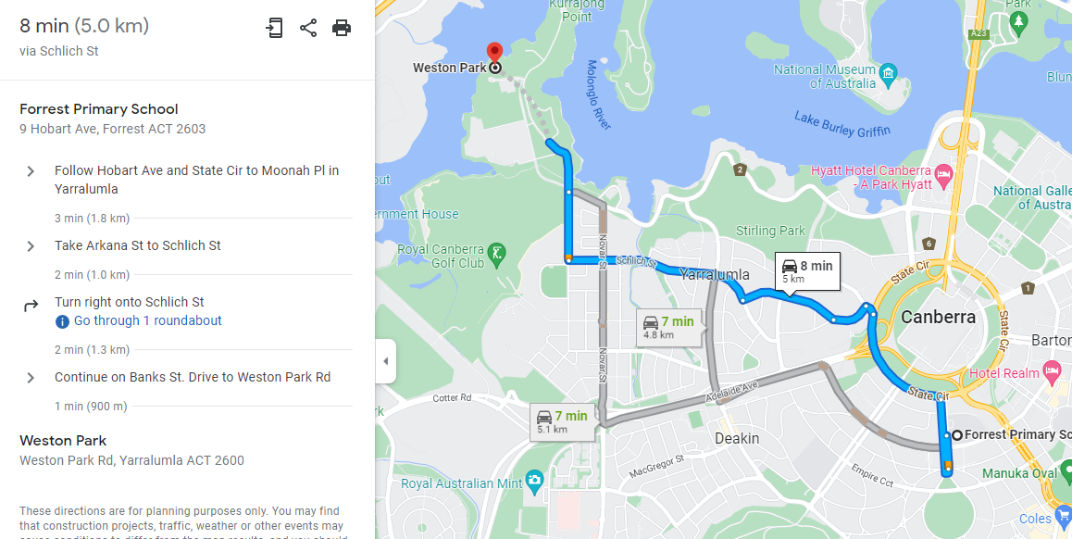

Tuff Nutterz
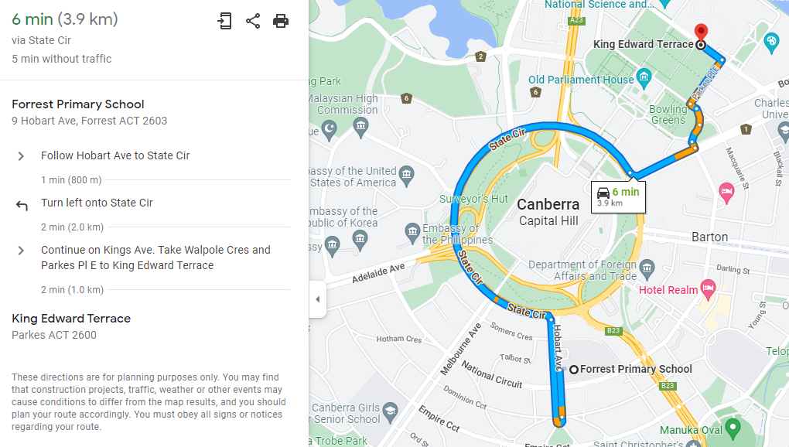

Pied Piper & Eddison Park
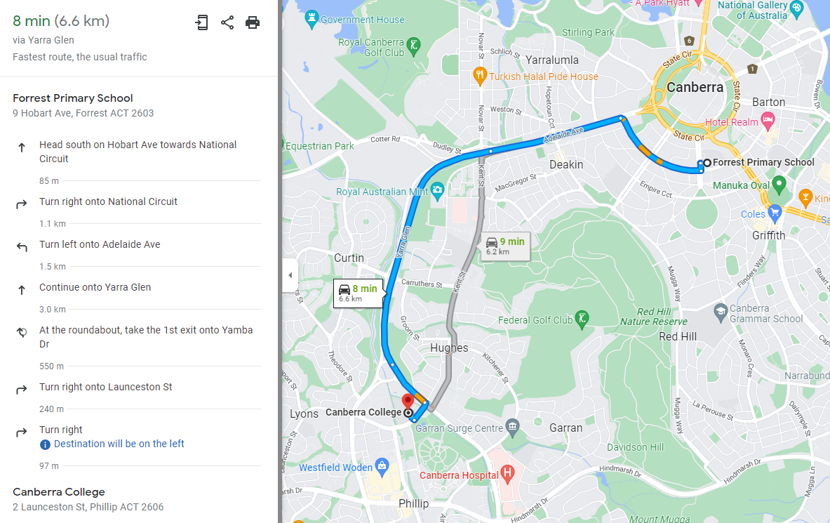

Kambah Playground
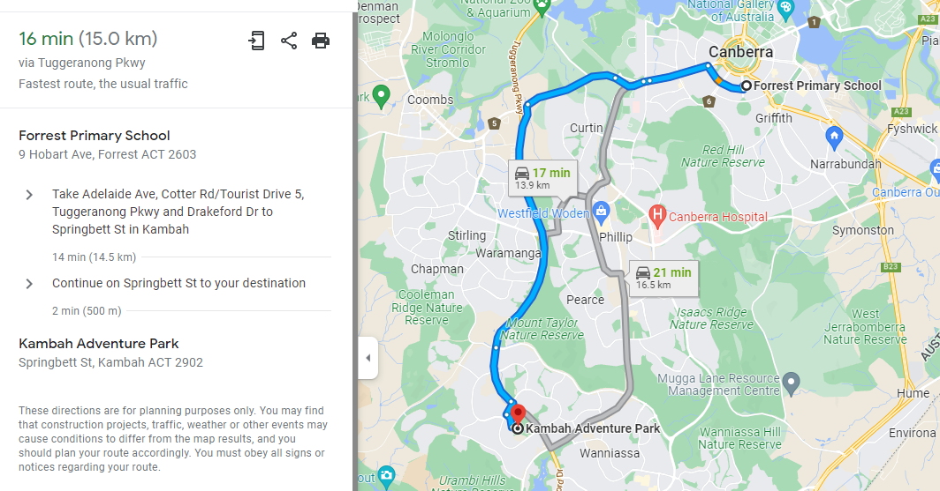

END OF PAPER

