FORREST OUT OF SCHOOL HOURS CARE
SEP/OCT 2022 SCHOOL HOLIDAY PROGRAM
Monday 26th Sep  $95 | Tuesday 27th Sep  $110 | Wednesday 28th Sep  $100 | Thursday 29th Sep  $110 | Friday 30th Sep  $90
Sewing Pencil Cases  Scare Crow Making  Baking Apples on the fire   | Excursion:  Lakeside Leisure Centre Indoor Pool  9 - 3:45pm  Hot Glue Art | FOOSHC Community  Picnic – Avengers Inflatable    Weaving frames under the big tree | EXCURSION:  Fadden Pines Playground with Ronnie from Culture on the move  Bush Animal Weaving, Geocaching, and games  9-3:30pm | Tie Dye    Just Dance!  Make Sushi for Afternoon Tea
Screen Time: 3:30-5:30 | Screen Time: 4-5:30 | Screen Time: 3:30 -5:30 | Screen Time: 4-5:30 | Screen Time: 3:30-5:30
Monday 3rd Oct | Tuesday 4th Oct  $110 | Wednesday 5th Oct  $95 | Thursday 6th Oct  $90 | Friday 7th Oct  $115
PUBLIC HOLIDAY – CLOSED | External Workshop:  Pallet Play  Building Planter Box  10am  Science workshop with FOOSHC Favs | Big Blue Table Tissue  Paper Flowers  EXCURSION:  Playground Crawl  Boundless, Castle Playground, Regatta Point  9:15-3:15pm  Painting Gnomes | Loose Parts Extravaganza!  External Workshop:  Native garden beds and Boomerang throwing with Aaron from Dreamtime Connections 1-3pm | Spy Day  EXCURSION:  B.Firm Ninja Warrior  12:15-3:45pm
 | Screen Time: 3:30 –5:30 | Screen Time: 3:30-5:30 | Screen Time: 3:30-5:30 | Screen Time: 3:30-5:30

About the Program
Forrest Out Of School Hours Care (FOOSHC) provides a safe and welcoming environment for the children and their families. We believe children are capable, competent, and creative learners that are entitled to participate in a program that facilitates their engagement in risk-taking, experimentation and exploration of indoor and outdoor spaces.
Our program is child led with a play-focused environment which is reflective of the children’s needs and interests. Children will have the opportunity for rest and relaxation and can move freely between activities and inside and outside environments. In addition to the experiences detailed on the cover page, all the fabulous FOOSHC resources will be available daily.

Our Philosophy
Everything we do is in the best interests of the child. We honour and respect their rights, views and ‘being’ throughout our program and believe that they are integral to our world.
Relationships:
We seek to build and nurture trusting, reciprocal relationships with children, families and each other. We believe this enables children to form secure attachments to each other, the educators and our environments, whilst honouring those with their families. We recognise the diverse backgrounds and cultures of each member of our FOOSHC community and how their presence greatly enriches our service. We acknowledge everyone as an individual who is capable and competent, and we strive to operate without bias. For children, this will provide a sense of belonging and ownership of their environments, whilst also enabling them to become empowered decision makers. FOOSHC believes children who have known kindness, trust and respect will value themselves and others.
Play:
FOOSHC is a place in which play takes priority because all children have the right to play, as such; our program is to plan for the possibilities of play. Our pedagogical practice is based on a Playwork approach which sees children as the constructors of their own experience in an environment which children are supported and encouraged to flourish and fail. A Playwork approach sees our educators facilitate and maintain the physical and psychological conditions that encourage and allow for children to play as ‘a process that is freely chosen, personally directed and intrinsically motivated.’
Professional Development:
High expectations and standards are held of all of our educators at FOOSHC. We embrace opportunities for innovative practice, critical reflection and embed professional development into our everyday practice. FOOSHC strives to create a culture of professional inquiry in which our educators are encouraged to engage in robust discussion and challenge themselves and others. Educators embody integrity, compassion, respect and motivation.
Advocacy and Leadership:
We are committed to advocating for the children of FOOSHC and for their right to have a childhood; the time, space and freedom to play, to take risks and to navigate life. We believe that by sharing what we do with the community and inspiring innovation in others that we are also advocating for all children to have these opportunities.

General Information
Open 8am – 6pm Monday 26th Sep 2022– Friday 7th Oct 2022
CLOSED Monday 3rd Oct 2022 - PUBLIC HOLIDAY

Enrolment
Step 1 – All families must complete a 2022 enrolment form which can be found on our website www.forrestpandc.com.au
Step 2 - Complete the attendance/booking sheet for this holiday period & permission notes attached for the relevant days

Enrolments close COB Sunday 18th Sep 2022 Bookings received after this date will incur a $25 surcharge per family.

Fees and Childcare Subsidy (CCS)
- Cancellation must be in writing, TWO weeks in advance for no charges to apply.
- To obtain CCS you must have registered your details with Centrelink or Mygov and have provided us with your child’s date of birth and Customer Reference Number for the parent registered for CCS and each child on the enrolment form.
Arrival and Departure
- Always access the service via Children’s Services Office entrance (FOOSHC Office).
- Children MUST be signed in and out of the program each day by a parent or guardian.
- With Covid restrictions easing the roll will be located for signing in the Junior Hall (next to the door) during the holidays.
Food
- Children are required to provide their own lunch and snacks each day. Children often get hungry in the holidays, please consider this when packing their daily food.
- Afternoon tea will be provided each day around 3pm.
- We encourage snacks with healthy high nutritional content to meet the growing needs of children.
- Breakfast is NOT provided during holiday care. We apologise for any inconvenience this may cause.
- Children should also bring a refillable water bottle.
- We promote healthy eating at Fooshc so No soft-drinks or juices are permitted. We encourage the children to drink water which will be readily available.
- As we are an allergy aware centre please no nuts/nut products or eggs.
Clothing
Please label / name all your child’s clothing
- Closed in shoes are required on Excursion days
- No singlets or sleeveless tops please as these are not sunsafe
- Children MUST have a rash shirt for ALL water based excursions
- As children engage in all sorts of adventurous play a change of clothes is recommended
- Children are required to bring a sun smart hat that protects the face, back of the neck, eyes and ears. Broad-brimmed, bucket or legionnaire hats offer the best protection. NO CAPS PLEASE.
Sun Safety
We actively promote children to be sunsafe and as the UV index rating will be high, we encourage children to be proactive in their approach to sun safe practices. Please encourage your child to apply sunscreen prior to their arrival. Sunscreen will be available throughout the day but please feel free to bring your own if you prefer.
Lost property
After the holiday period, all lost property will be donated to charity or recycled as appropriate.
Screen Time
Children will have access our electronic devices for 2-hour periods during the program. This means there will be NO BYO Device day. This decision was reached after lengthy consultation with families, children, and educators.
We hope that the way screen time has been structured these holidays will assist families in regulating screen time at home.
Please note: Based on the last January holidays we have increased the amount of screen times as a way to help children to rest, relax and cool down during the summer heat.

The FOOSHC laptop may be utilised for active and non-competitive group games, such as the “Just Dance” videos that were extremely popular in previous holidays. In unfavourable weather conditions, such as extreme heat or storms, a movie may be used depending on the needs of the children.

Wheels
- Children are welcome to bring their bikes, scooters, skateboards, rollerblades etc. to the program.
- Children MUST have their own fitted helmet to participate.
- Children are not allowed to share wheels. Each child will use their own wheels.
- Wheels may be left at FOOSHC overnight, however all wheels must be taken home at the end of the holiday period unless Ali will try and sell them on ebay 😊.

Day Specific Information
Monday 26th Sep 2022 – Pencil-case Sewing, Scare Crow Making, and Apple Baking
For the first day of our program, we are returning to one of children’s favourite activity of sewing their own pencil cases, for a chance to master this new skill! Children will choose between different materials to sew their own pencil cases using our sewing machines with the help of our very own resident designer Toni.
Through the day we are painting the service with a splash of autumn by making life sized scare crows and baking apples over the fire. This cosy and engaging first day of the holidays is one not to be missed!
Tuesday 27th Sep 2022 – Gungahlin Leisure Centre
It’s time to splash the day away at Lakeside Leisure Centre. The weather will not impact this one as we explore all that Tuggeranong Pool has to offer in its fabulous indoor set up. We have booked part of the Olympic pool so we can practice not only our swimming but our diving and creative jumps as well as having access to the smaller program pool for a splashtastic day of fun.
Then when we are back at the service relax and recover from the big day of fun by making Hot Glue Gun Art with Bronwyn.

Wednesday 28th Sep 2022 – Early Childhood Community Picnic
Today we welcome children from our surrounding Early Childhood Centres to come join us for a picnic to help assist in their transition and developing relationships with the children who will be joining our FOOSHC family in 2023. Grab a delicious snow cone, create some art with painting in the trees and join in with a variety of group games for all ages. We are also excited to be hiring Fun Day Out’s Marvel Avengers Inflatables for the very first time! We will be providing a picnic lunch however please ensure you pack a few energy fuelling nutritionally dense snacks.
Then come up to some calming weaving frames under the shade of the big tree Outside Junior Hall.
Thursday 29th Sep 2022 – Fadden Pines Geocaching
Join us for an action-packed day of adventure at Fadden Pines. Fadden Pines is also home to incredible adventure style play equipment which children will be able to utilise throughout the excursion as well as some of our popular sporting favourites such as our 16-meter badminton net. While we are there, we will be holding our very first Geocaching quest. Use a map of the space to find caches hidden throughout the environment – are you up for the challenge?
While at Fadden Pines we will also be joined by Ronnie from Culture on the Move for her “Bush Animal Making” weaving workshop. We are very lucky to have Ronnie back to be a part of our program for what is sure to be a fantastic day
Friday 30th Sep 2022 – Tie Dye, Sushi Making and Just Dance
We will stay in-service today having the opportunity to rest and relax after yesterday’s grand adventures. The day however will still be full of possibilities with children having the opportunity to get colourful with tie dye. Make sure to bring in a white piece of clothing or cloth item to tie dye but remember this activity is strictly One piece per child. Then get involved in cooking by making Sushi with Karren for Afternoon Tea.
Finally, it’s time to dance the afternoon away as you get the chance to find the costume that suits you and boogie to your heart’s content!

Monday 3rd Oct 2022 – Closed for Public Holiday

Tuesday 4th Oct 2022 – Pallet Play, and Science workshop with FOOSHC Fav
Today we are joined by Aaron from Pallet Play as he helps us create planter boxes to hold native plants so that they can flourish throughout our space. Aaron has previously helped us create bookshelves, go karts, and mud kitchens just to name a few. Please remember that due to power tools being used children MUST wear enclosed shoes. – Does this need its own permission box with the excursions.
And in the afternoon join Sonali as she leads us through a science workshop full of excitement and curiosity. Experiment with different materials and techniques as you are tasked with cleaning up a miniature oil spill! Then get the chance to make your own Newton’s cradle to take home with you.

Wednesday 5th Oct 2022 – Playground Crawl and Big Blue Table
As a Be You service FOOSHC has chosen today as our day to dress up in blue and acknowledge Beyond Blues Big Blue Table event. We will send more about this separately however expect an element of blue in all we do today. Please join us in wearing any and all things blue 😊

It is a day full of adventure as FOOSHC goes on a Playground Crawl! We start off at Boundless and then set off for a picnic lunch at Canberra’s famous Castle Playground before walking down to the playground at Commonwealth Park. Explore three of the most exciting playgrounds Canberra has to offer and master the unique challenges of each one.

And back at FOOSHC children will get the chance to fully embrace spring making Tissue Paper Flowers and painting Gnomes to add to our FOOSHC and School community garden beds.
Thursday 6th Oct 2022 – Loose Parts Extravaganza, Planting Native Plants and Boomerang Throwing with Aaron from Dreamtime Connections
In the morning we are bringing new life to our FOOSHC favourite Loose Parts Area. Children will be given free rein to use wooden pallets to design, combine and paint new objects for the space. The area is also being given a range of new parts for children to play with and make their own. If you have something that could use a second home in our Loose Parts space, we are always looking for community donations; Look out for an upcoming email about our Loose Parts space for more information.
We are also excited to welcome back Aaron from Dreamtime Connections these holidays. Aaron joins us to help continue to care for and expand our FOOSHC native garden, using our newly made planter boxes. Aaron will then share his knowledge on the history and use of boomerangs, followed by a demonstration and workshop on how to throw our very own boomerangs. Finally we finish off our time with Aaron for the day by painting our own designs on our individual boomerangs.

Friday 7th Oct 2022 – Spy Day and B-Firm Ninja Warrior

FOOSHC has been infiltrated by an evil enemy spy! Agents, we need your help to discover their secret identity and stop them before they get their hands on all our top-secret information! Join us for a day of secret missions and special training to become the world’s top team of spies.

Then we put our training to good use by going to B.Firm’s Ninja Warrior Course in the afternoon. BFirm’s Ninja Warrior Training Centre located in nearby Symonston offers a jam-packed adventure with a range of Ninja obstacles to explore and challenge yourself with climbing, hanging, jumping, rolling and maybe even crawling through the infamous muddy shoe alley! Just be careful not to lose your own shoe!

FORREST OUT OF SCHOOL HOURS CARE
2022 SEP/OCT SCHOOL HOLIDAY PROGRAM:
BOOKING FORM
Please complete the details below to enrol your child.

Account Name: Current Email Address:
Child’s name | Mon 26/9  $95 | Tue 27/9  $110 | Wed 28/9  $100 | Thu 29/9  $10 | Fri 30/9  $90 |  |  | Tue  4/10  $110 | Wed  5/10  $95 | Thu  6/10  $90 | Fri 7/10  $115

Important Information | Please sign below to acknowledge that you have read and understood this important information
I understand that children need to bring lunch, snacks and a refillable drink bottle each day. We are an Allergy Aware Centre – no nuts/nut products or eggs.
These holidays we may be using both still and movie cameras to record the children’s adventures. Please advise in writing if you do not want your child to participate in this part of the program. We may use the photos/footage to promote our program and to screen with families/friends of the service.
I understand that children need to be signed in and out of the program each day. This will occur by entering through the Children’s Services Office
If I wish to cancel days’ requests must be made in writing and for no charge to apply and must be received at least TWO WEEKS prior to the cancelled day.

Outstanding fees will incur a late payment fee unless arrangements are made on enrolment. Payment plans are available. Bookings after 18th Sep COB will incur a $25 late booking fee per child.
I give permission for my child to view suitable PG movies and play some electronic games that are also rated PG (older games originally rated G that today are rated PG but deemed suitable by Educators) during the program.
I understand that if I do not bring a sunsafe hat or drink bottle for my child then my child will be given a new hat or drink bottle at the cost of $15 (hat) or $5(bottle) which will then be charged to my account.
I give permission for my child to use their own wheels and I understand they required wear to a well fitted helmet and could used in multiple play spaces with various pieces of equipment.

PLEASE SIGN THE BOX FOR EACH DAY YOUR CHILD WILL ATTEND
Date/Time | Experience | Sign
I acknowledge that the proposed routes to all excursions my child is attending are inserted as images below.
I understand that these are proposed routes and the final route will be determined on the day by the driver due to a range of contributing factors.
27/9/2022 | Lakeside Leisure Centre Pools  I give permission for my child/ren to travel by charter bus to Lakeside Leisure Centre  I give permission for my child/ren to swim in the 2 pools and understand that the use of the 50m pool is dependant on the successful completion of a swim test  Departing: 9:30am  Returning: 3:30pm  Estimated number of children in attendance: 50  Ratio and estimated number of educators: 13 Educators Ratio 1:5 (raised ratio with an additional 3x educators)
29/9/2022 | Fadden Pines Playground  I give permission for my child/ren to travel by charter bus (no seatbelts) to Fadden Pines Playground  I give permission for my child to explore the multiple fixed playground structures onsite.  I understand that my child might get wet and/or dirty  I understand that my child will need appropriate clothing and foot ware to participate.  Departing: 9:30 am  Returning: 3:20pm  Estimated number of children in attendance: 52  Ratio and estimated number of educators: 9 Educators Ratio 1:8  (raised ratio with an additional 2x educators)
05/10/2022 | Playground Crawl  I give permission for my child/ren to travel by charter bus to Boundless Playground and to be picked up from Regatta Point Playground  I give my child permission to walk between the three proposed playgrounds along a route deemed appropriate by FOOSHC educators.  I give permission for my child to explore the fixed equipment at Boundless Playground, the Castle Playground in Commonwealth Park, and the Regatta Point Playground  I understand that the proposed walking route may change due to conditions on the day as deemed appropriate by FOOSHC educators  Departing: 9:45am  Returning: 3:00pm  Estimated number of children in attendance:52  Ratio and estimated number of educators: 8  (raised ratio with an additional 1x educator)
07/10/20212 | BFirm Ninja Warrior  I give permission for my child/ren to travel by charter bus to B-Firm Symonston.  I give my permission for my child to participate in obstacle and battle courses  I understand that my child will get wet and/or dirty  I understand that my child will need appropriate clothing and foot ware to participate and a warm change of clothes, and that children will not participate without these items.  I understand that the owner’s dogs may be present on site and may interact with the children  Departing: 12:30 pm  Returning: 3:30pm  Estimated number of children in attendance: 52  Ratio and estimated number of educators: 8 Educators Ratio 1:8  (raised ratio and additional 1x educator)

MINIMUM EDUCATOR: CHILD RATIOS WILL BE 1:11 at the centre, 1:8 for excursions, 1:5 for water excursion
Proposed routes for excursions- route may vary on the day Our regulations state we now need to show proposed routes on excursions

Lakeside Leisure Centre

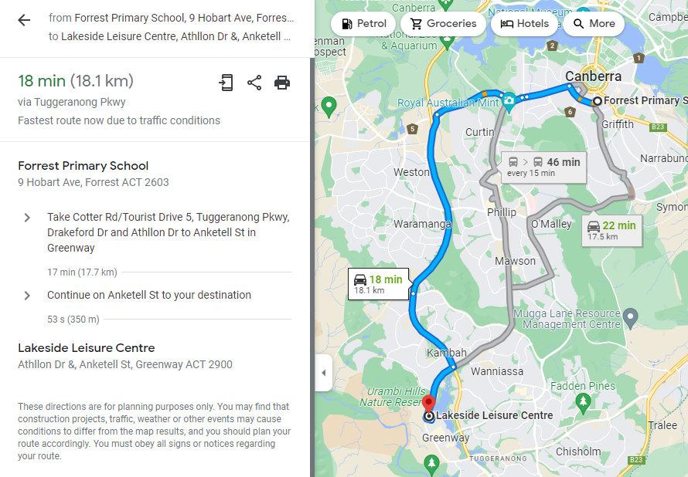

Fadden Pines Playground

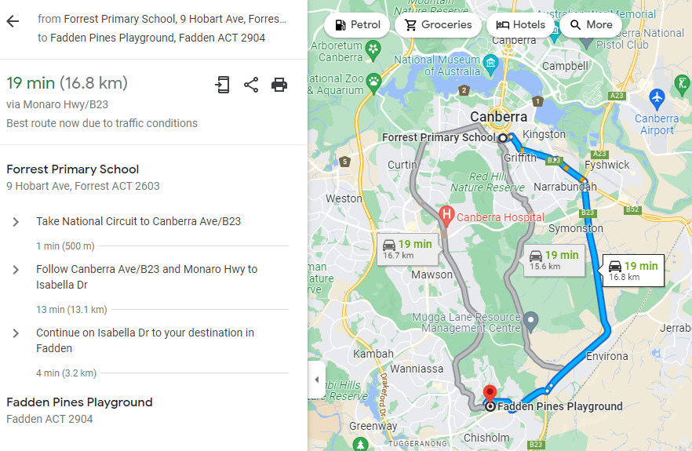

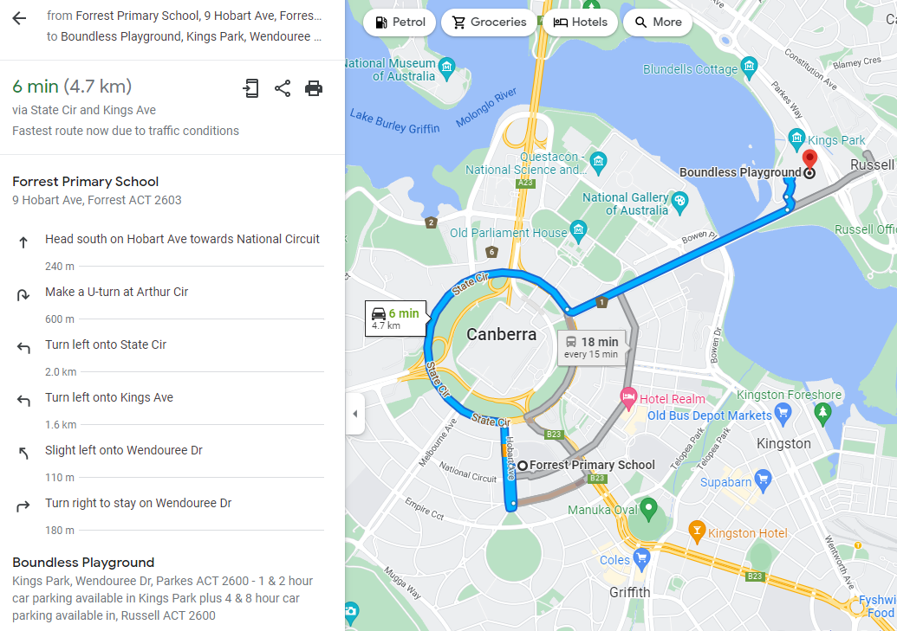
Boundless Playground (Forward Journey)

Regatta Point (Return Journey)

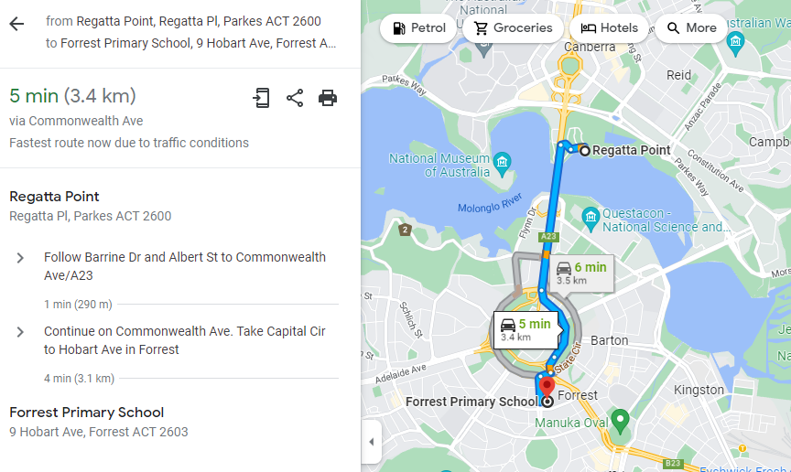

Playground Crawl Proposed Walking Route

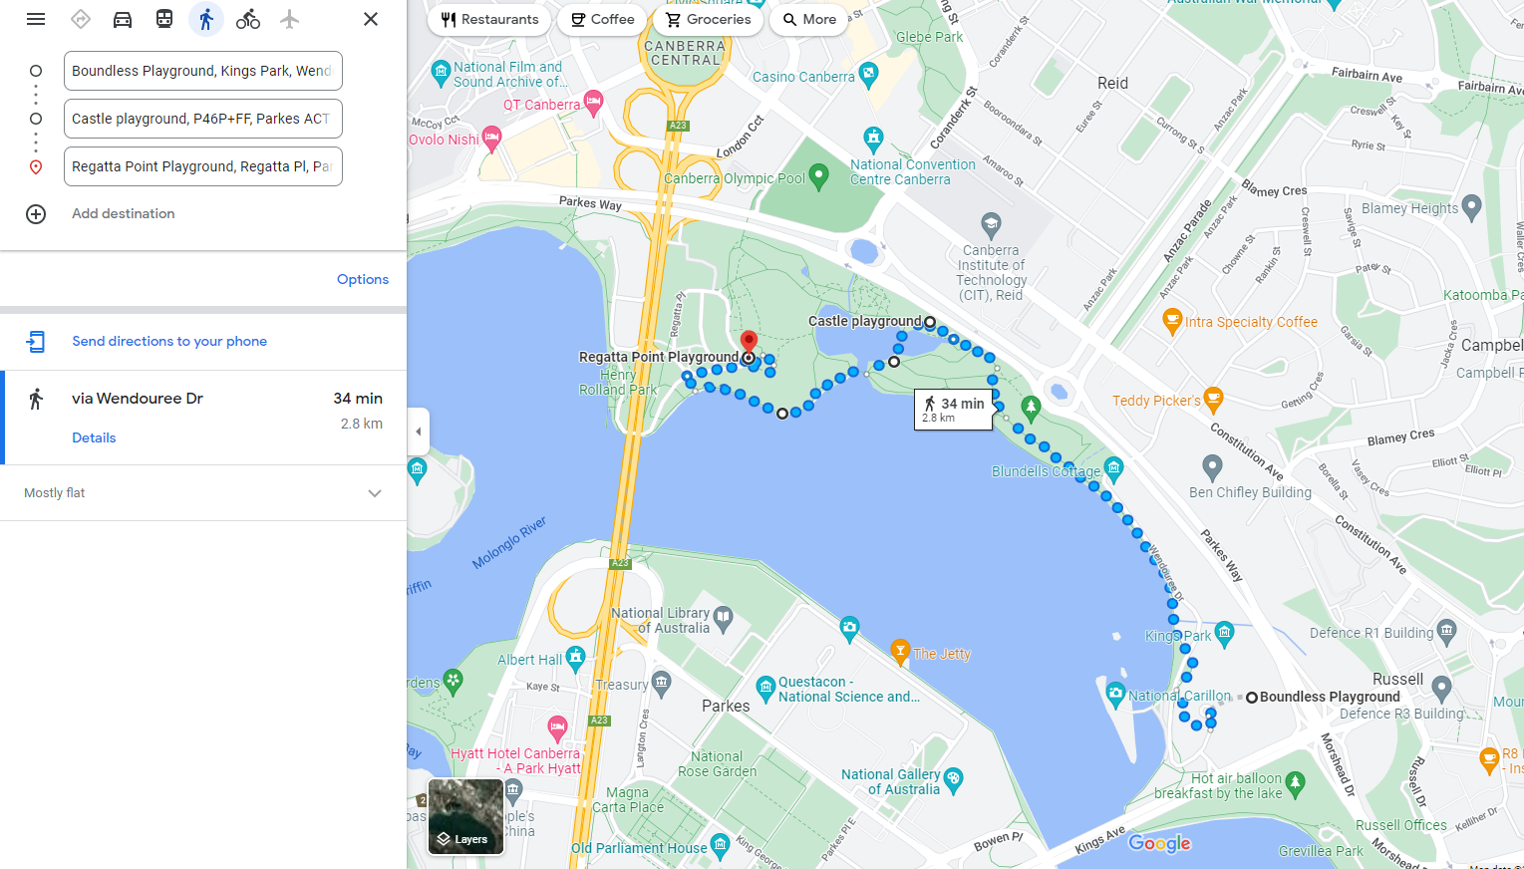

B.Firm Outdoor Activity Centre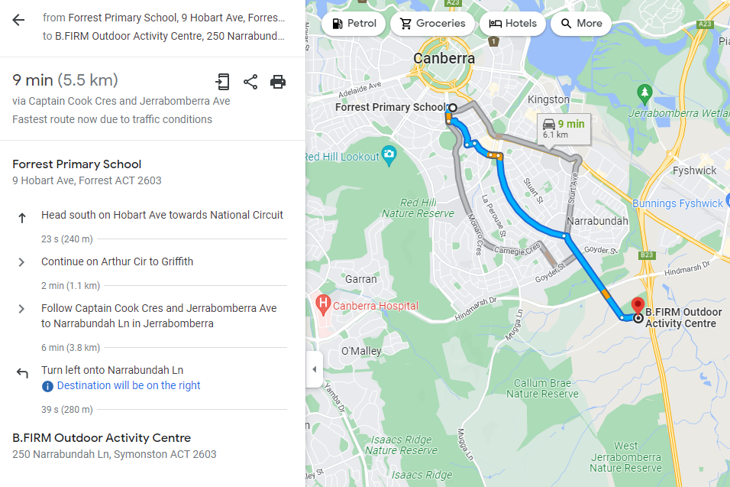

END OF PAPER

