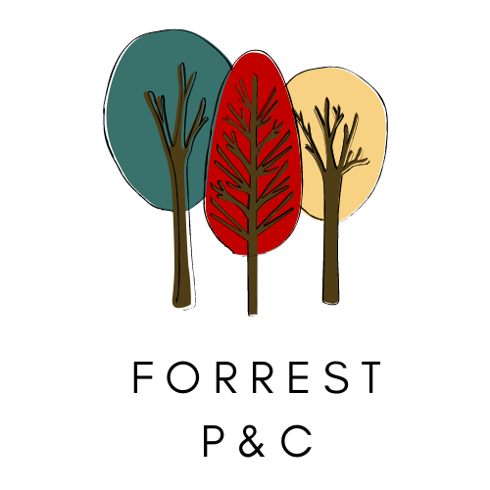
Meeting: Term 3 2022
Date/Time: Thursday 8 September- 7.30 pm
Chair: P&C President
Location: Library and via Zoom
Topic: Forrest School P&C meeting
Join Zoom Meeting
https://us02web.zoom.us/j/89231106099

Meeting ID: 892 3110 6099
One tap mobile
+61370182005,,89231106099# Australia
+61731853730,,89231106099# Australia

No | Item | Presenting
1 | Welcome and apologies | Chair
2 | Discussion items  - School presentation – literacy  - Car park update  - Kindy & Year 1 school visits  - FOOSCH updates including nominations  - Lease agreement update | School Exec  Chair  Chair  VP Business  Chair
3 | Standing Items  - Minutes of last meeting  - Action list review  - Principal’s/School’s Leadership team report  - School Board Report  - Deakin Preschool liaison report  - Parent Rep Liaison report  - P&C Council report  - Community Events update | Secretary  Secretary  Lucy Clynes  Hannah Bates  Cath White  Zoe Pleasants
4 | Any other business | Chair
5 | Thanks and Conclusion | Chair

