FORREST OUT OF SCHOOL HOURS CARE
2023 JANUARY SCHOOL HOLIDAY PROGRAM
Monday 9th January  $105 | Tuesday 10th January  $120 | Wednesday 11th January  $90 | Thursday 12th January  $135 | Friday 13th January  $105
Design your own hat  Playdoh Party  Make your own Challah! | External Workshop: Artist in Residence Jenny Blake  9:30-11:30am  Excursion:  Manuka Pool 12:30-6:00pm  Pick-up from Manuka Pool | FOOSHC’s Backyard Beach!  External Workshop: Artist in Residence Jenny Blake 2:00-4:00pm | Excursion:  CANBERRA AQUA PARK 8:30am-1:15pm  External Workshop:Artist in Residence Jenny Blake 2:00-4:00pm | External Workshop:  Cooking with Aaron from Dreamtime Connections  10:00-11:30am  Cooking Fijian Palusami with a FOOSHC Educator  Handball Mania
Screen Time:  3:30pm-5:30pm | Screen Time: none | Screen Time:  4pm-6pm | Screen Time:  4pm-6pm | Screen Time:  3:30pm-5:30pm
Monday 16th January  $115 | Tuesday 17th January  $105 | Wednesday 18th January  $115 | Thursday 19th January  $95 | Friday 20th January  $135
Paper Plane Making  Excursion: Manuka Pool 12:30-6:00pm  Pick-up from Manuka Pool | External Workshop:  Bricks 4 Kidz 10:00-11:30am  Lego Masters  Make your own Sausage roll | Excursion:  IPlay  9:00am-12:45pm  Giant Marble Run | Winnie the Pooh Teddy Bear picnic with Forrest Early Education and Care Centre  String Art  Arcade Hire! Air Hockey Table and Arcade Table-Top Games | Excursion:  Big Splash  with another P&C OSHC service  9am-4:45pm  Lunch Provided
Screen Time: none | Screen Time:  3:30pm-5:30pm | Screen Time:  3:30pm-5:30pm | Screen Time:  3:30pm-5:30pm | Screen Time:  4:45pm-6pm
Monday 23rd January  $105 | Tuesday 24th January  $135 | Wednesday 25th January  $115 | Thursday 26th January | Friday 27th January  $95
Return to Hogwarts – movie | Excursion:  CANBERRA AQUA PARK  8:30am-1:15pm  Loose Parts Engineering Challenge | Excursion: Manuka Pool 8am-12:45pm  Drop to Manuka Pool  Fake injuries | CLOSED:  PUBLIC HOLIDAY | Snow cone bar with natural homemade flavours  Making Lemon Meringue Pie Soap
Screen Time:  3:30pm-6pm | Screen Time:  3:30pm-5:30pm | Screen Time: 3:30pm-5:30pm |  | Screen Time: 3:30pm-5:30pm
About the Program
Forrest Out Of School Hours Care (FOOSHC) provides a safe and welcoming environment for the children and their families. We believe children are capable, competent, and creative learners that are entitled to participate in a program that facilitates their engagement in risk-taking, experimentation and exploration of indoor and outdoor spaces.
Our program is child led with a play-focused environment which is reflective of the children’s needs and interests. Children will have the opportunity for rest and relaxation and can move freely between activities and inside and outside environments. In addition to the experiences detailed on the cover page, all the fabulous FOOSHC resources will be available daily.

Our Philosophy –
Everything we do is in the best interests of the child. We advocate for children’s voices to be heard and we honour and respect their rights, views and ‘being’, as the foundation of our program.

Relationships:

We seek to build and nurture trusting, reciprocal relationships with children, families, and each other. We believe this enables children to form secure attachments to each other, the educators, and our environments, whilst honouring those with their families. We recognise the diverse backgrounds and cultures of each member of our FOOSHC community and how their presence greatly enriches our service. We acknowledge everyone as an individual who is capable and competent, and we strive to operate without bias. For children, this will provide a sense of belonging and ownership of their environments, whilst also enabling them to become empowered decision makers. FOOSHC believes children who have known kindness, trust and respect will value themselves and others.

Play:
FOOSHC is a place in which play takes priority because all children have the right to play, as such; our program is to plan for the possibilities of play. Our pedagogical practice is based on a Playwork approach which sees children as the constructors of their own experience in an environment which children are supported and encouraged to flourish and fail. A Playwork approach sees our educators facilitate and maintain the physical and psychological conditions that encourage and allow for children to play as ‘a process that is freely chosen, personally directed and intrinsically motivated.’
Professional Development:
High expectations and standards are held of all our educators at FOOSHC. We embrace opportunities for innovative practice, critical reflection and embed professional development into our everyday practice. FOOSHC strives to create a culture of professional inquiry in which our educators are encouraged to engage in robust discussion and challenge themselves and others. Educators embody integrity, compassion, respect, and motivation.

Advocacy and Leadership:
We are committed to advocating for the children of FOOSHC and for their right to have a childhood; the time, space and freedom to play, to take risks and to navigate life. We believe that by sharing what we do with the community and inspiring innovation in others that we are also advocating for all children to have these opportunities.

General Information
Open 8am – 6pm Monday 9th January 2023 – Friday 27th January 2023
CLOSED Thursday 26th JANUARY 2023 -AUSTRALIA DAY PUBLIC HOLIDAY

Enrolment
Step 1 – All families must complete a 2023 enrolment form which can be found on our website www.forrestpandc.com.au
Step 2 - Complete the attendance/booking sheet for this holiday period & permission notes attached for the relevant days

Enrolments close Sunday 11th December 2023. Please book quickly as places book out. Bookings received after this date will incur a $25 surcharge per family.

Fees and Childcare Subsidy (CCS)
- Cancelation must be in writing, TWO weeks in advance for no charges to apply.
- To obtain CCS you must have registered your details with Centrelink or Mygov and have provided us with your child’s date of birth and Customer Reference Number for the parent registered for CCS and each child on the enrolment form.
Arrival and Departure
- Always access the service via Children’s Services Office entrance (FOOSHC Office).
- Children MUST be signed in and out of the program each day by a parent or guardian.
- The roll will be located for signing in the Junior Hall (next to the door) during the holidays.
- On Tuesday 10th and Monday 16th January, children will need to be picked up and signed out directly from Manuka Pool.
- On Wednesday 25th January children will need to be dropped directly to Manuka Pool in the morning.

Food
- Children are required to provide their own lunch and snacks each day. Children often get hungry in the holidays, please consider this when packing their daily food.
- Afternoon tea will be provided each day around 3:30pm.
- We encourage snacks with high nutritional content to meet the growing needs of children.
- Breakfast is NOT provided during holiday care. We apologise for any inconvenience this may cause.
- Children should also bring a refillable water bottle. PLEASE NOTE ON EXCURSION DAYS, CHILDREN WITHOUT DRINK BOTTLES WILL BE GIVEN A NEW WATER BOTTLE TO KEEP AND A CHARGE OF $10 WILL BE ADDED TO YOUR ACCOUNT.
- No soft-drinks or juices are permitted. We encourage the children to drink water which will be readily available.
- As we are an allergy aware centre please no nuts/nut products or eggs.
Clothing
Please label / name all your child’s clothing
- Closed in shoes are required on Excursion days
- No singlets or sleeveless tops/dresses please as these are not sunsafe
- As children engage in all sorts of adventurous play a change of clothes is recommended
- Children are required to bring a sun smart hat that protects the face, back of the neck, eyes and ears. Broad-brimmed, bucket or legionnaire hats offer the best protection. NO CAPS PLEASE.
- PLEASE NOTE ON EXCURSION DAYS, CHILDREN WITHOUT A SUNSAFE HAT WILL BE GIVEN ONE AND A CHARGE OF $20 WILL BE ADDED TO YOUR ACCOUNT.

Sun Safety
As the UV index rating will be high, we encourage children to be sunsafe. Please encourage your child to apply sunscreen prior to their arrival. Sunscreen will be available throughout the day but please feel free to bring your own. We encourage children to check the UV levels written on the Wellness trolley empowering them to take control of their own wellbeing.
Lost property
After the holiday period, all lost property will be donated to charity or recycled as appropriate.
Screen Time
Children will have access our electronic devices for 2-hour periods during the program. This means there will be NO BYO Device day. This decision was reached after lengthy consultation with families, children, and educators.
We hope that the way screen time has been structured these holidays will assist families in regulating screen time at home.
Please note: Based on the last January holidays we have increased the amount of screen times as a way to help children to rest, relax and cool down during the summer heat.

The FOOSHC laptop may be utilised for active and non-competitive group games, such as the “Just Dance” videos that were extremely popular in previous holidays. In unfavourable weather conditions, such as extreme heat or storms, a movie may be used depending on the needs of the children.

Wheels
- Children are welcome to bring their bikes, scooters, skateboards, rollerblades etc. to the program.
- Children MUST have their own fitted helmet to participate.
- Children are not allowed to share wheels. Each child will use their own wheels.
- Wheels may be left at FOOSHC overnight, however all wheels must be taken home at the end of the holiday period.

Day Specific Information
Monday 9th January 2023 – Design your own hat, Playdoh Party, and make your own pretzel
Welcome to the first day of the January 2023 School Holiday Program. Today the children will get their creative juices flowing by designing their own white bucket hats which they will be able to keep and wear throughout the holidays showing off their amazing creations. Then we get stuck into mixing our very own batches of playdoh! Between the playdoh and the plethora of other upcycled resources, such as bottles and boxes, the possibilities for the children to get creative are endless. For afternoon tea we make Challah thanks to a suggestion from a family. Challah is a delicious, braided bread that is typically eaten on major Jewish holidays.
Tuesday 10th January 2023 – Artist in Residence and Excursion to Manuka Pool
We are so excited to be welcoming back local artist and one of our beloved Grandma’s Jenny Blake into FOOSHC this week as our Artist in Residence. Jenny is an award winning artist and will work with the children across Tuesday, Wednesday, and Thursday with a variety of mediums. If you would like to see some of Jenny’s work, please have a look at her website Jenny Blake Artist
We will then head to Manuka pool for the afternoon. Due to the heat of summer, we will travel by charter bus (included in cost) to Manuka pool where children will have access to both the paddling and 30m pool, however children would need to successfully pass a swim test to play in the 30m pool. The swim test involves swimming 15metres (any stroke) of the pool without assistance.
A yummy afternoon tea will be provided for all children at the pool (catering to dietary needs). Please note in the event of heavy rain, thunder and / or lightening when we are at Manuka Pool parents may be contacted early to collect their children because of safety concerns. In the event we are unable to attend due to weather we will arrange to go to either Tuggeranong Lakeside Leisure Centre or Stromlo Leisure centre as per permission form. If this occurs Pick up will be changed back to FOOSHC and we will return by 4:30
Please ensure your child/ren come prepared for a day of adventure and play with the following items:
- Sun smart Swimming attire - Children are required to wear a rash vest /sun smart shirt and hat while at the pool.
- Change of clothes
- Towel
- Sun smart Hat
- Filled Water bottle and lunch
Wednesday 11th January 2023 – FOOSHC’s Backyard Beach and Artist in Residence
Nothing says summer in Australia quite like the sun and the sand. Well today we bring them into the service in style with FOOSHC’s Backyard Beach! Pack your beach clothes and test your skills in a game of Cricket or volleyball, challenge your friends or work together to build the best Sandcastles and do some coloured sand art. Finally what trip to the beach would be complete without fish and chips and an ice cream?? We are so excited to be welcoming back local artist and one of our beloved Grandma’s Jenny Blake into FOOSHC this week as our Artist in Resident. Jenny will work with the children across Tuesday, Wednesday, and Thursday with a variety of mediums. If you would like to see some of Jenny’s work, please have a look at her website Jenny Blake Artist
Thursday 12th January 2023 – Excursion to Aqua Park and Artist in Residence
The Aqua Park was a fooshc favourite last January, and we are so pleased to be heading back there again. Get ready to have an awesome day out as you climb, splash, slip and slide through the giant inflatable obstacle course. Canberra Aqua Park is made up of slides, ladders and best of all their famous JUMPING PILLOW!! The Park will offer something for everyone to beat the summer heat. We will be traveling by charter bus to Black Mountain peninsular where will we spend the day testing out our skills on the new and exciting inflatable course. Children will be required to wear life jackets and the Aqua Park will have qualified lifeguards. Please note that the Aqua Park itself has an age requirement of 5+ to participate and please be rest assured all children MUST always wear a life jacket. This excursion is not suitable for those who are easily frightened by being in water as there is a high probability of falling off parts of the inflatable and into the lake. As mentioned, they will be safe due to the life jackets and strict supervision however it can be overwhelming for many who lack confidence in the water.
Please ensure your child/ren come prepared for a day of adventure and play with the following items:
- Sun smart Swimming attire - Children are required to wear a rash vest /sun smart shirt and hat while at the pool.
- Change of clothes
- Towel
- Sun smart Hat
- Filled Water bottle and lunch
In the event we are unable to attend due to weather we will arrange to head to Iplay instead as per permission note.
Today our Artist in Residence, Jenny Blake, will join one of our educators to lead the group through making their own paint brushes and paints. Explore resources in the natural environment to find whatever you can to make your paintbrush. Then put your new and unique paintbrush to good use as you combine and crush different fruits, spices, and natural resources to create your own paint to use!
Friday 13th January 2023 – External Workshop: Cooking with Aaron from Dreamtime Connections and making Fijian Palusami with a FOOSHC Educator. Handball Mania!
In the morning we are excited to welcome back Aaron from Dreamtime Connections to join us in cooking using a range of native ingredients. One of our very own educators will also share a recipe from their own culture as they help us make Fijian Palusami which we will enjoy for afternoon tea. In the afternoon every child will get the chance to decorate their very own handball to keep. Fill your ball with awesome and unique designs before seeing if they can stand against a gauntlet on different handball courts in a handball tournament. Avoid lava pools and clear badminton nets in the ultimate test of your handball skills.

Monday 16th^{th} January 2023 – Paper Planes and Excursion to Manuka Pool
Join us in the morning for as we fill the service Paper Planes of every variety. How far can yours fly? How high can it soar? Can you thread the plane through a hula hoop from across the room?
We will then head to Manuka pool for the afternoon. Due to the heat of summer, we will travel by charter bus (included in cost) to Manuka pool where children will have access to both the paddling and 30m pool, however children would need to successfully pass a swim test to play in the 30m pool. The swim test involves swimming 15 metres (any stroke) of the pool without assistance.
A yummy afternoon tea will be provided for all children at the pool (catering to dietary needs). Please note in the event of heavy rain, thunder and / or lightening when we are at Manuka Pool parents may be contacted early to collect their children because of safety concerns. In the event we are unable to attend due to weather we will arrange to go to either Lakeside Leisure Centre or Stromlo Leisure centre as per permission form. If this occurs Pick up will be changed back to FOOSHC and we will return by 4:30.
Please ensure your child/ren come prepared for a day of adventure and play with the following items:
- Sun smart Swimming attire - Children are required to wear a rash vest /sun smart shirt and hat while at the pool.
- Change of clothes
- Towel
- Sun smart Hat
- Filled Water bottle and lunch

Tuesday 17th January 2023 – External Workshop: Bricks 4 Kidz and make your own sausage roll
Calling all master-builders! Today we’re joined by Bricks 4 Kidz as the children get creative to build to their hearts content. Make a motorized lego creation and a piece of lego art. Then continue the Lego excitement through the afternoon by diving into piles of Lego to make your vision come to life! And for afternoon tea, choose between a variety of fillings to make your very own sausage roll.

Across the week we have hired some old-fashioned arcade game tables as well as an air hockey table that will complement the rest of the week’s activities.

Wednesday 18th January 2023 – Excursion to IPlay and Giant Marble Run To start the day off in style we are going to experience all the fun they have on offer over at IPlay in Belconnen. The children will get a go at the bumper cars, a game of laser tag and unlimited turns at the arcade machines. Please note that the Bumper cars have a minimum height of 120cm for all participants.
Then we roll on over to the sandpit to design, dig and construct paths through the sand to send marbles flying down the track. Don’t miss out on FOOSHC’s very own Giant Marble Run!
Across the week we have hired some old-fashioned arcade game tables as well as an air hockey table that will complement the rest of the week’s activities.
Thursday 19th January 2023 – Winnie the Pooh Teddy Bear Picnic and String Art
Today to celebrate Winnie the Pooh Day we are inviting Forrest Early Education and Care Centre for a Teddy Bear Picnic. In the morning we prepare for the picnic by sewing teddy bears and making yummy picnic food. Then next-door joins us to make plasticine animals before settling into the picnic foods with our Teddy Bears. Feel free to also bring your beloved bear from home.
Once the picnic is over, it’s time to get creative when designing and creating your very own piece of string art. Children will have the opportunity to use hammers and nails to create a pattern and use wool to bring their vision to life. Across the week we have hired some old-fashioned arcade game tables as well as an air hockey table that will complement the rest of the week’s activities.

Friday 20th January 2023 – Excursion to Big Splash with other P&C OSHC service
Are you ready to join us for a FOOSHC favourite excursion? You won’t want to miss our annual excursion to Big Splash! With access to the nine thrilling water slides, play pools and splash island there will be endless amounts of laughter and fun to be had. Please send your child with their sun-safe swimmers, hat, as well as any other swimming needs (ie. Goggles) to ensure they have an awesome time in the water. It is also necessary to pack them a change of clothes, towel and appropriate footwear to change into once they are finished in the water and are preparing to travel back to FOOSHC for non-water play. This year we will be joined by another P&C run OSHC service (Fraser Primary) which we know from our Community of Practice network. We are excited about the children meeting other children from this similar service.
A BBQ Lunch will be provided at the excursion but please ensure you pack a few energy-fuelling snacks.

Please note that children will need to pass a swim test that involves them swimming 15m (any stroke) of the pool without assistance, to access the 50m pool and the water slides. Children will be able to use Splash Island regardless of swimming ability. The water slides also have a minimum height requirement of 110cm to ride.

In the event we are unable to attend due to weather we will arrange to go to either Lakeside Leisure Centre or Stromlo Leisure centre as per permission form. If this occurs departure and arrival times will remain the same and lunch will still be provided

Please ensure your child/ren come prepared for a day of adventure and play with the following items:
- Sun smart Swimming attire - Children are required to wear a rash vest /sun smart shirt and hat while at the pool.
- A warm change of clothes
- Towel
- Sun smart Hat
- Filled Water bottle and lunch

Across the week we have hired some old-fashioned arcade game tables as well as an air hockey table that will complement the rest of the week’s activities.

Monday 23rd January 2023 – Return to Hogwarts
We are pleased to inform you that you have been accepted into Hogwarts School of Witchcraft and Wizardry. Term begins on 23rd January. We await your owl no later than 11th December.
Upon arrival you will be greeted by Professor McGonagall with classes beginning immediately.
Your first day will also mark your first feast in the Great Hall which may even see you experience your first Butter Beer.
We urge you to remember to pack your robes etc (if these are forgotten, fear not as the professors will be on hand to assist in the morning should you require assistance) No need to pack your broomsticks as we will be making yours today!
We will even watch the first Harry Potter movie in the afternoon. Please note this is rated PG and will be screened from 330 onwards if you do not wish for your muggle to watch you might consider collecting them beforehand.

Tuesday 24th January 2023 – Excursion to Aqua Park and Engineering Challenge
The Aqua Park was a favourite last January, and we are so pleased to be heading back there again. Get ready to have an awesome day out as you climb, splash, slip and slide through the giant inflatable obstacle course. Canberra Aqua Park is made up of slides, ladders and best of all their famous JUMPING PILLOW!! The Park will offer something for everyone to beat the summer heat. We will be traveling by charter bus to Black Mountain peninsular where will we spend the day testing out our skills on the new and exciting inflatable course. Children will be required to wear life jackets and the Aqua Park will have qualified lifeguards. Please note that the Aqua Park itself has an age requirement of 5+ to participate and please be rest assured all children MUST always wear a life jacket. This excursion is not suitable for those who are easily frightened by being in water as there is a high probability of falling off parts of the inflatable and into the lake. As mentioned, they will be safe due to the life jackets and strict supervision however it can be overwhelming for many who lack confidence in the water.
Please ensure your child/ren come prepared for a day of adventure and play with the following items:
- Sun smart Swimming attire - Children are required to wear a rash vest /sun smart shirt and hat while at the pool.
- Change of clothes
- Towel
- Sun smart Hat
- Filled Water bottle and lunch

In the event we are unable to attend due to weather we will arrange to head to Iplay instead as per permission note.
Then back at FOOSHC put your thinking caps on as you get ready to participate in a Loose Parts Engineering Challenge. Attempt to construct a machine that can move an object from one space to another as you push, pull, and manoeuvre your way through this challenge.

Wednesday 25th January 2023 – Excursion to Manuka Pool and Fake Injuries
Come along for our final day at Manuka Pool for the summer holidays. Today children will be dropped off at Manuka pool where they will have access to both the paddling and 30m pool, however children would need to successfully pass a swim test to play in the 30m pool. The swim test involves swimming 15metres (any stroke) of the pool without assistance.
Ensure their bag is full of lunch as well as a few energy fuelling snacks as no food will be served at manuka pool today.
Children can be dropped to Manuka Pool from 8am and will return to FOOSHC by charter bus at 12:30pm. In the event of bad weather we will be staying at FOOSHC today.

Please ensure your child/ren come prepared for a day of adventure and play with the following items:
- Sun smart Swimming attire - Children are required to wear a rash vest /sun smart shirt and hat while at the pool.
- Change of clothes
- Towel
- Sun smart Hat
- Filled Water bottle and lunch

When we return children will have the chance to make plaster casts to create and decorate their own fake injuries.

CLOSED: Thursday 26th JANUARY 2023 – AUSTRALIA DAY PUBLIC HOLIDAY

Friday 27th January 2023 – Soap Making and Snow Cone Bar
For the final day of the school holidays we will have the opportunity to bring a little bit more colour home as we see the return of FOOSHC favourite activity…soap making!!! These colourful lemon meringue pie soaps will brighten up your home and leave it smelling like a day-spa 😊 And as a special treat, we make use of our brand-new snow cone machine as each child gets the chance to combine whichever juices, fruits, and toppings they wish to create their own natural syrup for their snow cone.

PLEASE COMPLETE ALL PAGES OF THE ENROLMENT FORM.
THERE ARE THREE PAGES TO SIGN IN TOTAL

FORREST OUT OF SCHOOL HOURS CARE
2023 JANUARY SCHOOL HOLIDAY PROGRAM:
BOOKING FORM
Please complete the details below to enrol your child.

Child’s name | Mon 9/1  $105 | Tue 10/1  $120 | Wed 11/1  $90 | Thu 12/1  $135 | Fri 13/1$105 |  | Mon  16/1 $115 | Tue  17/1 $105 | Wed  18/1 $115 | Thu  19/1 $95 | Fri 20/1 $135
Account Name: Current Email Address:

Child’s name | Mon 23/1 $105 | Tue  24/1  $135 | Wed  25/1 $115 | Thu 26/1 | Fri 27/1 $95

Important Information | Please sign below to acknowledge that you have read and understood this important information
I understand that children need to bring lunch, snacks and a refillable drink bottle each day. We are an Allergy Aware Centre – no nuts/nut products or eggs.
These holidays we may be using both still and movie cameras to record the children’s adventures. Please advise in writing if you do not want your child to participate in this part of the program. We may use the photos/footage to promote our program and to screen with families/friends of the service.
I understand that children need to be signed in and out of the program each day. This will occur by entering through the Children’s Services Office
If I wish to cancel days’ requests must be made in writing and for no charge to apply and must be received at least TWO WEEKS prior to the cancelled day.

Outstanding fees will incur a late payment fee unless arrangements are made on enrolment. Payment plans are available. Bookings after 11th December 2022 midnight will incur a $25 late booking fee per child.
I give permission for my child to view suitable PG movies and play some electronic games that are also rated PG (older games originally rated G that today are rated PG but deemed suitable by Educators) during the program.
I understand that if I do not bring a sunsafe hat or drink bottle for my child then my child will be given a new hat or drink bottle at the cost of $20 (hat) or $10 (bottle) which will then be charged to my account.
I give permission for my child to use their own wheels and I understand they are required to wear a well fitted helmet and their wheels could be used in multiple play spaces with various pieces of equipment.
I give permission for my child to use sunscreen and/or Zinc provided by FOOSHC and understand that if I do not give permission I must provide my child with their own sunscreen each day.
I understand that FOOSHC uses a charter bus with seatbelts where possible for excursions and if my child is not signed in prior to the advertised departure time that I will need to drop my child at the excursion.

PLEASE SIGN THE BOX FOR EACH DAY YOUR CHILD WILL ATTEND
Date/Time | Experience | Sign
10/01/2023  16/01/2023 | Manuka Pool (Half Day - Afternoon) – proposed bus route below  I give permission for my child/ren to travel by charter bus to Manuka Pool. Or in the event of wet weather to Lakeside Leisure Centre or Stromlo Leisure Centre  I give permission for my child/ren to swim in all pools with successful completion of a swim test. And understand that without completing they will be limited to smaller pools/splash play areas.  Departing FOOSHC: 12.30pm  I agree to pick my child/ren up from the Pool by 6pm. In the event of It being changed to indoor pool we will return to FOOSHC by charter bus by 430pm  Estimated number of children in attendance: 50  Ratio and estimated number of educators: 12 Educators Ratio 1:5 (raised ratio with an additional 2x educators)
25/01/2023 | Manuka Pool (Half Day - Morning) – proposed bus route below  I give permission for my child/ren to swim in the 2 pools with successful completion of a swim test.  I agree to drop my child/ren up to the Pool from 8am.  I give permission for my child/ren to travel by charter bus to retufn to FOOSHC from the pool  Departing Manuka Pool: 12.30pm  Estimated number of children in attendance: 50  Ratio and estimated number of educators: 12 Educators Ratio 1:5 (raised ratio with an additional 2x educators)
12/01/2023  24/01/2023 | Aqua Park at Black Mountain peninsula - proposed bus route below  Please complete attached venue waiver for each day  I give permission for my child/ren to travel by charter bus to Black Mountain Peninsula and back to FOOSHC.  I give permission for my child to use the Aqua Park inflatable  I give permission for my child/ren to swim in the paddle area  Departing FOOSHC: 8:45am  Depart Aqua Park: 12:45pm to return to FOOSHC by approx. 1pm  Estimated number of children in attendance: 50  Ratio and estimated number of educators: 12 Educators Ratio 1:5 (raised ratio with an additional 2x educators)  I understand that my child must have turned 5 before on on this day in order to attend.  I give permission for my child/ren to travel by charter bus to Iplay Belconnen in the event that the Aqua Park excursion is cancelled due to unsafe weather – dropping off at Belconnen Bus Interchange and walking to venue  I give my permission for my child to participate in Laser Tag games, bumper cars and arcade games. I understand that my child will need to meet the minimum height of 120cm to use the bumper cars.
18/01/2023 | IPlay - proposed bus route below  I give permission for my child/ren to travel by charter bus to Iplay Belconnen – dropping off at Belconnen Bus Interchange and walking to venue  I give my permission for my child to participate in Laser Tag games, bumper cars and arcade games.  I understand that my child will need to meet the minimum height of 120cm to use the bumper cars.  Departing: 9:05 am  Returning: 12:30pm  Estimated number of children in attendance: 52  Ratio and estimated number of educators: 8 Educators Ratio 1:8  (Raised ratio with an additional 1 educator)
20/01/2023 | Big Splash - proposed bus route below  I give permission for my child/ren to travel by charter bus to Big Splash, Canberra.  I give permission for my child/ren to use the pools and water slides.  I understand that my child will only be able to use the water slides if they taller than 110cm and have passed a swim test. If not they will have access to small pool and splash island.  Departing FOOSHC: 9:30am to arrive at Big Splash at Approx. 10am  Departing Big Splash: 4pm to arrive back to FOOSHC by Approx. 4:30pm  Or in the event of wet weather to Lakeside Leisure Centre or Stromlo Leisure Centre times will remain the same.  Estimated number of children in attendance: 50  Ratio and estimated number of educators: 12 Educators Ratio 1:5  (raised ratio with an additional 2x educators)

MINIMUM EDUCATOR: CHILD RATIOS WILL BE
1:11 at the centre, 1:8 for excursions, 1:5 Manuka Pool, Canberra Aqua Park, Big Splash

Specific routes to various excursions- detour may occur if roadworks occur

Manuka Pool

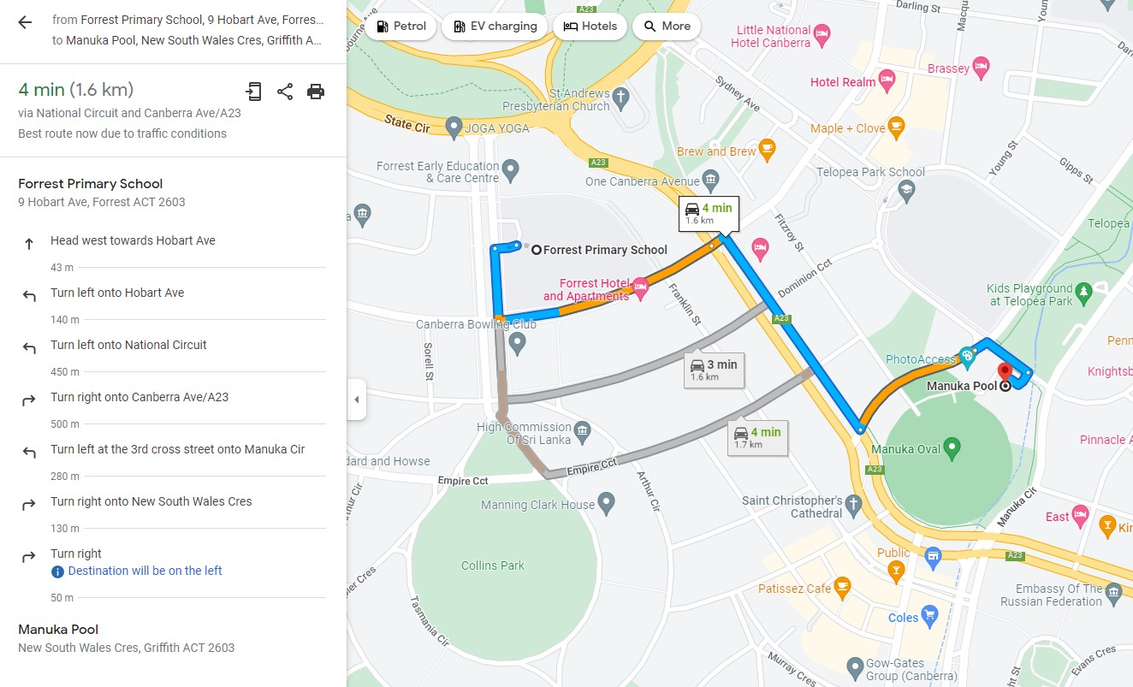

Aqua Park: Black Mountain Peninsula
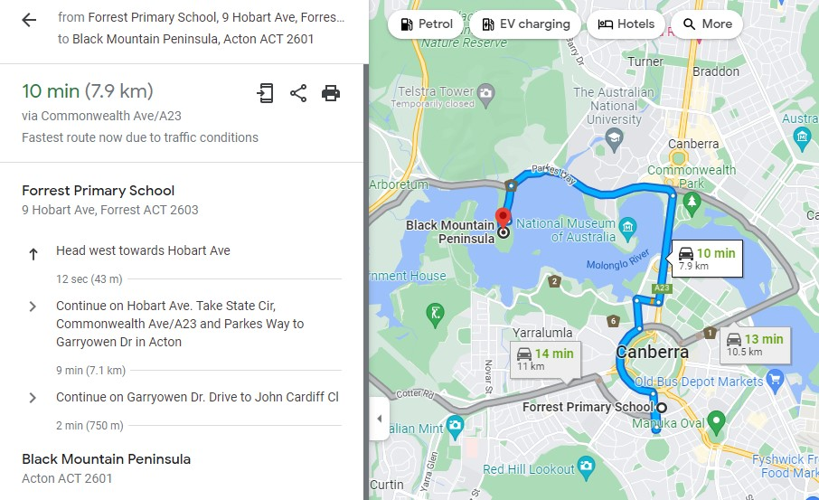

IPlay belconnen
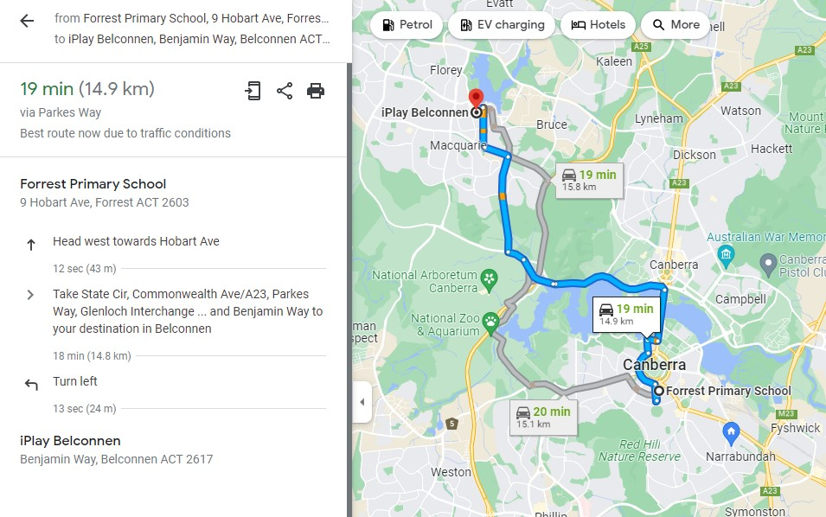

Big Splash
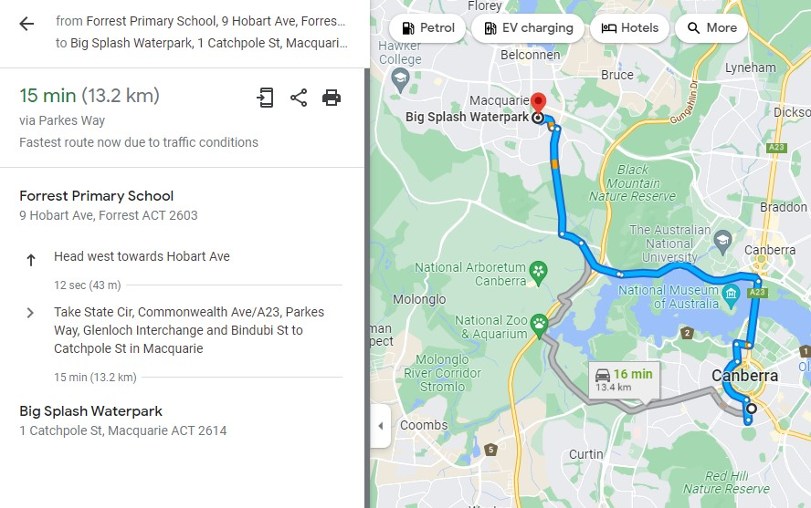

Stromlo aquatic centre
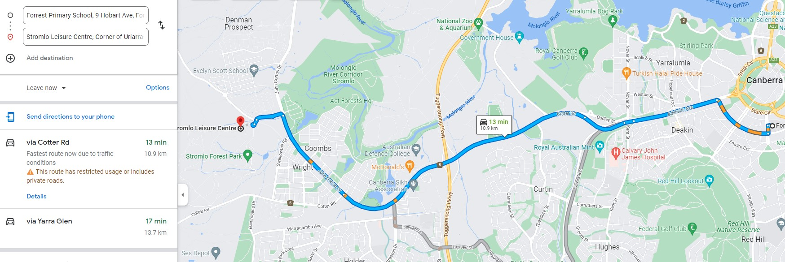

Lakeside Leisure Centre
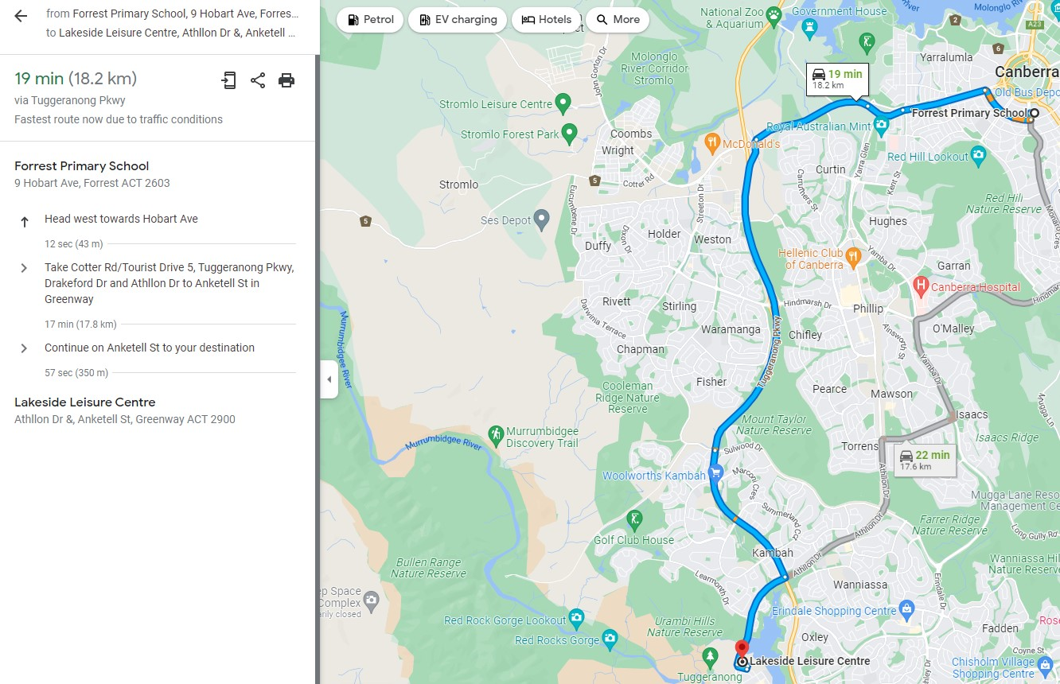

END OF PAPER

