FORREST OUT OF SCHOOL HOURS CARE
2024 JANUARY SCHOOL HOLIDAY PROGRAM
Monday 8th January  $100 | Tuesday 9th January  $105 | Wednesday 10th January  $115 | Thursday 11th January  $110 | Friday 12th January  $120
Design your own hat  Indoor duster hockey and other games | High School Musical Day!  Drama Workshop with FOOSHC staff  Basketball Training Games  Pizza Making for afternoon tea | Excursion:  Woden Valley Gymnastics Club  10:00am – 12:30pm  Dying sheets with natural dyes and sun printing | External Workshop:  Splashtastic  10:00am – 1:00pm  Water Games Galore | Excursion:  Manuka Pool Meet at Manuka Pool 8:00am – 12:30pm  Slushy Bar
Screen Time:  3:30pm-5:30pm | Screen Time: 3:30pm-5:30pm | Screen Time:  3:30pm-5:30pm | Screen Time:  3:30pm-5:30pm | Screen Time:  3:30pm-5:30pm
Monday 15th January  $105 | Tuesday 16th January  $140 | Wednesday 17th January  $110 | Thursday 18th January  $130 | Friday 19th January  $100
Smurf Village!  Making miniatures for our garden  Sew your own pencil case | Excursion:  Canberra Aqua Park  8:30am-1:15pm  Slushy Bar | External Workshop:  Making birdfeeders with  Sawdust and Chrome  Birdseed Ornaments | Excursion:  Kidzplore and Loose Parts at Dairy Rd  And BRODDOG  9:30am-1:30pm | Giant AND Human Board Games!  Movies!  Popcorn bar!
Screen Time: 3:30pm-5:30pm | Screen Time:  3:30pm-5:30pm | Screen Time:  3:30pm-5:30pm | Screen Time:  3:30pm-5:30pm | Screen Time:  Additional movie to be shown
Monday 22nd January  $120 | Tuesday 23rd January  $105 | Wednesday 24th January  $115 | Thursday 25th January  $95 | Friday 26th January
Excursion:  Manuka Pool  Pick up from Manuka Pool  12:30pm-6:00pm | Science workshop with FOOSHC educators  External Workshop: Aaron from Dreamtime Connections 10:00am-12:30pm | Excursion:  Limelight Cinema WISH Disney Movie  8:45am – 12:45pm  Nature craft and wonder watercolour | Scavenger Hunt  and  Cooking Experience  Native Ingredients will shine as the hero of the day | CLOSED:  PUBLIC HOLIDAY
Screen Time:  None | Screen Time:  3:30pm-5:30pm | Screen Time: None at FOOSHC | Screen Time: 3:30pm-5:30pm
About the Program
Forrest Out Of School Hours Care (FOOSHC) provides a safe and welcoming environment for the children and their families. We believe children are capable, competent, and creative learners that are entitled to participate in a program that facilitates their engagement in risk-taking, experimentation and exploration of indoor and outdoor spaces.
Our program is child led with a play-focused environment which is reflective of the children’s needs and interests. Children will have the opportunity for rest and relaxation and can move freely between experiences both within inside and outside environments. In addition to the experiences detailed on the cover page, all the fabulous FOOSHC resources will be available daily.

Our Philosophy –
Everything we do is in the best interests of the child. We advocate for children’s voices to be heard and we honour and respect their rights, views and ‘being’, as the foundation of our program.

Relationships:

We seek to build and nurture trusting, reciprocal relationships with children, families, and each other. We believe this enables children to form secure attachments to each other, the educators, and our environments, whilst honouring those with their families. We recognise the diverse backgrounds and cultures of each member of our FOOSHC community and how their presence greatly enriches our service. We acknowledge everyone as an individual who is capable and competent, and we strive to operate without bias. For children, this will provide a sense of belonging and ownership of their environments, whilst also enabling them to become empowered decision makers. FOOSHC believes children who have known kindness, trust and respect will value themselves and others.

Play:
FOOSHC is a place in which play takes priority because all children have the right to play, as such; our program is to plan for the possibilities of play. Our pedagogical practice is based on a Playwork approach which sees children as the constructors of their own experience in an environment which children are supported and encouraged to flourish and fail. A Playwork approach sees our educators facilitate and maintain the physical and psychological conditions that encourage and allow for children to play as ‘a process that is freely chosen, personally directed and intrinsically motivated.’
Professional Development:
High expectations and standards are held of all our educators at FOOSHC. We embrace opportunities for innovative practice, critical reflection and embed professional development into our everyday practice. FOOSHC strives to create a culture of professional inquiry in which our educators are encouraged to engage in robust discussion and challenge themselves and others. Educators embody integrity, compassion, respect, and motivation.

Advocacy and Leadership:
We are committed to advocating for the children of FOOSHC and for their right to have a childhood; the time, space and freedom to play, to take risks and to navigate life. We believe that by sharing what we do with the community and inspiring innovation in others that we are also advocating for all children to have these opportunities.

General Information
Open 8am – 6pm Monday 8th January 2024 – Thursday 25th January 2024
CLOSED Friday 26th JANUARY 2024 - PUBLIC HOLIDAY

Enrolment
Step 1 – All families must complete a 2024 enrolment form which can be found on our website www.forrestpandc.com.au
Step 2 - Complete the attendance/booking sheet for this holiday period & permission notes attached for the relevant days

Enrolments close Sunday 10th December 2024. Please book quickly as places book out. Bookings received after this date will incur a $25 surcharge per family.

Fees and Childcare Subsidy (CCS)
- Cancelation must be in writing, TWO weeks in advance for no charges to apply.
- To obtain CCS you must have registered your details with Centrelink or Mygov and have provided us with your child’s date of birth and Customer Reference Number for the parent registered for CCS and each child on the enrolment form.
Arrival and Departure
- Always access the service via Children’s Services Office entrance (FOOSHC Office).
- Children MUST be signed in and out of the program each day by a parent or guardian.
- The roll will be located for signing in the Junior Hall (next to the door) during the holidays.
- On Friday 12th January children will need to be dropped directly to Manuka Pool in the morning.
- On Monday 22nd January, children will need to be picked up and signed out directly from Manuka Pool.

Food
- Children are required to provide their own lunch and snacks each day. Children often get hungry in the holidays, please consider this when packing their daily food.
- Afternoon tea will be provided each day around 3:30pm.
- We encourage snacks with high nutritional content to meet the growing needs of children.
- Breakfast is NOT provided during holiday care. We apologise for any inconvenience this may cause.
- Children should also bring a refillable water bottle. PLEASE NOTE ON EXCURSION DAYS, CHILDREN WITHOUT DRINK BOTTLES WILL BE GIVEN A NEW WATER BOTTLE TO KEEP AND A CHARGE OF $10 WILL BE ADDED TO YOUR ACCOUNT.
- No soft-drinks or juices are permitted. We encourage the children to drink water which will be readily available.
- As we are an allergy aware centre please no nuts/nut products or hard boiled eggs.
Clothing
Please label / name all your child’s clothing
- Closed in shoes are required on Excursion days
- No singlets or sleeveless tops/dresses please as these are not sunsafe
- As children engage in all sorts of adventurous play a change of clothes is recommended
- Children are required to bring a sun smart hat that protects the face, back of the neck, eyes and ears. Broad-brimmed, bucket offer the best protection. NO BASEBALL TYPE CAPS PLEASE.
- PLEASE NOTE ON EXCURSION DAYS, CHILDREN WITHOUT A SUNSAFE HAT WILL BE GIVEN ONE AND A CHARGE OF $20 WILL BE ADDED TO YOUR ACCOUNT.

Sun Safety
As the UV index rating will be high, we encourage children to be sunsafe. Please encourage your child to apply sunscreen prior to their arrival. Sunscreen will be available throughout the day but please feel free to bring your own. We encourage children to check the UV levels written on the Wellness trolley empowering them to take control of their own wellbeing.
Lost property
After the holiday period, all lost property will be donated to charity or recycled as appropriate.
Screen Time
Children will have access our electronic devices for 2-hour periods during the program. This means there will be NO BYO Device day. This decision was reached after lengthy consultation with families, children, and educators.
We hope that the way screen time has been structured these holidays will assist families in regulating screen time at home.
Please note: Based on the last January holidays we have increased the amount of screen times as a way to help children to rest, relax and cool down during the summer heat. The exception to having 2 hours of screen time will be days where it is listed on the program.

The FOOSHC laptop may be utilised for active and non-competitive group games, such as the “Just Dance” videos that were extremely popular in previous holidays. In unfavourable weather conditions, such as extreme heat or storms, a movie may be used depending on the needs of the children.

Wheels
- Children are welcome to bring their bikes, scooters, skateboards, rollerblades etc. to the program.
- Children MUST have their own fitted helmet to participate.
- Children are not allowed to share wheels. Each child will use their own wheels.
- Wheels may be left at FOOSHC overnight, however all wheels must be taken home at the end of the holiday period.

Day Specific Information
Monday 8th January 2024 – Design your own hat, Duster Hockey, Just Dance, and other indoor games
Welcome to the first day of the January 2024 School Holiday Program. Today the children will get creative by designing their own white bucket hats which they will be able to keep and wear throughout the holidays showing off their amazing creations.
Then join in a day of indoor sports and games including some of FOOSHC’s favs duster hockey, badminton and dodge ball. We will also do just dance on the big screen. Come along in your favourite team’s jersey if you can! Remember that to be sun safe you might need to pop a t-shirt on under any jersey/singlet!
Tuesday 9th January 2024 – FOOSHC’s High School Musical! Drama Workshop, Basketball training games, and Pizza making
We’re all in this together as FOOSHC gets ready to transform into High School Musical! Choose between your dramatic side and your sporty side OR you can embrace both as we hold a drama workshop and basketball training games. We will even finish the day by watching the first High School Musical movie on the big screen.
For afternoon tea we are making pizzas due to popular request through the family survey. This is a day that is sure to have a little bit of something for everyone.
Wednesday 10th January 2024 – Excursion: Woden Valley Gymnastics Club, then sheet decorating, and sun printing
Today we are returning to a recent favourite with the children, Woden Valley Gymnastics Club! Get ready to roll, hop, and jump your way through the various activities and pieces of equipment this Gymnastics Club provides. Children will get to rotate through the various workshops on offer and have time for free play to show off their skills!
We will spend the afternoon making colourful hanging tapestries to decorate our cubbies and make forts for the entire holiday break! We will use food, plants and sunshine to make FOOSHC bright and beautiful!
Thursday 11th January 2024 – External Workshop: Splashtastic! Water games galore
Cool off this summer with the Splashtastic external workshop. This workshop is filled with water games that include partner battles, team challenge races, and much more! Throughout the day we will continue the fun with a range of classic beach games.
Please come prepared to get very wet and sandy throughout the day by bringing clothes that can get wet and a change of clothes. Bringing a change of clothes is preferable to swimmers to ensure everyone is ready for Manuka pool early the next morning.

Friday 12th January 2024 – Excursion: Manuka Pool (morning)
Come along for our first day at Manuka Pool for the summer holidays. Today families will drop their children off at Manuka pool where they will have access to both the paddling and 30m pool, however children would need to successfully pass a swim test to play in the 30m pool. The swim test involves swimming 15metres (any stroke) of the pool without assistance.
Please ensure their bag is full of lunch as well as a few energy fuelling snacks as no food will be served at manuka pool today.
Children can be dropped to Manuka Pool from 8am and will return to FOOSHC by charter bus at 12:30pm. In the event of poor weather we will head off to iPlay today.

Please ensure your child/ren come prepared for a day of adventure and play with the following items:
- Sun smart Swimming attire - Children are required to wear a rash vest /sun smart shirt and hat while at the pool.
- Change of clothes
- Towel
- Sun smart Hat
- Filled Water bottle and lunch

In the afternoon, Children will be able to cool off with a slushie bar back at FOOSHC! Choose between different native teas to flavour your slushy and relax after a long, hot day of adventure.

Monday 15th^{th} January 2024 – Smurf Village and Sew your own pencil case
Today we are returning to one of children’s favourite activity of sewing their own pencil cases, for a chance to master this new skill! Children will choose between different materials to sew their own pencil cases using our sewing machines with the help of our very own resident designer Toni.
We will also be thinking in miniature as we create our own Smurf Village! Use clay, plasticine, cardboard, paints, and whatever other materials you please to create your own miniature to place through our garden bed to make a shared Smurf village.

Tuesday 16th January 2024 – Excursion: Canberra Aqua Park
The Aqua Park was a fooshc favourite last January, and we are so pleased to be heading back there again. Get ready to have an awesome day out as you climb, splash, slip and slide through the giant inflatable obstacle course. Canberra Aqua Park is made up of slides, ladders and best of all their famous JUMPING PILLOW!! The Park will offer something for everyone to beat the summer heat. We will be traveling by charter bus to Black Mountain peninsular where will we spend the day testing out our skills on the new and exciting inflatable course. Children will be required to wear life jackets and the Aqua Park will have qualified lifeguards. Please note that the Aqua Park itself has an age requirement of 5+ to participate and as such we cannot accept children below 5 on this day. This excursion is not suitable for those who are easily frightened by being in water as there is a high probability of falling off parts of the inflatable and into the lake. As mentioned, they will be safe due to the life jackets and strict supervision however it can be overwhelming for many who lack confidence in the water.
Please ensure your child/ren come prepared for a day of adventure and play with the following items:
- Sun smart Swimming attire - Children are required to wear a rash vest /sun smart shirt and hat while at the pool.
- Change of clothes
- Towel
- Sun smart Hat
- Filled Water bottle and lunch
For your child/ren to participate in the Aquapark excursion you must sign the relevant waiver that is attached to this form and return to FOOSHC with your booking form.
Then cool off with a slushy bar back at FOOSHC! Choose between different native teas to flavour your slushy and cool off after a long, hot day of adventure.

Wednesday 17th January 2024 – External Workshop: Sawdust and Chrome – making birdfeeders and a FOOSHC mail box
We are excited to welcome back one of the most popular external workshops from recent programs, Sawdust and Chrome. This time round, Jason from Sawdust and Chrome is helping each child make their own birdfeeder to take home with them. Children have loved getting stuck into the building process with this sort of workshop in the past and this is sure to be no different.
If you just can’t get enough of building we are also going to make a shared FOOSHC mailbox that we can put around our spaces and use to collect comments from the children and families.
We will also get the chance to make birdfeed ornaments to be hung wherever you please.

Thursday 18th January 2024 – Excursion: Kidzplore and Loose parts on Dairy Rd
Come to our Dairy Rd extravaganza! We have booked out Kidzplore Indoor Play Centre for the children to take over and explore the numerous indoor playgrounds they have on offer. Meanwhile, we have borrowed the space outside Kidzplore that is home to the Play Dairy Rd pop-up project. We will have a range of loose parts at our disposal to fill the space and children will be able to move freely between the indoor and outdoor spaces. Explore, play, and choose your favourite space in this massive new excursion! Then we finish by having lunch together in an adjacent outdoor area – a BRODDOG!!!
Friday 19th January 2024 – Giant boardgames, movies, and popcorn bar

Today we take a break from the action and escape the heat with this relaxed home day and what better way to relax indoors than with board games? I know… GIANT BOARDGAMES! Slither your way around the life size snakes and ladders board, a large garden chess set to test your skill, become a hungry hippo, and a large game of guess who featuring your favourite educators.
POP! POP! POP! in the afternoon we will have a popcorn bar with multiple seasonings available to try. Take your unique popcorn mix and settle in as we screen a few movies in the afternoon.

Monday 22nd January 2024 – Excursion: Manuka Pool (afternoon)
Manuka pool for the afternoon. Due to the heat of summer, we will travel by charter bus to Manuka pool where children will have access to both the paddling and 30m pool, however children would need to successfully pass a swim test to play in the 30m pool. The swim test involves swimming 15metres (any stroke) of the pool without assistance.
A yummy afternoon tea will be provided for all children at the pool (catering to dietary needs). Please note in the event of heavy rain, thunder and / or lightening when we are at Manuka Pool parents may be contacted early to collect their children because of safety concerns. In the event we are unable to attend due to weather we will spend the day at iPlay Belconnen.

Please ensure your child/ren come prepared for a day of adventure and play with the following items:
- Sun smart Swimming attire - Children are required to wear a rash vest /sun smart shirt and hat while at the pool.
- Change of clothes
- Towel
- Sun smart Hat
- Filled Water bottle and lunch
Please note that for this excursion we require that you collect your child directly from Manuka pool

Tuesday 23rd January 2024 – External workshop: Aaron from Dreamtime Connections and science workshop
Today we are welcoming back Aaron from Dreamtime Connections! Through Aaron’s workshop he will touch on the science behind some Aboriginal practices as we explore Aboriginal and Torres Strait Islander people as the first scientists. In the afternoon our FOOSHC educators will run their own science workshop to share some of their favourite scientific activities. Join us for this day full of inquisitive fun!

Wednesday 24th January 2024 – Excursion: Limelight Cinemas: Disney Movie WISH and Nature craft and Wonder Watercolour
Come along to our exciting final excursion of the holidays as we see the brand new Disney film Wish! We have booked out a cinema for your enjoyment and every person will even get their own small popcorn and water. Please note that children will not be able to spend money at the cinema.

Come back to an afternoon full of creativity with nature crafts and water colour wonders. Come and find of natural materials and craft supplies to make your own unique creations. Then make a water colour wonder by laying down a design using hot glue guns and bring them to life using water colours.

Thursday 25th January 2024 – Native ingredient scavenger hunt and cooking experience
Today you will adventure across the service for Australia’s best scavenger hunt! Be ready to run around, solve clues, find plants and trees, and gather all the ingredients on your list for a delightful feast. We will spend the morning searching our Land for the most delicious ingredients like Lemon Myrtle, Finger Lime, and Davidson Plum. Then, we’ll put our Chef’s hat on to bake cake and make refreshing tasty drinks to enjoy for afternoon tea!

CLOSED: Friday 26th January 2024 – PUBLIC HOLIDAY

PLEASE COMPLETE ALL PAGES OF THE ENROLMENT FORM.
THERE ARE THREE PAGES TO SIGN IN TOTAL

FORREST OUT OF SCHOOL HOURS CARE
2024 JANUARY SCHOOL HOLIDAY PROGRAM:
BOOKING FORM
Please complete the details below to enrol your child.

Child’s name | Mon 8/1  $100 | Tue 9/1  $105 | Wed 10/1  $115 | Thu 11/1  $110 | Fri 12/1$120 |  | Mon  15/1 $105 | Tue  16/1 $140 | Wed  17/1 $110 | Thu  18/1 $130 | Fri 19/1 $100
Account Name: Current Email Address:

Child’s name | Mon 22/1 $120 | Tue  23/1  $105 | Wed  24/1 $115 | Thu 25/1  $95 | Fri 26/1

Important Information | Please sign below to acknowledge that you have read and understood this important information
I understand that children need to bring lunch, snacks and a refillable drink bottle each day. We are an Allergy Aware Centre – no nuts/nut products or eggs.
These holidays we may be using both still and movie cameras to record the children’s adventures. Please advise in writing if you do not want your child to participate in this part of the program. We may use the photos/footage to promote our program and to screen with families/friends of the service.
I understand that children need to be signed in and out of the program each day. This will occur by entering through the Children’s Services Office
If I wish to cancel days’ requests must be made in writing and for no charge to apply and must be received at least TWO WEEKS prior to the cancelled day.

Outstanding fees will incur a late payment fee unless arrangements are made on enrolment. Payment plans are available. Bookings after 10th December 2024 midnight will incur a $25 late booking fee per child.
I give permission for my child to view suitable PG movies and play some electronic games that are also rated PG (older games originally rated G that today are rated PG but deemed suitable by Educators) during the program.
I understand that if I do not bring a sunsafe hat or drink bottle for my child then my child will be given a new hat or drink bottle at the cost of $20 (hat) or $10 (bottle) which will then be charged to my account.
I give permission for my child to use their own wheels and I understand they are required to wear a well fitted helmet and their wheels could be used in multiple play spaces with various pieces of equipment.
I give permission for my child to use sunscreen and/or Zinc provided by FOOSHC and understand that if I do not give permission I must provide my child with their own sunscreen each day.
I understand that FOOSHC uses a charter bus with seatbelts where possible for excursions and if my child is not signed in prior to the advertised departure time that I will need to drop my child at the excursion directly.

PLEASE SIGN THE BOX FOR EACH DAY YOUR CHILD WILL ATTEND
Date/Time | Experience | Sign
10/01/2024 | Woden Valley Gymnastics Club:  I give permission for my child/ren to travel by Charter Bus to Woden Valley Gymnastics Club.  I give my permission to participate in guided activities and free play using the equipment provided by Woden Valley Gymnastics Club.  I understand that the experiences at this excursion will be run by the staff of Woden Valley Gymnastics Club.  Departing: 10:15am  Returning: approx. 12:30pm  Estimated number of children in attendance: 48  Estimated number of educators: 8  Ratio: 1:8 with 1 additional educator required for supervision and RP
12/01/2024 | Manuka Pool (Half Day - Morning):  I give permission for my child/ren to swim in the 2 pools with successful completion of a swim test.  I agree to drop my child/ren up to the Pool from 8am.  I give permission for my child/ren to travel by charter bus to return to FOOSHC from the pool  Returning to FOOSHC: approx. 12.45pm  Estimated number of children in attendance: 45  Estimated number of educators: 12  Ratio: 1:5 with 2 additional educators required for supervision and RP  In the event of unsafe weather conditions making this excursion unviable the excursion may be changed to Iplay Belconnen  In the event of it being changed to iPlay we will leave FOOSHC at 9:20am return to FOOSHC by charter bus by 12:30pm, this will be communicated in advance.  I give permission for my child/ren to travel by charter bus to Iplay Belconnen in the event that the Manuka pool excursion is cancelled due to unsafe weather – dropping off at Belconnen Bus Interchange and walking to venue  I give my permission for my child to participate in Laser Tag games, bumper cars and arcade games. I understand that my child will need to meet the minimum height of 120cm to use the bumper cars.  I understand that IPLAY being used as a backup excursion location is dependant on several factors and that alternative activities at FOOSHC may be required and is at the discretion of FOOSHC educators.
16/01/2024 | Aqua Park at Black Mountain peninsula:  Please complete attached venue waiver for each day  I give permission for my child/ren to travel by charter bus to Black Mountain Peninsula and back to FOOSHC.  I give permission for my child to use the Aqua Park inflatable  I give permission for my child/ren to swim in the paddle area  I understand that I must have signed and returned the Aqua Park waiver to use the equipment and that information will be passed on to the aqua park on my behalf  I understand that if my child is under 5 they will not be able to attend this excursion or book in this day.  I understand that my child must swim to the inflatable while wearing a lifejacket to use the equipment  Departing FOOSHC: 8:45am  Returning: approx. 1pm  Estimated number of children in attendance: 45  Estimated number of educators: 12  Ratio: 1:5 with 2 additional educators required for supervision and RP  In the event of unsafe weather conditions making this excursion unviable the excursion may be changed to Iplay Belconnen  In the event of it being changed to iPlay we will leave FOOSHC at 9:20am return to FOOSHC by charter bus by 12:30pm, this will be communicated in advance.  I give permission for my child/ren to travel by charter bus to Iplay Belconnen in the event that the aqua park is cancelled due to unsafe weather – dropping off at Belconnen Bus Interchange and walking to venue  I give my permission for my child to participate in Laser Tag games, bumper cars and arcade games. I understand that my child will need to meet the minimum height of 120cm to use the bumper cars.  I understand that Iplay being used as a backup excursion location is dependant on several factors and that alternatives at FOOSHC may be required and is at the discretion of FOOSHC educators.
18/01/2024 | Kidzplore and Dairy Rd  I give permission for my child/ren to travel by charter bus to Kidzplore Indoor Playcentre.  I give my permission for my child to use the various pieces of indoor play equipment provided by Kidzplore  I understand that my child/ren MUST have/wear socks to participate.  I give permission for my child to play in the outdoor playspace on Dairy Rd and explore its elements based on a DRBA conducted by FOOSHC educators.  I give permission for my child to use a range of Loose Parts provided by Greenhat at Dairy Rd and enjoy a BRODDOG  Departing: 9:45am  Returning: approx. 1:15pm  Estimated number of children in attendance: 48  Estimated number of educators: 8  Ratio: 1:8 with 1 additional educator required for supervision and RP
22/01/24 | Manuka Pool (Half Day - Afternoon)  I give permission for my child/ren to travel by charter bus to Manuka Pool. Or in the event of wet weather to IPlay Belconnen.  I give permission for my child/ren to swim in all pools with successful completion of a swim test. And understand that without completing they will be limited to smaller pools/splash play areas.  Departing FOOSHC: 12.30pm  I agree to pick my child/ren up from the Pool by 6pm.  Estimated number of children in attendance: 45  Estimated number of educators: 12  Ratio: 1:5 with 2 additional educators required for supervision and RP  In the event of unsafe weather conditions making this excursion unviable the excursion may be changed to Iplay Belconnen  In the event of it being changed to iPlay we will leave FOOSHC at 9:20am return to FOOSHC by charter bus by 12:30pm, this will be communicated in advance.  I give permission for my child/ren to travel by charter bus to Iplay Belconnen in the event that the Manuka pool excursion is cancelled due to unsafe weather – dropping off at Belconnen Bus Interchange and walking to venue  I give my permission for my child to participate in Laser Tag games, bumper cars and arcade games. I understand that my child will need to meet the minimum height of 120cm to use the bumper cars.  I understand that Iplay being used as a backup excursion location is dependant on several factors and that alternatives at FOOSHC may be required and is at the discretion of FOSHC educators.
24/01/24 | Limelight Cinemas Tuggeranong  I give permission for my child/ren to travel by charter bus to the bus stop on Reed Street North in Tuggeranong and to walk from there to the Limelight Cinema accompanied by educators  I give permission for my child/ren to walk with educators to Limelight Cinemas see “Wish”, a G/PG rated movie – rating tbd.  Departing: 9:00am  Return: approx. 12:45pm  Estimated number of children in attendance: 48  Ratio and estimated number of educators: 8 Educators  Ratio: 1:8 with 1 additional educator required for supervision and RP

MINIMUM EDUCATOR: CHILD RATIOS WILL BE
1:11 at the centre, 1:8 for excursions, 1:5 Manuka Pool, Canberra Aqua Park

Proposed Routes
Specific routes to various excursions- detour may occur if roadworks occur

Woden Valley Gymnastics Club

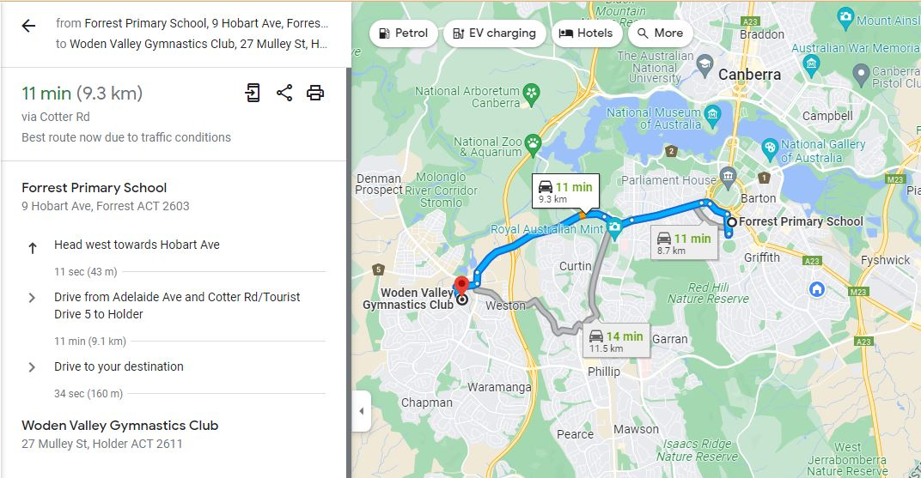

Manuka Pool
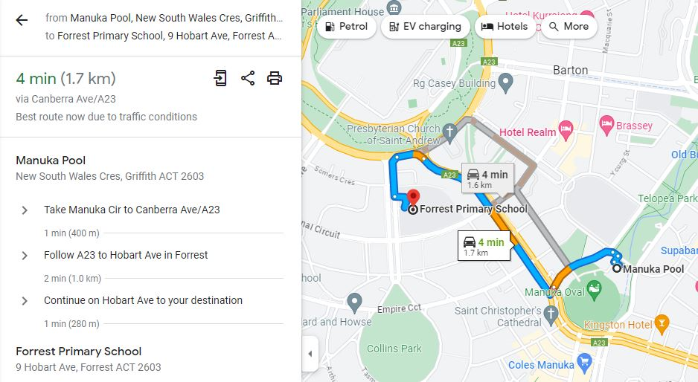

Aqua Park
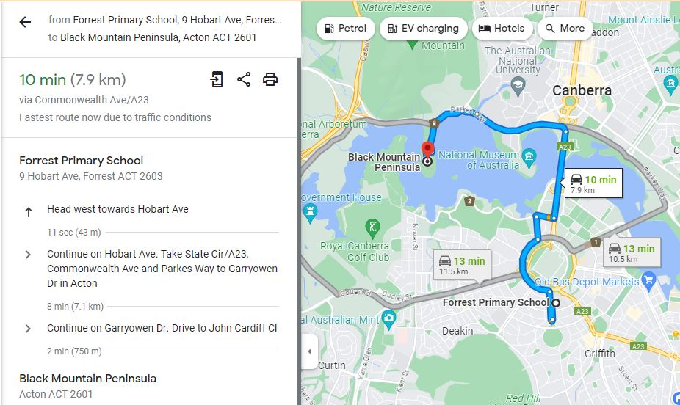

Kidzplore Dairy Rd
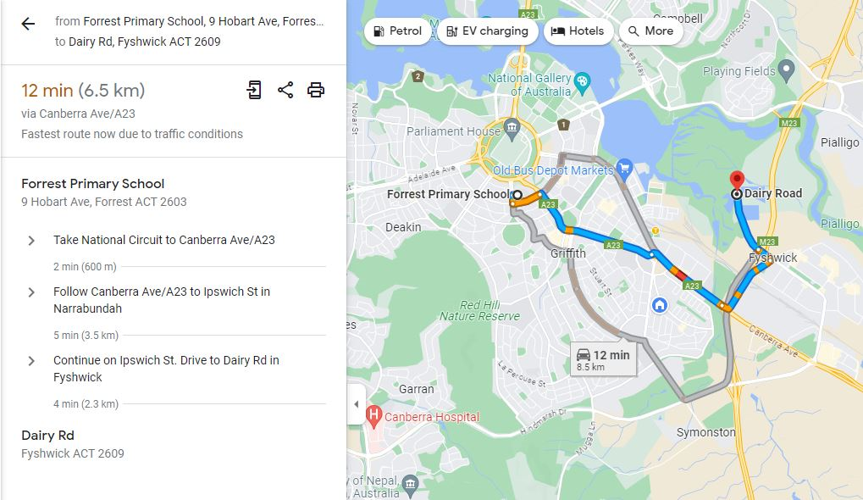

Limelight Cinemas
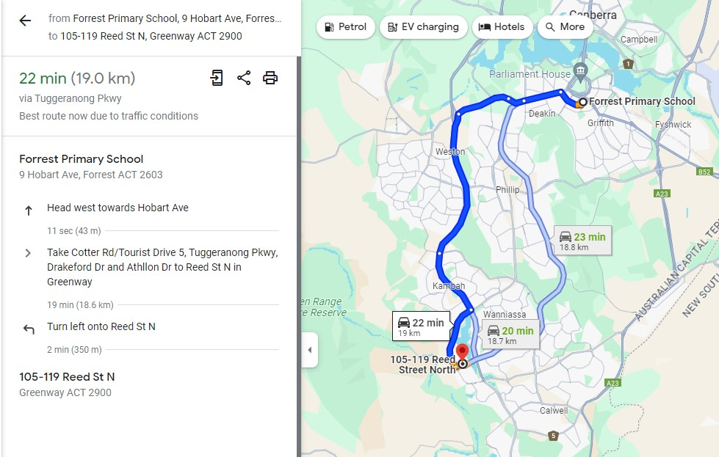
BACK UP EXCURSION PLAN - IPlay
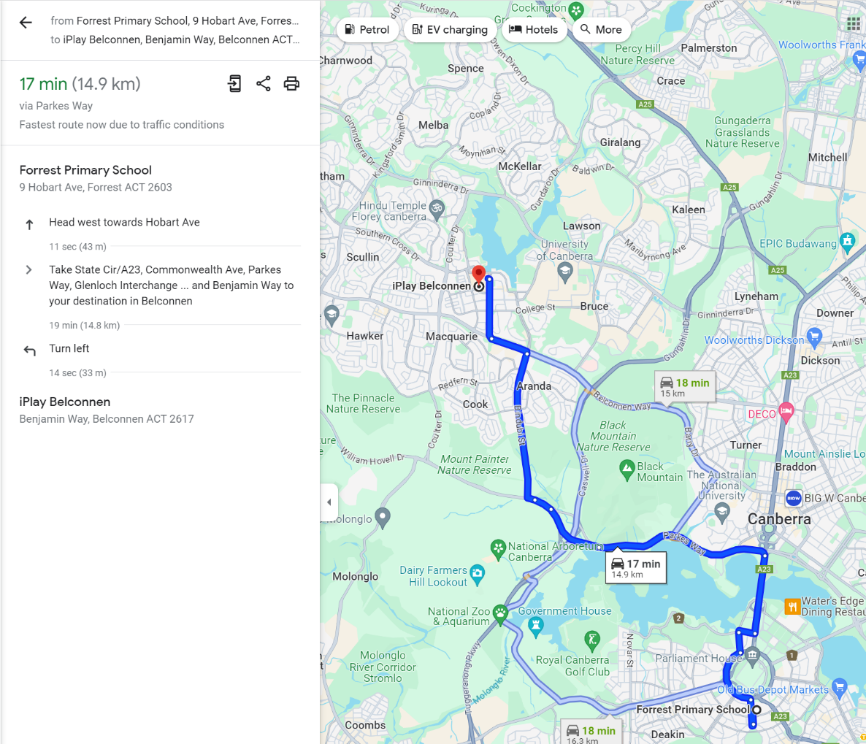

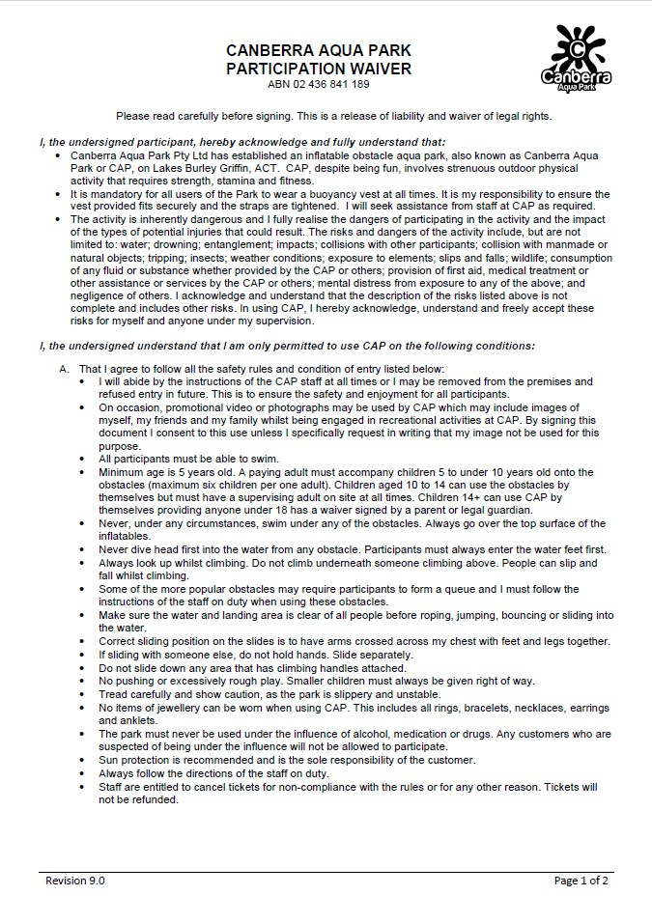

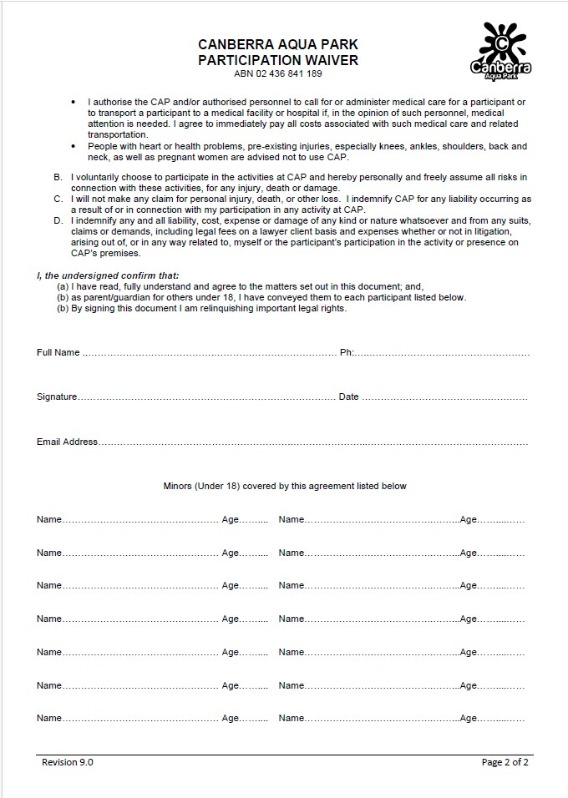

END OF PAPER

