FORREST OUT OF SCHOOL HOURS CARE
2024 JULY SCHOOL HOLIDAY PROGRAM
Monday 8th July  $100 | Tuesday 9th July  $110 | Wednesday 10th July  $115 | Thursday 11th July  $105 | Friday 12th July  $120
Buoyant Boats!  Life Sized Marble Run  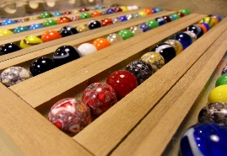 | Artist in Residence:  Kiln Fired Clay Creations  Making  Baked Pretzels | 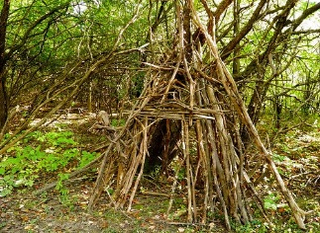  Excursion:  Wilderness wildlings at Arboretum Forrest with BBQ lunch  9:15am – 2:45pm  This week is NAIDOC week and as part of our holiday program we have scheduled a number of experiences to help us to explore and acknowledge this year’s theme – Keep the Fire Burning! Blak, Loud and Proud! | Make your own deep-sea creature  External workshop:  Fire with our Indigenous guide Aaron from Dreamtime Connections | Excursion:  Weston Creek Indoor Sports Centre  Futsal Soccer, Dodge Ball and Nerf games  9:15am – 1:15pm    Hessian Designs
Screen Time: 3:30-5:30 | Screen Time: 3:30-5:30 | Screen Time: 4:00-5:30 | Screen Time: 3:30 – 5:30 | Screen Time: 3:30-5:30

Monday 15th July  $105 | Tuesday 16th July  $120 | Wednesday 17th July  $100 | Thursday 18th July  $120 | Friday 19th July  $100 | Monday 22nd July  $110
Jewellery Making  Make your own sushi for afternoon tea   | Excursion:  Greenhills with our Indigenous guide Aaron from Dreamtime Connections – Bushwalks, games, and making damper on the fire  9:30am – 3:00pm | FOOSHC Olympics   | Mask Making  Excursion:  Inflatable World  1:30pm – 4:45pm | National PJ Day  Sock Puppets  Bath Bomb Making  Wii Games | External workshop:  Amazing Race  12:30pm – 3:30pm  Blondie Monsters
Screen Time: 3:30 – 5:30 | Screen Time: 3:30 – 5:30 | Screen Time: 3:30 – 5:30 | Screen Time: 3:30 – 5:30 | Screen Time: 3:30 – 5:30 | Screen Time: 3:30 – 5:30

About the Program
Forrest Out of School Hours Care (FOOSHC) provides a safe and welcoming environment for the children and their families. We believe children are capable, competent, and creative learners that are entitled to participate in a program that facilitates their engagement in risk-taking, experimentation and exploration of indoor and outdoor spaces.
Our program is child led with a play-focused environment which is reflective of the children’s needs and interests. Children will have the opportunity for rest and relaxation and can move freely between activities and inside and outside environments. In addition to the experiences detailed on the cover page, all the fabulous FOOSHC resources will be available daily.

Our Philosophy- currently under review – your feedback can be sent to info@fooshc.org.au

Everything we do is in the best interests of the child. We advocate for children’s voices to be heard and we honour and respect their rights, views and ‘being’, as the foundation of our program.
Relationships:
We seek to build and nurture trusting, reciprocal relationships with children, families and each other. We believe this enables children to form secure attachments to each other, the educators and our environments, whilst honouring those with their families. We recognise the diverse backgrounds and cultures of each member of our FOOSHC community and how their presence greatly enriches our service. We acknowledge everyone as an individual who is capable and competent, and we strive to operate without bias. For children, this will provide a sense of belonging and ownership of their environments, whilst also enabling them to become empowered decision makers. FOOSHC believes children who have known kindness, trust and respect will value themselves and others.
Play:
FOOSHC is a place in which play takes priority because all children have the right to play, as such; our program is to plan for the possibilities of play. Our pedagogical practice is based on a Playwork approach which sees children as the constructors of their own experience in an environment which children are supported and encouraged to flourish and fail. A Playwork approach sees our educators facilitate and maintain the physical and psychological conditions that encourage and allow for children to play as ‘a process that is freely chosen, personally directed and intrinsically motivated.’
Professional Development:
High expectations and standards are held of all of our educators at FOOSHC. We embrace opportunities for innovative practice, critical reflection and embed professional development into our everyday practice. FOOSHC strives to create a culture of professional inquiry in which our educators are encouraged to engage in robust discussion and challenge themselves and others. Educators embody integrity, compassion, respect and motivation.
Advocacy and Leadership:
We are committed to advocating for the children of FOOSHC and for their right to have a childhood; the time, space and freedom to play, to take risks and to navigate life. We believe that by sharing what we do with the community and inspiring innovation in others that we are also advocating for all children to have these opportunities.

General Information
Open 8am – 6pm Monday 8th July 2024 – Monday 22nd July 2024

Enrolment
Step 1 – All families must complete a 2024 enrolment form which can be found on our website www.forrestpandc.com.au
Step 2 - Complete this attendance/booking form for this holiday period & permission notes attached for the relevant days

Enrolments close Sunday 30th June 2024 Bookings received after this date will incur a $25 surcharge per family.

Fees and Childcare Subsidy (CCS)
- Cancellation must be in writing, TWO weeks in advance for no charges to apply.
- To obtain CCS you must have registered your details with Centrelink or MyGov and have provided us with your child’s date of birth and Customer Reference Number for the parent registered for CCS and each child on the enrolment form.

Arrival and Departure
- Always access the service via Children’s Services Office entrance (FOOSHC Office).
- Children MUST be signed in and out of the program each day by a parent or guardian.
- The iPad will be located for signing in the Junior Hall (next to the door) during the holidays.
Food
- Children are required to provide their own lunch and snacks each day. Children often get hungry in the holidays, please consider this when packing their daily food.
- Afternoon tea will be provided each day around 3:30pm.
- We encourage snacks with healthy high nutritional content to meet the growing needs of children.
- Breakfast is NOT provided during holiday care. We apologise for any inconvenience this may cause.
- Children should also bring a refillable water bottle. PLEASE NOTE ON EXCURSION DAYS, CHILDREN WITHOUT DRINK BOTTLES WILL BE GIVEN A WATER BOTTLE TO KEEP AND A CHARGE OF $10 WILL BE ADDED TO YOUR ACCOUNT.
- We promote healthy eating at FOOSHC so No soft-drinks or juices are permitted. We encourage the children to drink water which will be readily available.
- As we are an Allergy Aware centre please no nuts/nut products or eggs (eggs in cooked products are acceptable -eg:cake)
Clothing
Please label / name all your child’s clothing
- Closed in shoes are required on Excursion days
- No singlets or sleeveless tops please as these are not sunsafe
- Children MUST have a rash shirt for ALL water based excursions
- As children engage in all sorts of adventurous play a change of clothes is recommended
- Children are required to bring a sun smart hat that protects the face, back of the neck, eyes and ears. Broad-brimmed, bucket or legionnaire hats offer the best protection. NO CAPS PLEASE.
- PLEASE NOTE ON EXCURSION DAYS, CHILDREN WITHOUT A SUNSAFE HAT WILL BE GIVEN A HAT AND A CHARGE OF $15 WILL BE ADDED TO YOUR ACCOUNT.

Sun Safety
We actively promote children to be sunsafe and as the UV index rating will be low, we still encourage children to be proactive in their approach to sun safe practices’: checking the UV level is below 3 and hats may still be encouraged. We still encourage your child to apply sunscreen prior to their arrival. Sunscreen will be available throughout the day but please feel free to bring your own if you prefer. Please ensure your children wear sunsafe clothing.
Lost property
After the holiday period, all lost property will be donated to charity or recycled as appropriate if not collected at then of holiday period. .
Screen Time
Children will have access our electronic devices for 2-hour periods during the program. This means there will be NO BYO Device day. We do have a special Pyjama Day planned with our own devices. This decision was reached after lengthy consultation with families, children, and educators.
We hope that the way screen time has been structured these holidays will assist families in regulating screen time at home.

The FOOSHC laptop may be utilised for active and non-competitive group games, such as the “Just Dance” videos that were extremely popular in previous holidays. Beyond our typical screen time we have heard feedback from families that want a video game day. However, all devices and games will be provided by FOOSHC to ensure they are age appropriate and that no families devices are damaged. In unfavourable weather conditions, such as extreme heat or storms, a movie may be used depending on the needs of the children.

Wheels
- Children are welcome to bring their bikes, scooters, skateboards, rollerblades etc. to the program.
- Children MUST have their own fitted helmet (In line with Australian standards) to participate.
- Children are not allowed to share wheels. Each child will use their own wheels.
- Wheels may be left at FOOSHC overnight; however all wheels must be taken home at the end of the holiday period unless Ali will try and sell them on eBay 😊.

Day Specific Information
Monday 8th July 2024 – Buoyant Boats and Life-Sized Marble Run
We start the holidays by putting our engineering skills to the test by designing and building our very own boats! Pick your materials, perfect your design, and decorate your beautiful boats before seeing if they can survive the ultimate test of making them float.
Then we roll on over to the sandpit to design, dig and construct paths through the sand to send marbles flying down the track complete with loose parts. Don’t miss out on FOOSHC’s very own Giant Marble Run!
Tuesday 9th July 2024 – Artist in Residence Clay Creations and Baked Pretzel Bar
Today we welcome a local artist into FOOSHC to work with the children and show them their creative process on how they make ceramics. Children get the chance to carefully mould their clay to create their art piece with the help of our artist. These pieces will then be fired in a kiln offsite and then given back to the children a few weeks later. This exciting and engaging opportunity for children to learn about ceramics is not to be missed.
For afternoon tea the children will help knead and shape pretzels to then choose their toppings for this scrumptious afternoon tea.
Wednesday 10th July 2024 – Excursion: Wilderness Wildlings at the Arboretum
Today we are going back to one of our favourite excursions of the last vacation care, the Himalayan Cedar Lookout. Today we take in some of the best scenery that Canberra has to offer by going deep into the grounds of the arboretum to the Himalayan Cedar Forest. Children will get to play and explore the Himalayan Cedar Lookout. This space offers ample possibilities to build forts, explore the surrounds and connect to Country. We’ll take advantage of the beautiful view by taking various art mediums to capture and explore the site and enjoy a BBQ sausage sizzle for lunch.
Last holidays, we saw a lot of children forming a great connection with this space and by returning in a different season we are hoping to deepen their connection to their local space. Please help us achieve this by packing appropriate warm clothes so that the children can explore the outdoor environment through winter.
Please ensure your child/ren come prepared for a day of adventure and play with the following items:
- Change of clothes
- Hat or beanie
- Filled water bottle and snacks
- A Jumper
- A warm jacket
While we will be providing a Sausage sizzle for lunch please ensure you pack plenty of energy fuelling foods to help your child make the most of this big day.

Thursday 11th July 2024 – External Workshop: Fire with our Indigenous guide Aaron from Dream Time Connections and Deep Sea Creatures
To help us celebrate and acknowledge NAIDOC week with the children, Aaron Chatfield from Dreamtime Connections will be joining us here at FOOSHC. Aaron will join us at our fire pit and help us in learning about several native ingredients and trying them in different foods. Fireside chats have always provided our educators and children a time to come together and have a yarn and we are thrilled Aaron will be joining us for this one. The Fire is dependent on weather and will not take place if there are high winds on the day.

Delve into the exotic, vibrant and unexplored imaginary depths of the ocean as you create your very own Deep-Sea Creature! From wildly rainbow sea slugs with a million tendrils, to giant friendly squids, sea tubes, angler fish and whatever else your mind's eye can see. Bring your creature to life in a semi-guided mixed-media crafting workshop / extravaganza with recycled materials, colourful crepe paper, glue, clay, paint, and so much more.

Friday 12th July 2024 – Excursion: Weston Creek Indoor Sports and Designing Hessian Squares
Channel your inner Sam Kerr as we head off to Western Creek Indoor Sports Centre. Join us for a morning of fun as we rotate through three 45-minute sessions of indoor soccer, dodge ball, and nerf games. Get a taste of each sport as you dodge, strike, and take aim in three super energetic indoor sports.
Then come back to FOOSHC to a relaxing afternoon of craft. Draw shapes onto hessian squares and bring your piece to life by weaving, sticking, and layering different materials to make an art piece that all yours!

Monday 15th July 2024 – Jewellery Making and Make your own Sushi
Get ready to design and make beautiful pieces of jewellery with a member of our team as they facilitate a Jewellery making workshop. Explore combinations of polymer clay and all sorts of magnificent beads to make your own bracelets, earrings, and necklaces.
Then join Resident Chef Mimi in the kitchen to make your own Sushi for afternoon tea. Mimi is a qualified Japanse sushi chef and will be teaching all the children the techniques and art of this traditional dish.
Tuesday 16th July 2024 – Excursion: Green Hills
Green Hills is an engaging outdoor environment that will see us participate in various activities ranging from bushwalking , sand court volleyball and badminton. We will be cooking damper over the campfire as well as enjoying time to explore the natural environment connecting to country. We will also be joined by Aaron our indigenous guide from Dreamtime Connections who will join the children on a bushwalk and participate in games on the grass area. This is an amazing opportunity for the children and educators to further explore conversations around the NAIDOC 2024 theme – Blak, Loud and Proud!
Please support this excursion by packing appropriate warm clothes so that the children can explore the outdoor environment through winter.
Please ensure your child/ren come prepared for a day of adventure and play with the following items:
- Change of clothes
- Sun smart hat/Beanie
- Filled water bottle and snacks
- A Jumper
- A warm jacket

Wednesday 17th July 2024 – FOOSHC Olympics
We are excited to announce “The FOOSHC Olympics” a fun filled day of competitive games and activities. This special event will feature a variety of competitions tailored to all ages and skill levels. That’s right, you won’t have to go all the way to Paris to experience the Olympic Spirit! Remember that it is not all about winning, and that glory can be achieved by all competitors just by doing their best and cheering on their fellow participants.
Thursday 18th July 2024 – Excursion: Inflatable World and Mask Design
Today, we will bounce on down to Inflatable World. Inflatable in Kambah by charter bus. Inflatable World is a high energy, maximum activity zone (kids get hot and sweaty), so we suggest children wear loose, comfortable clothing. Everyone on the inflatables must be wearing socks, as they have a NO SOCK -NO play policy. Unfortunately, FOOSHC are unable to provide children with socks so please ensure that your child comes prepared to avoid disappointment. Also, please bring a water bottle as the child exert lots of energy.
Please ensure your child/ren come prepared for a day of adventure and play with the following items:
- Socks
- Sun smart hat
- Filled water bottle and snacks
- A Jumper

Friday 19th July 2024 – PJ and Spa Day
Come Dressed in your comfiest Pyjamas as we celebrate National PJ Day. Today we aim to enjoy a little rest and relaxation with a super cozy day of fun. We will have wacky makeovers with temporary hair colour and face paint. Then take some of the comfort home by making a fizzy bath bomb and sock puppets. We will also have additional screen time on the day to play Wii games. We will finish the afternoon with a popcorn bar and a movie.

Monday 22nd July 2024- External Workshop: Amazing Race and Blondie Monstrosities
Fitkidz Australia an external provider are returning to run another exciting workshop: The Amazing Race! Children will get into teams and go through a wide range of challenges and activities to see who can complete them first. We will take on challenges for your body and mind as you solve riddles, take on different sporty challenges, and complete any task they throw at you. This workshop promises to be a great team building opportunity for all ages.

Alongside the amazing race we will be baking blondies for the children to decorate and turn into crumbly, delicious monsters.
After a jam filled school holiday program we will be ready for school the next day.

FORREST OUT OF SCHOOL HOURS CARE
2024 JULY SCHOOL HOLIDAY PROGRAM:
BOOKING FORM
Please complete the details below to enrol your child.

Account Name: Current Email Address:

Child’s name | Mon  8/7  $100 | Tue  9/7  $110 | Wed 10/7  $115 | Thu  11/7  $105 | Fri  12/7  $120 |  | Mon  15/7  $ 105 | Tue  16/7 $120 | Wed  17/7 $100 | Thu  18/7 $120 | Fri 19/7 $100 | Mon  22/7  $110

Important Information | Please sign below to acknowledge that you have read and understood this important information
I understand that children need to bring lunch, snacks and a refillable drink bottle each day. We are an Allergy Aware Centre – no nuts/nut products or eggs.
These holidays we may be using both still and movie cameras to record the children’s adventures. Please advise in writing if you do not want your child to participate in this part of the program. We may use the photos/footage to promote our program and to screen with families/friends of the service. I understand that this will include photos of my children in their swimmers during water excursions and water play at the service.
I understand that children need to be signed in and out of the program each day. This will occur by entering through the Fooshc Children’s Services Office
If I wish to cancel days’ requests must be made in writing and for no charge to apply and must be received at least TWO WEEKS prior to the cancelled day.

Outstanding fees will incur a late payment fee unless arrangements are made on enrolment. Payment plans are available. Bookings after 30th June will incur a $25 late booking fee per child.
I give permission for my child to view suitable PG movies and play some electronic games that are also rated PG (older games originally rated G that today are rated PG but deemed suitable by Educators) during the program.
I understand that FOOSHC uses a charter bus without seatbelts for excursions and if my child is not signed in prior to the advertised departure time that I will need to drop my child at the excursion.
I understand that if I do not bring a sunsafe hat or drink bottle for my child then my child will be given a new hat or drink bottle at the cost of $10 (hat) or $5(bottle) which will then be charged to my account.
I give permission for my child to use their own wheels and I understand they are required wear to a well fitted helmet that meets Australian Standards that could used in multiple play spaces with various pieces of equipment.
PLEASE SIGN THE BOX FOR EACH DAY YOUR CHILD WILL ATTEND
Date/Time | Experience | Sign
ALL  DAYS | I acknowledge that the proposed routes to all excursions my child is attending are inserted as images over the page.  I understand that these are proposed routes and the final route will be determined on the day by the driver due to a range of contributing factors.
10/07/2024 | National Arboretum Himalayan Cedar Look Out Carpark:  I have read and understood the proposed activities for today and give permission for my child/ren to travel by charter bus to the National Arboretum – Himalayan Cedar Look Out and Surrounds  I understand that my child will need appropriate clothing and foot ware to participate. I understand that my child may engage in nature-based activities which could include: fort building, mud play, bush walking, tree climbing, and bush games.  Departing FOOSHC: 9:30am Approx arrival to venue: 9:50am  Departing venue: 2:15pm Approx. arrival to FOOSHC 2:35pm  Ratio and estimated number of educators: 8 Educators, Ratio 1:8  (raised ratio with an additional 1x educators)
12/07/2024 | Weston Creek Indoor Sports:  I give permission for my child/ren to travel by Charter Bus to Western Creek Sports.  I give permission for my child/ren to participate in rotating indoor sports, consisting of Nerf games, indoor soccer, and dodgeball.  I understand that the activities will be facilitated by the staff at Weston Creek Indoor Sports under FOOSHC supervision.  Departing FOOSHC: 9:30am Approx arrival to venue: 9:50am  Departing Venue: 12:45pm Approx arrival to FOOSHC: 13:05pm  Ratio 1:8  (raised ratio with an additional 1x educators)
16/07/2024 | Greenhills Centre:  I give permission for my child/ren to travel by Charter Bus to Greenhills Centre.  I understand that today will include cooking on fire, exploring surrounding bush land, tree climbing  I understand that my child will need appropriate clothing  Such as warm layers and closed in foot ware to participate.  Departing FOOSHC: 10:00am Approx arrival to venue: 10:20am  Departing venue: 14:30pm Approx arrival to FOOSHC: 14:50pm  Ratio and estimated number of educators:Ratio 1:8 with 3 raised for spread of experiences and RP
18/07/2023 | Inflatable World Kambah:  I give permission for my child/ren to travel by charter bus to Inflatable world.  I give permission for my child/ren to use the inflatable play equipment.  I understand that my child must have socks to wear on inflatables in order to participate.  Departing FOOSHC: 13:30pm Approx arrival to venue: 13:50pm  Departing venue: 16:15pm Approx arrival to FOOSHC: 16:35pm  Estimated number of educators:, Ratio 1:8  (Raised ratio with an additional 1x educator)

MINIMUM EDUCATOR: CHILD RATIOS WILL BE
1:11 at the centre, 1:8 for excursions
Risk Benefit Assessments for all excursions have been completed and are available upon request.
Please see proposed routines for Excursions on the next page
Proposed routes for excursions- route may vary on the day. Our regulations state we need to show proposed routes on excursions

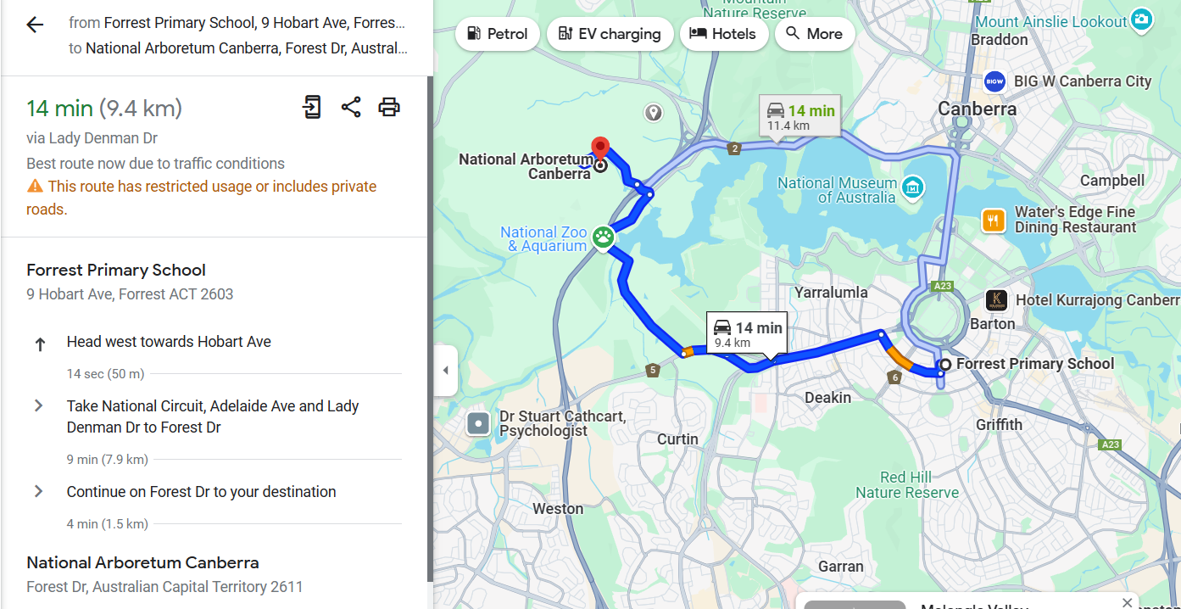
Proposed Route: National Arboretum Cedar Himalayan Lookout

Proposed Route: Western Creek Indoor Sports centre

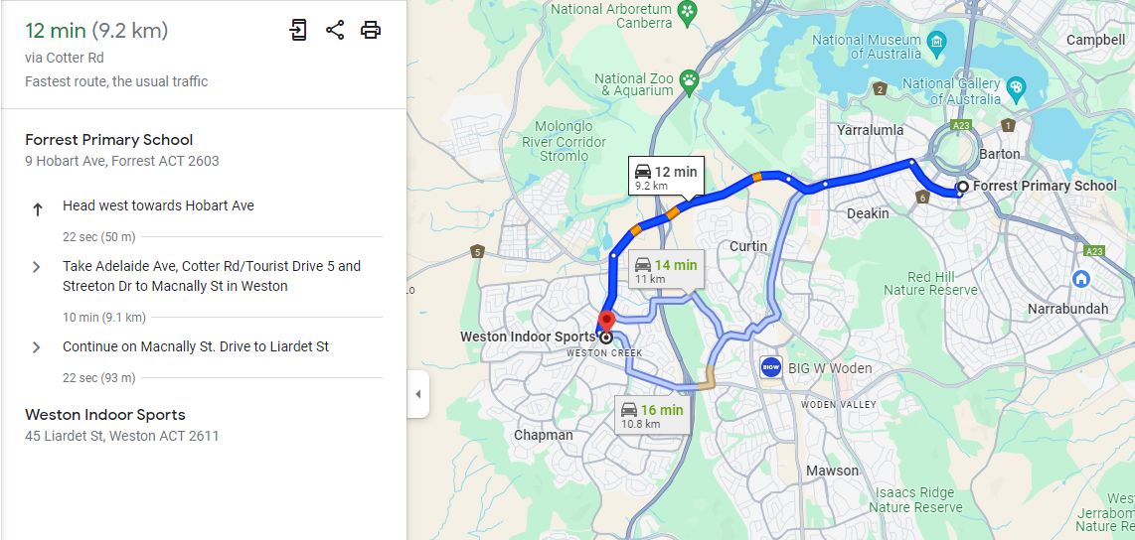

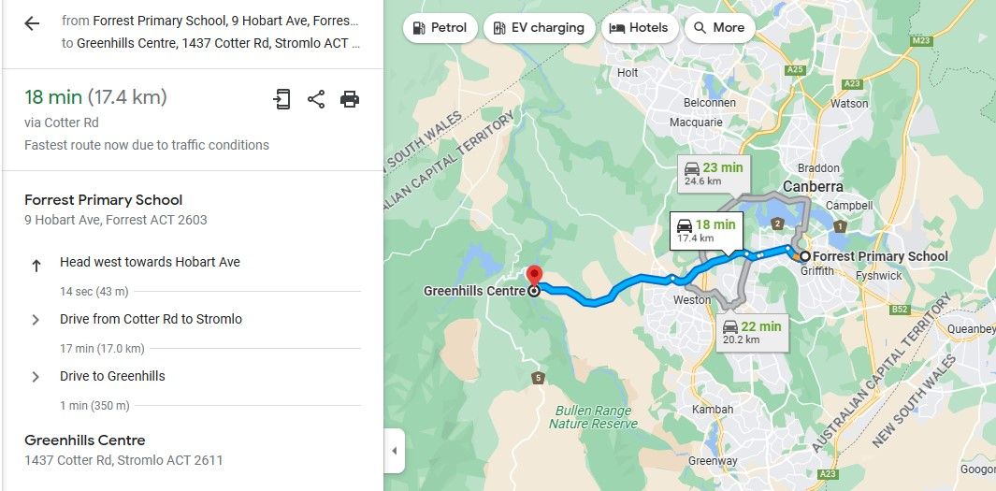
Proposed Route: Greenhills Centre

Proposed Route:

Proposed Route:

END OF PAPER

Proposed Route: Inflatable World
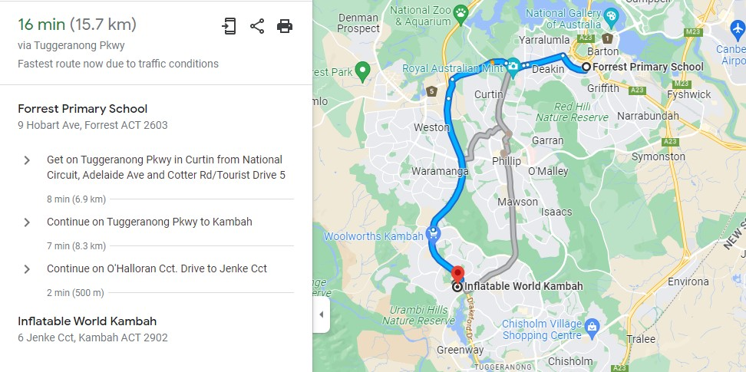

END OF FORM

