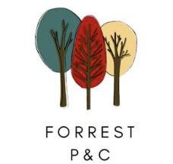
Forrest P&C Sock Fundraiser
The P&C has organised a sock fundraiser to raise money for school improvements*.
The fundraiser will run from June to 5 July 2024, just scan the QR code below to order.

Or use the following link: https://sockable.com.au/collections/socks?ref=FORRESTPRIMARYS
Your order will be sent direct to you within 7 business days.
Orders over $60 will be delivered for free. So get a group together and order. You can also share the QR Code with your friends and family.

This is just a small selection of the socks available in child and adult sizes, great gift idea. Jump online and check out the designs!

The P&C is also planning a Crazy Sock Day in Term 3.
*P&C fundraising has previously provided interactive whiteboards and air conditioning in classrooms as well as sinks and refurbished toilets.

