FORREST OUT OF SCHOOL HOURS CARE
2024 SEPTEMBER-OCTOBER SCHOOL HOLIDAY PROGRAM
Excursion:
Kambah Adventure Playground
with Coen from Culture on the Move for Bush Animal Weaving
9:30am – 3:30pm

Monday 30th September  $95 | Tuesday 1st  October  $135 | Wednesday 2nd October  $115 | Thursday 3rd  October  $120 | Friday 4th  October  $105
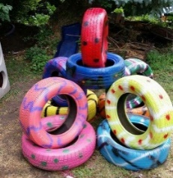  Loose Parts Construction & Painting Extravaganza!  Make your own  Rice Paper Rolls | Excursion:  Bounce Indoor Trampoline Park (Belconnen)  Trampolines, Dodgeball, and Climbing Wall  9:00am – 1pm  Slime-topia | External workshop:  Lego Robotics Workshop with e2 Young Engineers Australia  Interstellar Space Mystery | 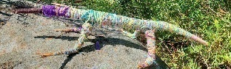 | Bagtastic Creations  Sew your own pencil case/bag  Splashmania Water Games  
Screen Time: 3:30-5:30 | Screen Time: 3:30-5:30 | Screen Time: 4:00-5:30 | Screen Time: 3:30 – 5:30 | Screen Time: 3:30-5:30

Monday 7th October | Tuesday 8th October  $95 | Wednesday 9th October  $105 | Thursday 10th October  $95 | Friday 11th October  $120 | Monday 14th October  $105
PUBLIC HOLIDAY | Loose Parts ‘Mario Kart’ Track Racing  Make Your own Calzones | Excursion:  Boundless Playground Picnic  With Picnic Lunch!  9:00am – 1:30pm  Fruit Slushie Bar   | 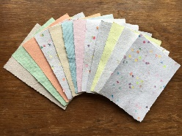  Make your own Recycled Paper  Exploring natural pigments Making paints and brushes! | Excursion:  iPlay  Belconnen  9:00am – 12:30pm  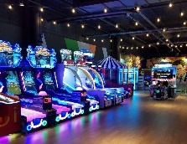  Make your own Funky Fidgets | Forrest Primary Pupil Free Day!  External workshop:  Gladiators  10am – 1pm  Cooking  Chocolate Crackles
PUBLIC HOLIDAY | Screen Time: 3:30 – 5:30 | Screen Time: 3:30 – 5:30 | Screen Time: 3:30 – 5:30 | Screen Time: 3:30 – 5:30 | Screen Time: 3:30 – 5:30

About the Program
Forrest Out of School Hours Care (FOOSHC) offers a safe and inclusive space for children and their families, underpinned by the belief that children are capable, competent, and creative learners. The program enables children to engage in risk-taking, experimentation, and exploration in both indoor and outdoor settings. Using a child-led, play-focused environment, the program reflects the needs and interests of the children. Fooshc provides opportunities for rest, relaxation, and the freedom to move between activities and spaces freely. Additionally, FOOSHC ensures that all its fabulous resources are available to children each day supporting our Playwork ideology.

Our Philosophy

Everything we do is in the best interests of the child. We advocate for children’s voices to be heard, and we honour and respect their rights, views and ‘being’, as the foundation of our program.
Relationships:
We seek to build and nurture trusting, reciprocal relationships with children, families and each other. We believe this enables children to form secure attachments to each other, the educators and our environments, whilst honouring those with their families. We recognise the diverse backgrounds and cultures of each member of our FOOSHC community and how their presence greatly enriches our service. We acknowledge everyone as an individual who is capable and competent, and we strive to operate without bias. For children, this will provide a sense of belonging and ownership of their environments, whilst also enabling them to become empowered decision makers. FOOSHC believes children who have known kindness, trust and respect will value themselves and others.
Play:
FOOSHC is a place in which play takes priority because all children have the right to play, as such; our program is to plan for the possibilities of play. Our pedagogical practice is based on a Playwork approach which sees children as the constructors of their own experience in an environment which children are supported and encouraged to flourish and fail. A Playwork approach sees our educators facilitate and maintain the physical and psychological conditions that encourage and allow for children to play as ‘a process that is freely chosen, personally directed and intrinsically motivated.’
Professional Development:

High expectations and standards are held of all of our educators at FOOSHC. We embrace opportunities for innovative practice, critical reflection and embed professional development into our everyday practice. FOOSHC strives to create a culture of professional inquiry in which our educators are encouraged to engage in robust discussion and challenge themselves and others. Educators embody integrity, compassion, respect and motivation.
Advocacy and Leadership:

We are committed to advocating for the children of FOOSHC and for their right to have a childhood; the time, space and freedom to play, to take risks and to navigate life. We believe that by sharing what we do with the community and inspiring innovation in others that we are also advocating for all children to have these opportunities.

General Information
Open 8am – 6pm Monday 30th September 2024 – Monday 14th October 2024

Enrolment
Step 1 – All families must complete a 2024 enrolment form which can be found on our website www.forrestpandc.com.au
Step 2 - Complete this attendance/booking form for this holiday period & permission notes attached for the relevant days

Enrolments close Sunday 22nd September 2024 Bookings received after this date will incur a $25 surcharge per family.

Fees and Childcare Subsidy (CCS)
- Cancellation must be in writing, TWO weeks in advance for no charges to apply.
- To obtain CCS you must have registered your details with Centrelink or MyGov and have provided us with your child’s date of birth and Customer Reference Number for the parent registered for CCS and each child on the enrolment form.
Arrival and Departure
- Always access the service via Children’s Services Office entrance (FOOSHC Office).
- Children MUST be signed in and out of the program each day by a parent or guardian.
- The iPad will be located for signing in the Junior Hall (next to the door) during the holidays.
Food
- Children are required to provide their own lunch and snacks each day. Children often get hungry in the holidays, please consider this when packing their daily food.
- Afternoon tea will be provided each day around 3:30pm.
- We encourage snacks with healthy high nutritional content to meet the growing needs of children.
- Breakfast is NOT provided during holiday care. We apologise for any inconvenience this may cause.
- Children should also bring a refillable water bottle. PLEASE NOTE ON EXCURSION DAYS, CHILDREN WITHOUT DRINK BOTTLES WILL BE GIVEN A WATER BOTTLE TO KEEP AND A CHARGE OF $10 WILL BE ADDED TO YOUR ACCOUNT.
- We promote healthy eating at FOOSHC so No soft-drinks or juices are permitted. We encourage the children to drink water which will be readily available.
- As we are an Allergy Aware centre please no nuts/nut products or eggs (eggs in cooked products are acceptable -eg:cake)
Clothing
Please label / name all your child’s clothing
- Closed in shoes are required on Excursion days
- No singlets or sleeveless tops please as these are not sun-safe
- Children MUST have a rash shirt for ALL water-based excursions
- As children engage in all sorts of adventurous play a change of clothes is recommended
- Children are required to bring a sun smart hat that protects the face, back of the neck, eyes and ears. Broad-brimmed, bucket or legionnaire hats offer the best protection. NO CAPS PLEASE.
- PLEASE NOTE ON EXCURSION DAYS, CHILDREN WITHOUT A SUNSAFE HAT WILL BE GIVEN A HAT AND A CHARGE OF $15 WILL BE ADDED TO YOUR ACCOUNT.

Sun Safety
We actively promote children to be sunsafe and as the UV index rating will be rising we encourage children to be proactive in their approach to sun safe practices’: checking the UV level is above 3 and sunsafe hats and sunscreen will be required We still encourage your child to apply sunscreen prior to their arrival. Sunscreen will be available throughout the day but please feel free to bring your own if you prefer. Please ensure your children wear sunsafe clothing to help to protect their precious skin.
Lost property
After the holiday period, all lost property will be donated to charity or recycled as appropriate if not collected at then of holiday period. .
Screen Time
Children will have access our electronic devices for 2-hour periods during the program. This means there will be NO BYO Device day. We do have a special Pyjama Day planned with our own devices. This decision was reached after lengthy consultation with families, children, and educators.
We hope that the way screen time has been structured these holidays will assist families in regulating screen time at home.

The FOOSHC laptop may be utilised for active and non-competitive group games, such as the “Just Dance” videos that were extremely popular in previous holidays. Beyond our typical screen time we have heard feedback from families that want a video game day. However, all devices and games will be provided by FOOSHC to ensure they are age appropriate and that no families devices are damaged. In unfavourable weather conditions, such as extreme heat or storms, a movie may be used depending on the needs of the children.

Wheels
- Children are welcome to bring their bikes, scooters, skateboards, rollerblades etc. to the program.
- Children MUST have their own fitted helmet (In line with Australian standards) to participate.
- Children are not allowed to share wheels. Each child will use their own wheels.
- Wheels may be left at FOOSHC overnight; however all wheels must be taken home at the end of the holiday period unless Ali will try and sell them on eBay 😊.

Day Specific Information
Monday 30th September 2024 – Loose Parts Construction Extravaganza and make your own Rice Paper Rolls
Start the holidays by constructing, painting, and building up the Loose Parts space. We will offer a range of different wooden pallets and other materials to revamp the space and will spend the morning with an educator on hand to help you leave your mark on the space. Get creative with a hammer, paint a pallet, or just enjoy our Loose Parts space.
Then in the afternoon we are making some delicious Rice Paper Rolls. Choose from a range of fresh and scrumptious ingredients to put together your perfect Rice Paper Roll.
Tuesday 1st October 2024 – Excursion: Bounce and Slime-topia
Hop, skip, and jump your way over to Bounce in Belconnen. This high energy indoor trampoline park provides countless possibilities for the children to explore and master skills like never before. To ensure they are ready for a day full of adventure we suggest children wear loose, comfortable clothing that they can move freely in. Bounce Socks are included in the price.
Enclosed flat-soled shoes are required for Rock Climbing and the X-Park Adventure Challenge Course (excluding gumboots), please note that the rock-climbing section has a minimum height of 110cm and the X-Park has a minimum height of 125cm.
Please ensure your child/ren come prepared for a day of adventure and play with the following items:
- Filled water bottle and snacks
- Enclosed flat-soled shoes (gumboots not permitted)

Then back at FOOSHC spend the afternoon with us and make your very own Slime to play with for the day or take home. Experiment with various ingredients, textures and recipes until you are happy with your slimy creation!

Wednesday 2nd October 2024 – Lego Robotics-Coding Workshop and the Great Space Hunt
We are excited to welcome Young Engineers Canberra for the first time. Their exciting workshop gives you the chance to play with Lego like never before as you start to think like an engineer. Build robots, develop and test computer algorithms, and learn how to code to get your robot to move around its environment. This unique opportunity is sure to be just as challenging as it is fun!
Join in on an epic Space Scavenger Hunt filled with cosmic fun! Our alien friend has landed at FOOSHC and needs your assistance to track down their missing space gear before zooming back home. Dive into the clues and unravel the intergalactic mystery.

Thursday 3rd October 2024 – Excursion: Kambah Adventure Playground with Bush Animal Weaving
Join us as we go to explore the Kambah Adventure Playground. Children will be able to make use of the many unique fixed equipment areas. We will then sit down together for a picnic lunch before FOOSHC-favourite Culture on the Move returns to facilitate a bush animal weaving workshop under the trees.
Today is a big day for the children so please ensure you pack an energy fuelling lunch including a few snacks.
Please ensure your child/ren come prepared for a day of adventure and play with the following items:
- Sun smart hat
- Filled water bottle and lunch box
- A jumper
- Enclosed shoes

Friday 4th October 2024 – Bag-tastic Creations: Sew your Own Style and Splashtastic Water Games
Choose from a range of wonderful designs and work on your sewing skills to carry everything you need in style! Our educators will help you design and sew one of a few designs including simple pencil cases, bags, and more. Using vibrant fabrics, simple patterns, and a sewing machine, you'll craft a one-of-a-kind tote or pouch to show off. Get ready for a session full of creativity, learning, and a bag-tastic good time! In the afternoon, come down to the oval and join us for a SPLASHTASTIC day of exciting water games and challenges to cool off in the sun. Dodge through a splash obstacle course, race to fill your bucket without spills and much more. Outside junior hall, the fun continues with an igloo building challenge.
Please ensure your child/ren come prepared for a day of adventure and play with the following items:
- Sun smart hat
- Filled water bottle and snacks
- Clothes that can get wet
- A change of clothes

Monday 7th October 2024 – CLOSED FOR PUBLIC HOLIDAY
Tuesday 8th October 2024 – Loose-Parts Mario Kart Racetrack and making customised Calzones
Race into fooshc, grab a trike, and start your engines. Today we create a life-sized Mario Kart track out of loose parts. Weave and turn through obstacles with your mates speeding behind.

Throughout the afternoon we will be making flavour-packed Calzones (stuffed pizza)! Pick your fillings from a range of ingredients, then kick back for a relaxed afternoon and enjoy your calzone as we screen a movie.

Wednesday 9th October 2024 – Excursion: Boundless Playground and Fruit-a-Lucious Slushie Bar
Today, we will head out to the exciting and much-loved Boundless Playground! With plenty of room to run around, climb, play, explore, and master unique challenges of the equipment, we will round out the day with a picnic-style lunch together at base.
A picnic lunch is provided however please ensure you pack a few energy-fuelling snacks.
Please ensure your child/ren come prepared for a day of adventure and play with the following items:
- Sun smart hat
- Filled water bottle and snacks
- A jumper

In the afternoon, we will cool off with a refreshing and delicious Slushie Bar back at FOOSHC. Children get to chop and mash the fruits of their choosing to top their fruit juice slushies!
Thursday 10th October 2024 – Natural Pigments, Paintbrush and Recycled Paper Crafts
Join us as we get crafty and make our very own paper! We love drawing and colouring at FOOSHC, let’s make it even better by using paper we made ourselves. We will blend up old paper and turn it new at our very own recycling workshop.
After making your very own recycled paper in the morning – spend the afternoon testing out how to make your own pigments and paintbrushes as well! Use entirely natural ingredients to make your own colours for the paints, and make paintbrushes out of sticks, leaves and anything else you can find.

Friday 11th October 2024 – Excursion: iPlay Belconnen and Fidget Making

To start the day off in style we are going to experience all the fun they have on offer over at iPlay in Belconnen. The children will get a go at the Dodgem Cars, a game of Laser Tag (minimum age 6) and unlimited turns at the Arcade machines. Please note that the Dodgem Cars have a minimum height of minimum height of 130cm to drive, or 90cm to ride with a driver over 130cm tall.

Spend your afternoon relaxing back at service making various DIY fidget toys! After a high energy excursion, come make your own bead snake, stress ball or flextangle to take home.

Monday 14th October 2024- External Workshop: Gladiators and Baking Chocolate Crackles
Fitkidz Australia are returning to run another exciting workshop: Gladiators! Children will run, jump and spar their way through a variety of fun training games, including boxing with pad holders and sword play, before splitting into teams for a final epic challenge! This workshop promises to be exciting, challenging, and a great team building opportunity for all ages.

Alongside Gladiators, we will be making delicious Chocolate Crackles with the children as an afternoon treat.

FORREST OUT OF SCHOOL HOURS CARE
2024 SEPTEMBER / OCTOBER SCHOOL HOLIDAY PROGRAM:
BOOKING FORM
Please complete the details below to enrol your child.

Account Name: Current Email Address:

Child’s name | Mon  30/9  $95 | Tue  1/10  $135 | Wed 2/10  $115 | Thu  3/10  $120 | Fri  4/10  $105 |  | Tue  8/10 $95 | Wed  9/10 $105 | Thu  10/10 $95 | Fri 11/10 $120 | Mon  14/10  $105

Important Information | Please sign below to acknowledge that you have read and understood this important information
I understand that children need to bring lunch, snacks and a refillable drink bottle each day. We are an Allergy Aware Centre – no nuts/nut products or eggs.
These holidays we may be using both still and movie cameras to record the children’s adventures. Please advise in writing if you do not want your child to participate in this part of the program. We may use the photos/footage to promote our program and to screen with families/friends of the service. I understand that this will include photos of my children in their swimmers during water excursions and water play at the service.
I understand that children need to be signed in and out of the program each day. This will occur by entering through the Fooshc Children’s Services Office
If I wish to cancel days’ requests must be made in writing and for no charge to apply and must be received at least TWO WEEKS prior to the cancelled day.

Outstanding fees will incur a late payment fee unless arrangements are made on enrolment. Payment plans are available. Bookings after Sunday 22nd September will incur a $25 late booking fee per child.
I give permission for my child to view suitable PG movies and play some electronic games that are also rated PG (older games originally rated G that today are rated PG but deemed suitable by Educators) during the program.
I understand that FOOSHC uses a charter bus without seatbelts for excursions and if my child is not signed in prior to the advertised departure time that I will need to drop my child at the excursion.
I understand that if I do not bring a sunsafe hat or drink bottle for my child then my child will be given a new hat or drink bottle at the cost of $10 (hat) or $5(bottle) which will then be charged to my account.
I give permission for my child to use their own wheels and I understand they are required wear to a well fitted helmet that meets Australian Standards that could used in multiple play spaces with various pieces of equipment.
PLEASE SIGN THE BOX FOR EACH DAY YOUR CHILD WILL ATTEND
Date/Time | Experience | Sign
ALL  DAYS | I acknowledge that the proposed routes to all excursions my child/ren is/are attending are inserted as images over the page.  I understand that these are proposed routes, and the final route will be determined on the day by the driver due to a range of contributing factors.
1/10/2024 | Bounce Belconnen:  I have read and understood the proposed activities for today and give permission for my child/ren to travel by charter bus to Bounce Belconnen – dropping off at Lathlain Street interchange and walking to venue.  I give permission for my child/ren to use the indoor trampolines, climbing and play equipment available at Bounce.  I understand that my child/ren MUST wear enclosed flat-soled shoes (excluding gumboots) to participate in Rock Climbing and the X-Park Adventure Challenge Course at Bounce.  I understand that my child/ren will need to meet the minimum height of 110cm to participate in Rock Climbing.  I understand that my child/ren will need to meet the minimum height of 125cm to participate in the X-Park Adventure Challenge Course.  I have read and agree to the terms and conditions (4 pages) provided by Bounce at the end of this document.  Departing FOOSHC: 9:15am Approx arrival to venue: 9:45am  Departing venue: 12:30pm Approx. arrival to FOOSHC 1pm  Ratio and estimated number of educators: 8 Educators, Ratio 1:8  (raised ratio with an additional 1x educators)
03/10/2024 | Kambah Adventure Playground:  I give permission for my child/ren to travel by Charter Bus to Kambah Adventure Playground.  I give permission for my child/ren to use the various fixed equipment at the Kambah Playground including flying foxes.  I understand that my child/ren may be allowed to participate in tree climbing, as determined by a Dynamic Risk Benefit Assessment conducted on the day.  Departing FOOSHC: 9:40am Approx arrival to venue: 10:00am  Departing Venue: 3pm Approx arrival to FOOSHC: 3:20pm  Ratio and estimated number of educators: 8 Educators, Ratio 1:8  (raised ratio with an additional 3x educators)
09/10/2024 | Boundless Playground:  I give permission for my child/ren to travel by Charter Bus to Boundless Playground.  I give permission for my child/ren to explore the fixed equipment at Boundless Playground.  I understand that my child/ren may be allowed to participate in tree climbing, as determined by a Dynamic Risk Benefit Assessment conducted on the day.  Departing FOOSHC: 9:15am Approx arrival to venue: 9:30am  Departing venue: 1:00pm Approx arrival to FOOSHC: 1:15pm  Ratio and estimated number of educators: 8 Educators, Ratio 1:8  (raised ratio with an additional 1x educators)
11/10/2024 | iPlay Belconnen:  I give permission for my child/ren to travel by charter bus to iPlay Belconnen – dropping off at Belconnen Bus Interchange and walking to venue.  I give my permission for my child/ren to participate in Laser Tag games, Dodgem Cars and Arcade Games.  I understand that my child/ren will need to meet the minimum height of 130cm to drive the Dodgem Cars, or 90cm to ride with a driver over 130cm.  I understand that my child/ren will need to meet the minimum age of 6 to participate in Laser Tag.  I understand that my child/ren MUST wear enclosed flat-soled shoes to participate in Laser Tag and Dodgem Cars at iPlay.  Departing FOOSHC: 9:15am Approx arrival to venue: 9:45am  Departing venue: 12:00pm Approx arrival to FOOSHC: 12:30pm  Ratio and estimated number of educators: 8 Educators, Ratio 1:8  (raised ratio with an additional 1x educators)

MINIMUM EDUCATOR: CHILD RATIOS WILL BE
1:11 at the centre, 1:8 for excursions
Risk Benefit Assessments for all excursions have been completed and are available upon request.
Please see proposed routines for Excursions on the next page
Proposed routes for excursions- route may vary on the day. Our regulations state we need to show proposed routes on excursions

Proposed Route: BOUNCE Belconnen (01/10/24)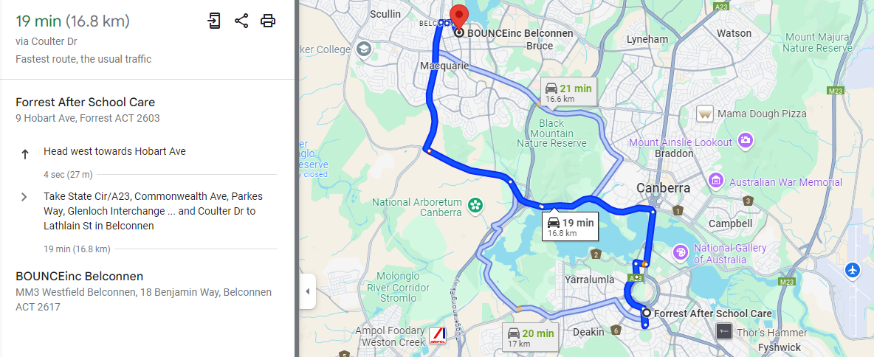

Proposed Route: Kambah Adventure Playground (03/10/24)

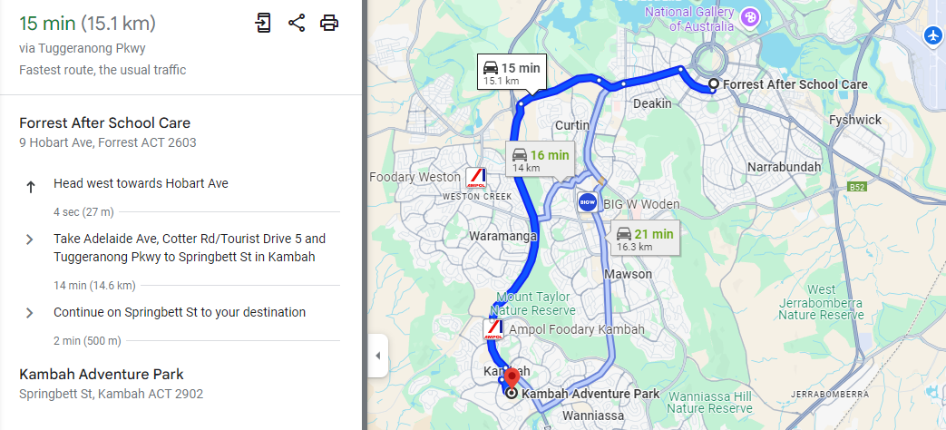

Proposed Route: Boundless Playground (09/10/24)
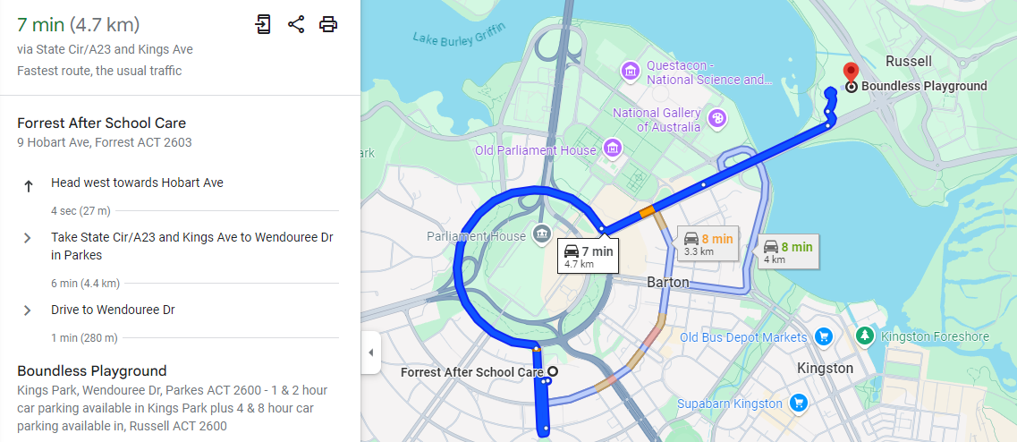
Proposed Route: iPlay Belconnen (11/10/24)
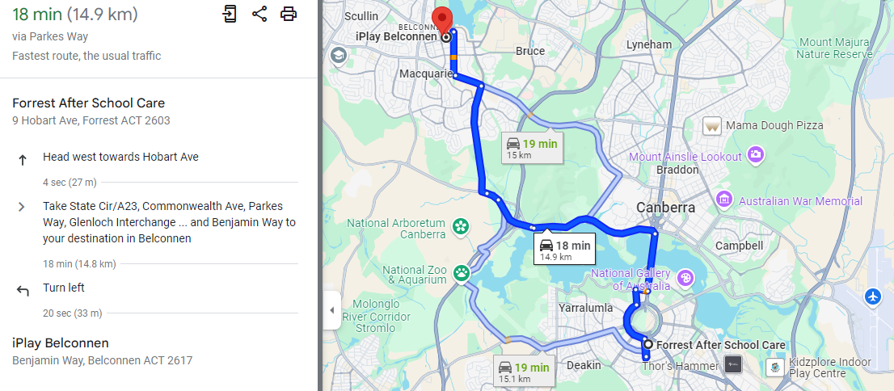

BOUNCE Belconnen Terms and Conditions
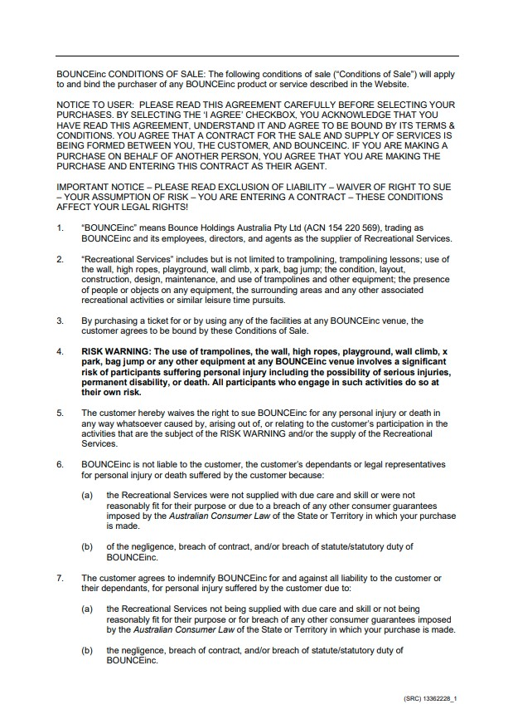
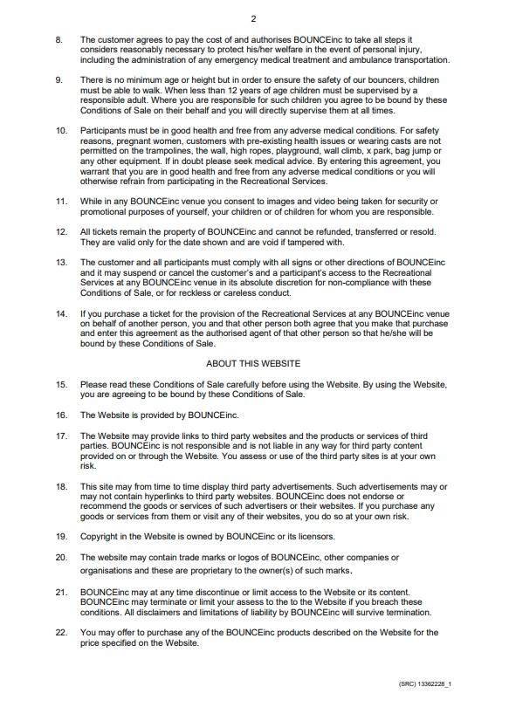
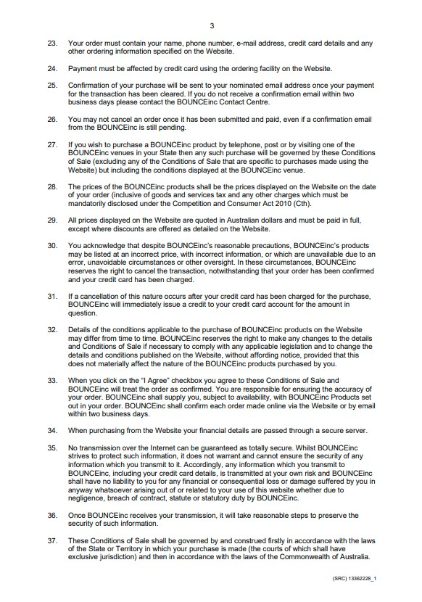


END OF FORM



