FOOSHC 2025 JANUARY SCHOOL HOLIDAY PROGRAM
Monday 6th January  $100 | Tuesday 7th January  $115 | Wednesday 8th January  $105 | Thursday 9th January  $110 | Friday 10th  January  $110
Personalised Hats  1-minute challenges  Educator VS Children | EXCURSION: Woden Valley Gymnastics  9:30am-12:30pm | Windchimes and Hanging Décor  Baked Pretzels |   Tie Dye  First Nations Games | Giant boardgames    Water Olympics
Screen Time: 3:30pm-6pm | Screen Time: 3:30pm-6pm | Screen Time: 3:30pm-6pm | Screen Time: 3:30pm-6pm | Screen Time: 3:30pm-6pm
Monday 13th January  $120 | Tuesday 14th January  $105 | Wednesday 15th January  $145 | Thursday 16th January  $105 | Friday 17th  January  $110
Raffia Weaving  EXCURSION: Manuka Pool  Pick up from Manuka Pool  12:30pm-6pm |   Pokémon Day!    Pikachu Lemon Tarts | EXCURSION: Canberra Aqua Park  8:45am-1pm   | EXTERNAL WORKSHOP:  Aaron from Dreamtime Connections  Strawberry Gum Scones | Yoga  EXTERNAL WORKSHOP:  Ceramics with Anna Rapp of Canberra Potters
Screen Time: None | Screen Time: 3:30pm-6pm | Screen Time: 3:30pm-6pm | Screen Time: 3:30pm-6pm | Screen Time: 3:30pm-6pm
Monday 20th January  $95 | Tuesday 21st January  $120 | Wednesday 22nd January  $115 | Thursday 23rd January  $110 | Friday 24th  January  $120
  Forrest’s magical forest  Ninja Workshop | EXCURSION: Weston Indoor Sports-,  Nerf Wars, Futsal, Dodge Ball  9:15am-1:15pm | EXTERNAL WORKSHOP:  Mosaics with Tracey Elliott  (EX-FORREST TEACHER)  Making Edible Slime |   EXTERNAL WORKSHOP:  Mosaics  (CONT.)  Jewellery Design | EXCURSION: Manuka Pool  Pick up from Manuka Pool  12:30pm-6pm
Screen Time: 3:30pm-6pm | Screen Time: 3:30pm-6pm | Screen Time: 3:30pm-6pm | Screen Time: 3:30pm-6pm | Screen Time: None
Monday 27th January | Tuesday 28th January  $110 | Wednesday 29th January  $110 | Thursday 30th January  $130 | Friday 31st  January  $105
CLOSED:  PUBLIC HOLIDAY |   Water Activities  Stop Motion / Short Film Workshop | Stop Motion / Short Film Workshop  Fence Weaving | EXCURSION: NINJA PARC 9:30am-12:30pm    Short Film Festival + Popcorn | EXTERNAL WORKSHOP:  AFL with FitKidz  Making Sushi
CLOSED:  PUBLIC HOLIDAY | Screen Time: Throughout | Screen Time: Throughout | Screen Time: 3:30pm-6pm | Screen Time: 3:30pm-6pm
About the Program
Forrest Out of School Hours Care (FOOSHC) provides a safe and welcoming environment for the children and their families. We believe children are capable, competent, and creative learners that are entitled to participate in a program that facilitates their engagement in risk-taking, experimentation and exploration of indoor and outdoor spaces.
Our program is child led with a play-focused environment which is reflective of the children’s needs and interests. Children will have the opportunity for rest and relaxation and can move freely between experiences both within inside and outside environments. In addition to the experiences detailed on the cover page, all the fabulous FOOSHC resources will be available daily.

Our Philosophy –
Everything we do is in the best interests of the child. We advocate for children’s voices to be heard and we honour and respect their rights, perspectives and ‘being’, as the foundation of our program.

Relationships:
We seek to build and nurture trusting, reciprocal relationships with children, families, and each other. We firmly believe that these connections enable children to form secure attachments -to each other, to educators, and our environments, whilst honouring the relationships with their families.
We honour their individuality and acknowledge them as capable and competent individuals. We value and respect the members of the FOOSHC community in all of their diversities, recognising how their involvement greatly enriches our service. Using culturally responsive approaches, we actively advocate for Aboriginal and Torres Strait Islanders in our community, embedding their perspectives into our practice. Operating without bias, we endeavour to create an environment where every child feels a sense of belonging and ownership, empowering them to become confident decision-makers. We believe that children who experience kindness, trust, and respect will, in turn, embrace these values within themselves and towards others.

Play:

FOOSHC prioritises play as an essential right for all children and our program is planned for the possibilities to play. Guided by a Playwork approach, we perceive children as the architects of their own experiences, thriving within an environment where they are supported and encouraged to flourish and grow. Our practice ensures that educators maintain the necessary physical and psychological conditions conducive to play—a process we believe is characterised by personal choice, self-direction, and intrinsic motivation. Through this approach we move with intentionality to positively affect the environment in support of the children’s well-being and ability to play.

Professional Development:
We hold our educators at FOOSHC to high standards and expectations. We embrace opportunities for innovative practice, critical reflection, and embed professional development into our everyday practice. FOOSHC strives to create a culture of professional inquiry, in which educators are encouraged to engage in robust discussion, self-reflection, and critical reflection. Our educators operate with integrity, compassion, respect, and kindness, embodying the values we demonstrate to the children.

Advocacy and Leadership:
We are committed advocates for the children of FOOSHC, advocating for their right to a childhood rich in play, freedom, exploration, and growth. We provide opportunities for children to take risks and develop their abilities to help navigate their world. By sharing our practices with the wider community and inspiring innovation, we champion the cause of all children, ensuring they too have access to these opportunities.

General Information
Open 8am – 6pm Monday 6th January 2025 – Friday 31st January 2025
CLOSED Monday 27th JANUARY 2025 - PUBLIC HOLIDAY

Enrolment
Step 1 – All families must complete a 2025 enrolment form which can be found on our website www.forrestpandc.com.au
Step 2 - Complete the attendance/booking sheet for this holiday period & permission notes attached for the relevant days

Enrolments close Sunday 15th December 2025 midnight. Please book quickly as places book out. Bookings received after this date will incur a $25 surcharge per family.

Fees and Childcare Subsidy (CCS)
- Cancelation must be in writing, TWO weeks in advance for no charges to apply.
- To obtain CCS you must have registered your details with Centrelink or MyGov and have provided us with your child’s date of birth and Customer Reference Number for the parent registered for CCS and each child on the enrolment form.
Arrival and Departure
- Always access the service via Children’s Services Office entrance (FOOSHC Office).
- Children MUST be signed in and out of the program each day by a parent or guardian.
- The roll will be located for signing in the Junior Hall (next to the door) during the holidays.
- On Monday 13th January and Friday 24th January, children will need to be picked up and signed out directly from Manuka Pool.

Food
- Children are required to provide their own lunch and snacks each day. Children often get hungry in the holidays, please consider this when packing their daily food.
- Afternoon tea will be provided each day around 3:30pm.
- We encourage snacks with high nutritional content to meet the growing needs of children.
- Breakfast is NOT provided during holiday care. We apologise for any inconvenience this may cause.
- Children should also bring a refillable water bottle. PLEASE NOTE ON EXCURSION DAYS, CHILDREN WITHOUT DRINK BOTTLES WILL BE GIVEN A NEW WATER BOTTLE TO KEEP AND A CHARGE OF $10 WILL BE ADDED TO YOUR ACCOUNT.
- No soft-drinks or juices are permitted. We encourage the children to drink water which will be readily available.
- As we are an allergy aware centre please no nuts/nut products or hard boiled eggs.
Clothing
Please label / name all your child’s clothing
- Closed in shoes are required on Excursion days
- No singlets or sleeveless tops/dresses please as these are not sunsafe
- As children engage in all sorts of adventurous play a change of clothes is recommended
- Children are required to bring a sun smart hat that protects the face, back of the neck, eyes and ears. Broad-brimmed, bucket offer the best protection. NO BASEBALL TYPE CAPS PLEASE.
- PLEASE NOTE ON EXCURSION DAYS, CHILDREN WITHOUT A SUNSAFE HAT WILL BE GIVEN ONE AND A CHARGE OF $20 WILL BE ADDED TO YOUR ACCOUNT.

Sun Safety
As the UV index rating will be high, we encourage children to be sunsafe. Please encourage your child to apply sunscreen prior to their arrival. Sunscreen will be available throughout the day but please feel free to bring your own. We encourage children to check the UV levels written on the Wellness trolley and daily information board empowering them to take control of their own wellbeing. Sunsafe clothing is strongly encouraged.
Lost property
After the holiday period, all lost property will be donated to charity or recycled as appropriate.
Screen Time
Children will have access our electronic devices for 2-hour periods during the program. This means there will be NO BYO Device day. This decision was reached after lengthy consultation with families, children, and educators.
We hope that the way screen time has been structured these holidays will assist families in regulating screen time at home.
Please note: Based on the last January holidays we have increased the amount of screen times as a way to help children to rest, relax and cool down during the summer heat. The exception to having 2 hours of screen time will be days where it is listed on the program.

The FOOSHC laptop may be utilised for active and non-competitive group games, such as the “Just Dance” videos that were extremely popular in previous holidays. In unfavourable weather conditions, such as extreme heat or storms, a movie may be used depending on the needs of the children.

Wheels
- Children are welcome to bring their bikes, scooters, skateboards, rollerblades etc. to the program.
- Children MUST have their own fitted helmet to participate.
- Children are not allowed to share wheels. Each child will use their own wheels.
- Wheels may be left at FOOSHC overnight, however all wheels must be taken home at the end of the holiday period.
- Please ensure all wheels are in good condition and are worthy to ride safely.

Day Specific Information
Monday 6th January 2025 – Design Personalised Hats and 1-minute Educator vs Children Challenges
Welcome to the first day of the January 2025 School Holiday Program. Today the children will get creative by designing their own white bucket hats which they will be able to keep and wear throughout the holidays showing off their amazing creations.
Then get ready to race the clock as children and educators face off in thrilling 1-minute battles - from crafty creations to speedy sports and wacky games, every second counts in this ultimate showdown. The educators think it won’t even be a competition: come along and prove us wrong!
Come along in your favourite team’s jersey if you can! Remember that to be sun safe you might need to pop a t-shirt on under any jersey/singlet!

Tuesday 7th January 2025 – Excursion: Woden Valley Gymnastics Club
Today we are returning to a recent favourite with the children, Woden Valley Gymnastics Club! Get ready to roll, hop, and jump your way through the various activities and pieces of equipment this Gymnastics Club provides. Children will get to rotate through the various workshops on offer and have time for free play to show off their skills!
After an exciting morning out, we will have a laid-back afternoon at FOOSHC enjoying a movie screening.

Wednesday 8th January 2025 – Windchimes / Hanging Décor and Cooking Pretzels
Unleash your creativity these holidays! Make your very own hanging decorations using mixed media craft materials. Whether it’s a colourful wind chime that sways in the breeze or an stylish paper lantern, your decorations will be one-of-a-kind!
For afternoon tea, children will have the opportunity to knead and shape their own pretzels, then pick from a variety of toppings to make their treat extra delicious.
In-between the fun, we will also be installing our very own FOOSHC mist garden. Can you guess where it will it be? Nothing could be finer than running through a misty garden to cool down.

Thursday 9th January 2025 – First Nations Games and Tie Dye
Today, we will be playing some fun and exciting traditional Indigenous games that have been enjoyed by Aboriginal and Torres Strait Islander peoples for thousands of years! Test your teamwork and catching skills with Boogalah (played by the Juwalarai peoples), challenge your memory in a game of Walbiri (played by children in central Australia), put your dodging skills to the test with Kutturi (played by Ngemba women in New South Wales), or try your luck with Nandrra-Rna, a game played all across Australia.
Then, get ready to create some colourful magic with tie-dye! In this holiday activity, you will get to explore tie-dying by twisting, folding, and colouring fabric to make your own unique, vibrant piece to take home. Bring in a piece of your own clothing or we will provide socks for you to customize and make your own.

Friday 10th January 2025 – Giant Boardgames and Water Olympics
What better way to unwind indoors than with board games? But not just any board games… GIANT BOARD GAMES! Slither your way around life-sized Snakes and Ladders, test your strategy with a huge garden chess set, become a huge hungry hippo, or take on a giant Connect 4 challenge. Let the fun begin!
If you’re seeking some more action, dive into Fooshc’s ultimate Water Olympics and make a splash. Get ready to beat the heat with epic events on the oval, including ‘There’s a Hole in My Bucket’, Sponge ball, archery, and more! The fun doesn’t stop there, keep the competition going all day long for your chance to go for Olympic gold.

***
Monday 13th^{th} January 2025 – Excursion: Manuka Pool (afternoon) and Raffia Weaving
Manuka pool for the afternoon. Due to the heat of summer, we will travel by charter bus to Manuka pool where children will have access to both the paddling and 30m pool, however children would need to successfully pass a swim test to play in the 30m pool. The swim test involves swimming 15metres (any stroke) of the pool without assistance.
A yummy afternoon tea will be provided for all children at the pool (catering to dietary needs). Please note in the event of heavy rain, thunder and / or lightening when we are at Manuka Pool parents may be contacted early to collect their children because of safety concerns. In the event we are unable to attend due to weather we will spend the day at a suitable alternate venue, where possible.

Please ensure your child/ren come prepared for a day of adventure and play with the following items:
- Sun smart Swimming attire - Children are required to wear a rash vest /sun smart shirt and hat while at the pool.
- Change of clothes
- Towel
- Sun smart Hat
- Filled Water bottle and lunch
! Please note that for this excursion we require that you collect your child directly from Manuka pool !

In the morning, come join us for a crafty adventure in raffia weaving! Raffia is a soft, natural material that comes from Raffia palm trees, used in various cultures to create all sorts of beautiful and useful things - from baskets and sculptures to jewellery and decorative pieces. In this activity, you'll learn how to twist, weave, and tie raffia to make bookmarks, bangles and hat bands, or let your imagination run wild with your own creations!

Tuesday 14th January 2025 – Pokemon Day and Pikachu Lemon Tarts
Calling all Pokemon Trainers! Get ready for an epic adventure! Choose your starter—Team Pikachu or Team Eevee—and craft your own Pokemon ears headband to show your team spirit. Then, catch your first Pokemon by creating a clay masterpiece! Will you replicate an existing Pokemon or invent a brand-new one? Once it’s ready, house it in a clear Pokeball to keep safe.

Join in the fun with a Pokemon Hunt to complete your Pokedex, then in the afternoon, enjoy a delicious Pokemon-themed cooking activity. It’s a day full of excitement and creativity—let’s go, Trainers!

Wednesday 15th January 2025 – Excursion: Canberra Aqua Park
The Aqua Park was a fooshc favourite last January, and we are so pleased to be heading back there again. Get ready to have an awesome day out as you climb, splash, slip and slide through the giant inflatable obstacle course. Canberra Aqua Park is made up of slides, ladders and best of all their famous JUMPING PILLOW!! The Park will offer something for everyone to beat the summer heat. We will be traveling by charter bus to Black Mountain peninsular where will we spend the day testing out our skills on the new and exciting inflatable course. Children will be required to wear life jackets and the Aqua Park will have qualified lifeguards. Please note that the Aqua Park itself has an age requirement of 5+ to participate, and as such children under 5 will only have access to a cordoned off paddling area. This excursion is not suitable for those who are easily frightened by being in water as there is a high probability of falling off parts of the inflatable and into the lake. As mentioned, they will be safe due to the life jackets and strict supervision however it can be overwhelming for many who lack confidence in the water. In the event we are unable to attend due to weather we will spend the day at a suitable alternate venue, where possible.
Please ensure your child/ren come prepared for a day of adventure and play with the following items:
- Sun smart Swimming attire - Children are required to wear a rash vest /sun smart shirt and hat while at the pool.
- Change of clothes
- Towel
- Sun smart Hat
- Filled Water bottle and lunch
For your child/ren to participate in the Aquapark excursion you must sign the relevant waiver that is attached to this form and return to FOOSHC with your booking form.

Thursday 16th January 2025 – External workshop: Aaron from Dreamtime Connections and Native Ingredient Cooking Experience
We are also excited to welcome back Aaron from Dreamtime Connections these holidays. Aaron will be joining us once again to help nurture our FOOSHC native garden and guide an inspiring Indigenous painting workshop - an exciting opportunity to connect with nature and culture.

Then, we’ll put our Chef’s hats on to bake Strawberry Gum scones for afternoon tea, served alongside refreshing, tasty, native ingredient iced teas.
Friday 17th January 2025 – External Workshop: Ceramic Creations with Anna of Canberra Potters and Yoga
Today, we’re excited to welcome back a talented local artist to FOOSHC, who will guide the children through their creative process as they mould their own art pieces. Afterward, their creations will be fired in a kiln and returned to the children a few weeks later. This hands-on opportunity to learn about ceramics is one you won’t want to miss!
To continue our laid-back home day, take a deep breath and get ready to relax, stretch, and unwind with an afternoon of relaxing yoga. Whether you're a yoga pro or trying it for the first time, this activity is all about having fun while becoming stronger, focused and more at ease.

Monday 20th January 2025 – Forrest’s Magical Forest and Ninja Workshop
Get ready to create a magical forest using recycled materials! In this fun and eco-friendly activity, you’ll transform loose parts, cardboard boxes, and craft supplies into a forest full of wonder. Let your imagination run wild as you build trees, creatures, and hidden treasures, all made from recycled goodies.
Or have you ever wondered what it might be like to spy and sneak around like a real ninja? In our ninja workshop you’ll get the chance to make your own ninja tools and disguises, as well as learn some of the secret techniques used by super-skilled ninjas hundreds of years ago!

Tuesday 21st January 2025 – Excursion: Weston Creek Indoor Sports
Channel your inner Sam Kerr as we head off to Western Creek Indoor Sports Centre. Join us for a morning of fun as we rotate through three 45-minute sessions of indoor soccer, dodge ball, and nerf games. Get a taste of each sport as you dodge, strike, and take aim in three super energetic indoor sports.

Wednesday 22nd January 2025 – External Workshop: Mosaic Murals with Tracey Elliott and Edible Slime
We are excited to welcome back former Forrest teacher, Tracey Elliott, to help us create a stunning nature-themed mosaic mural! Get ready to explore the ancient art of creating beautiful mosaic pieces, as our guest instructor shares their expert techniques.

Slime, slime, slime!!! We know this is a FOOSHC favourite and these holidays we have something extra special in store for you all… EDIBLE SLIME!! That right you heard us … EDIBLE!! This sweet treat is sure to be just as fun to make as it is to eat.

Thursday 23rd January 2025 – External Workshop: Mosaic Murals with Tracey Elliott and Jewellery Design
Alongside continuing our Mosaics workshop, get creative and design your own stunning jewellery! Craft one-of-a-kind necklaces, bracelets, or keychains with vibrant beads, charms, and cords. The design possibilities are limitless, so create a personalized piece for yourself or as a thoughtful gift for someone special.

Friday 24th January 2025 – Excursion: Manuka Pool (afternoon)
Manuka pool for the afternoon. Due to the heat of summer, we will travel by charter bus to Manuka pool where children will have access to both the paddling and 30m pool, however children would need to successfully pass a swim test to play in the 30m pool. The swim test involves swimming 15metres (any stroke) of the pool without assistance.
A yummy afternoon tea will be provided for all children at the pool (catering to dietary needs). Please note in the event of heavy rain, thunder and / or lightening when we are at Manuka Pool parents may be contacted early to collect their children because of safety concerns. In the event we are unable to attend due to weather we will spend the day at a suitable alternate venue, where possible.

Please ensure your child/ren come prepared for a day of adventure and play with the following items:
- Sun smart Swimming attire - Children are required to wear a rash vest /sun smart shirt and hat while at the pool.
- Change of clothes
- Towel
- Sun smart Hat
- Filled Water bottle and lunch
! Please note that for this excursion we require that you collect your child directly from Manuka pool !

CLOSED: Monday 27th January 2025 – PUBLIC HOLIDAY

Tuesday 28th January 2025 – Water Activities and Stop Motion / Short Film Workshop
LIGHTS, CAMERA, ACTION! Join us for a day of Short film & Stop Motion film making. Whether it’s a superhero adventure, a spooky mystery, or a funny comedy, YOU get to write the script, choose the characters, and even act in your film! Or learn to make your drawings, lego, or clay move frame by frame in a stop motion workshop, and become the mastermind behind the animation magic.
While you’re waiting to film, slip and slide into water-filled fun! From the challenge of hose limbo to a homemade slip-and-slide adventure, there’s something for everyone, sure to leave you refreshed and smiling.

Wednesday 29th January 2025 – Stop Motion / Short Film Workshop and Fence Weaving Experience
Today, we will continue with our Short film and Stop Motion film workshop, alongside weaving on the fence.

Grab your colours and get ready to weave! In this fun-filled activity, we’ll turn a plain fence into a burst of bright, beautiful art. You’ll twist, twirl, and weave colourful ribbons and yarns through the fence to create your very own masterpiece. It's like making a giant, fabulous tapestry – one colourful strand at a time!

Thursday 30th January 2025 – Excursion: Ninja Parc and FOOSHC Short Film Festival + Popcorn!
Get ready for an action-packed adventure at Ninja Parc in Fyshwick! This high-energy indoor obstacle course challenges kids to test their agility, strength, and speed while navigating through exciting ninja-inspired obstacles. With endless fun and opportunities to master new skills, your child will have a blast. To make sure they’re prepared for all the action, we recommend wearing loose, comfortable clothing that allows for plenty of movement. While the main obstacle course is recommended for those aged 6+, the Ninja Parc includes a soft play obstacle course for younger ‘ninjas’ or those simply seeking a more relaxed play space.
For your child/ren to participate in the Ninja Parc excursion you must complete the following online waiver and return confirmation to FOOSHC with your booking form.
MANDATORY WAIVER: https://ninjaparcbook.venuesumo.app/form/?FormID=1&LocationID=2
Please ensure your child/ren come prepared for a day of adventure and play with the following items:
- Filled water bottle and snacks
- Enclosed flat-soled shoes (gumboots not recommended)

POP! POP! POP! In the afternoon, grab some popcorn with multiple seasonings available to try, sit back and relax for the FOOSHC film festival. Showcasing works made throughout the holiday program, the film festival is a chance to see your work on the big screen!
Friday 31st January 2025 – External Workshop: AFL with Fit Kids and Sushi Cheffing
Get ready to run, kick, and make your mark with this exciting AFL workshop. Children will learn ball skills, work as a team, and build up to playing in games of AFL against each other.
Then join Resident Chef Mimi in the kitchen to make your own Sushi for afternoon tea. Mimi is a qualified Japanese sushi chef and will be teaching all the children the techniques and art of this traditional dish.
PLEASE COMPLETE ALL PAGES OF THE ENROLMENT FORM.
THERE ARE FOUR PAGES TO SIGN IN TOTAL

FORREST OUT OF SCHOOL HOURS CARE
2025 JANUARY SCHOOL HOLIDAY PROGRAM:
BOOKING FORM
Please complete the details below to enrol your child.

Child’s name | Mon 6/1  $100 | Tue 7/1  $115 | Wed 8/1  $105 | Thu 9/1  $110 | Fri 10/1$110 |  | Mon  13/1 $120 | Tue  14/1 $105 | Wed  15/1 $145 | Thu  16/1 $105 | Fri 17/1 $110
Account Name: Current Email Address:

Child’s name | Mon 20/1  $95 | Tue 21/1  $120 | Wed 22/1  $115 | Thu 23/1  $110 | Fri 24/1$120 |  | Mon  27/1 | Tue  28/1 $110 | Wed  29/1 $110 | Thu  30/1 $130 | Fri 31/1 $105

Important Information | Please sign below to acknowledge that you have read and understood this important information
I understand that children need to bring lunch, snacks and a refillable drink bottle each day. We are an Allergy Aware Centre – no nuts/nut products or eggs.
These holidays we may be using both still and movie cameras to record the children’s adventures. Please advise in writing if you do not want your child to participate in this part of the program. We may use the photos/footage to promote our program and to screen with families/friends of the service.
I understand that children need to be signed in and out of the program each day. This will occur by entering through the Children’s Services Office
If I wish to cancel days’ requests must be made in writing and for no charge to apply and must be received at least TWO WEEKS prior to the cancelled day.

Outstanding fees will incur a late payment fee unless arrangements are made on enrolment. Payment plans are available. Bookings after 15th December 2025 midnight will incur a $25 late booking fee per child.
I give permission for my child to view suitable PG movies and play some electronic games that are also rated PG (older games originally rated G that today are rated PG but deemed suitable by Educators) during the program.
I understand that if I do not bring a sunsafe hat or drink bottle for my child then my child will be given a new hat or drink bottle at the cost of $20 (hat) or $10 (bottle) which will then be charged to my account.
I give permission for my child to use their own wheels and I understand they are required to wear a well fitted helmet and their wheels could be used in multiple play spaces with various pieces of equipment.
I give permission for my child to use sunscreen and/or Zinc provided by FOOSHC and understand that if I do not give permission, I must provide my child with their own sunscreen each day.
I understand that FOOSHC uses a charter bus with seatbelts where possible for excursions and if my child is not signed in prior to the advertised departure time that I will need to drop my child at the excursion directly.
PLEASE SIGN THE BOX FOR EACH DAY YOUR CHILD WILL ATTEND
Date/Time | Experience | Sign
07/01/2025 | Woden Valley Gymnastics Club:  I give permission for my child/ren to travel by Charter Bus to Woden Valley Gymnastics Club.  I give my permission to participate in guided activities and free play using the equipment provided by Woden Valley Gymnastics Club.  I understand that the experiences at this excursion will be run by the staff of Woden Valley Gymnastics Club.  Departing: 10:10am  Returning: approx. 12:30pm  Estimated number of children in attendance: 48  Estimated number of educators: 8  Ratio: 1:8 with 1 additional educator required for supervision and RP
13/01/2025 | Manuka Pool (Half Day - Afternoon):  I give permission for my child/ren to travel by charter bus to Manuka Pool. Or in the event of wet weather, to a suitable alternate venue where possible.  I give permission for my child/ren to swim in all pools with successful completion of a swim test. And understand that without completing they will be limited to smaller pools/splash play areas.  Departing FOOSHC: 12.30pm  I agree to pick my child/ren up from the Pool by 6pm.  Estimated number of children in attendance: 45  Estimated number of educators: 12  Ratio: 1:5 with 2 additional educators required for supervision and RP  In the event of unsafe weather conditions making this excursion unviable, the excursion may be changed another suitable venue where possible.  I understand that a backup excursion location is dependent on several factors and that alternatives at FOOSHC may be required and is at the discretion of FOOSHC educators.
15/01/2025 | Canberra Aqua Park at Black Mountain peninsula:  Please complete attached venue waiver for each day  I give permission for my child/ren to travel by charter bus to Black Mountain Peninsula and back to FOOSHC.  I give permission for my child to use the Aqua Park inflatable  I give permission for my child/ren to swim in the paddle area  I understand that I must have signed and returned the Aqua Park waiver to use the equipment and that information will be passed on to the Aqua Park on my behalf.  I understand that if my child is under 5 they will only be able to swim in the paddle area.  I understand that my child must swim to the inflatable while wearing a lifejacket to use the equipment  Departing FOOSHC: 9:00am  Returning: approx. 12:50pm  Estimated number of children in attendance: 45  Estimated number of educators: 12  Ratio: 1:5 with 2 additional educators required for supervision and RP  In the event of unsafe weather conditions making this excursion unviable, the excursion may be changed another suitable venue where possible.  I understand that a backup excursion location is dependent on several factors and that alternatives at FOOSHC may be required and is at the discretion of FOOSHC educators.
21/01/2025 | Weston Creek Indoor Sports:  I give permission for my child/ren to travel by Charter Bus to Western Creek Sports.  I give permission for my child/ren to participate in rotating indoor sports, consisting of Nerf games, indoor soccer, and dodgeball.  I understand that the activities will be facilitated by the staff at Weston Creek Indoor Sports under FOOSHC supervision.  Departing FOOSHC: 9:30am Approx arrival to venue: 9:50am  Departing Venue: 12:45pm Approx arrival to FOOSHC: 13:05pm  Ratio 1:8  (raised ratio with an additional 1x educators)
24/01/25 | Manuka Pool (Half Day - Afternoon)  I give permission for my child/ren to travel by charter bus to Manuka Pool. Or in the event of wet weather, to a suitable alternate venue where possible.  I give permission for my child/ren to swim in all pools with successful completion of a swim test. And understand that without completing they will be limited to smaller pools/splash play areas.  Departing FOOSHC: 12.30pm  I agree to pick my child/ren up from the Pool by 6pm.  Estimated number of children in attendance: 45  Estimated number of educators: 12  Ratio: 1:5 with 2 additional educators required for supervision and RP  In the event of unsafe weather conditions making this excursion unviable, the excursion may be changed another suitable venue where possible.  I understand that a backup excursion location is dependent on several factors and that alternatives at FOOSHC may be required and is at the discretion of FOOSHC educators.
28/01/25  29/01/25 | Stop Motion / Short Film Workshop  I give permission for my child/ren to participate in the short film/stop motion workshop, during which they may be filmed as part of the production process. I understand that my child may be featured in the final film, which may be released to families of other children in the film upon request.  By signing, I confirm that I have read and understand this waiver, and I give my consent for my child to participate in the workshop, including being filmed. Please indicate in writing if you consent to stop motion film, only, wherein children’s faces will not be filmed.
30/01/25 | Ninja Parc Fyshwick  Please complete the linked venue waiver below  https://ninjaparcbook.venuesumo.app/form/?FormID=1&LocationID=2  I give permission for my child/ren to travel by charter bus to Ninja Park (Fyshwick).  I give permission for my child/ren to use the indoor climbing, obstacle course and play equipment available at Ninja Parc.  I understand that my child/ren MUST wear enclosed flat-soled shoes to participate.  I understand that my child/ren must have a completed online Ninja Parc waiver to use the equipment.  Departing: 9:30am  Return: approx. 12:45pm  Estimated number of children in attendance: 48  Ratio and estimated number of educators: 8 Educators  Ratio: 1:8 with 2 additional educators required for supervision and RP

MINIMUM EDUCATOR: CHILD RATIOS WILL BE
1:11 at the centre, 1:8 for excursions, 1:5 Manuka Pool, Canberra Aqua Park
Risk Benefit Assessments are available upon request

PROPOSED EXCURSION ROUTES
(Detour may occur if roadworks occur)

Woden Valley Gymnastics Club

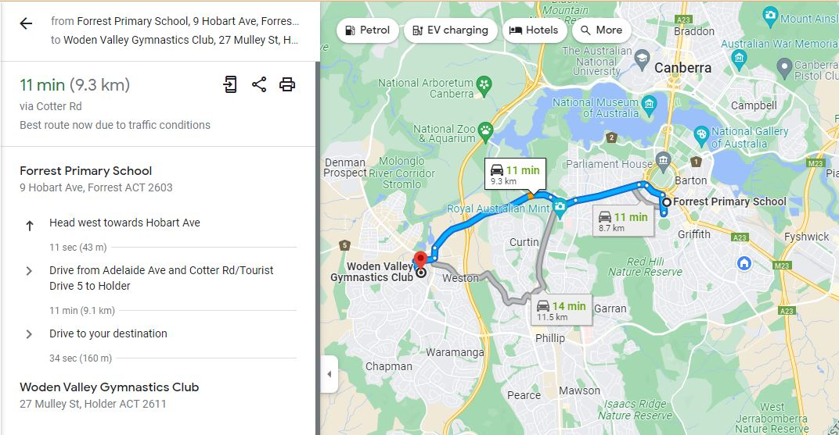

Manuka Pool
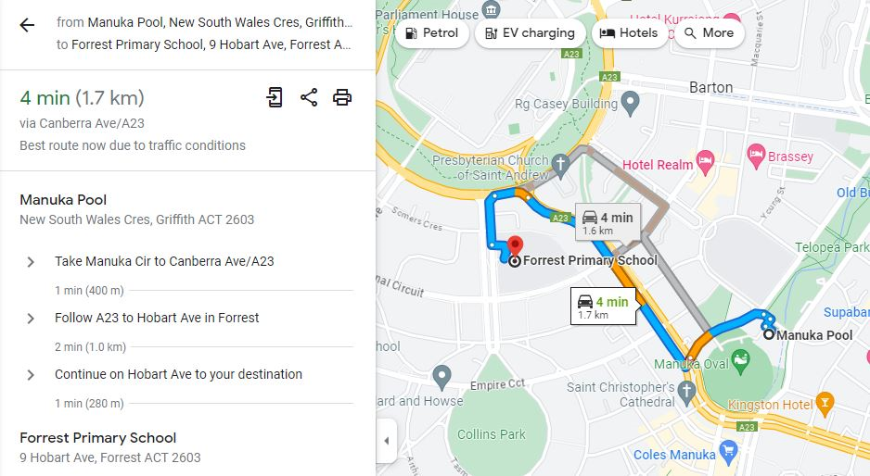

Canberra Aqua Park
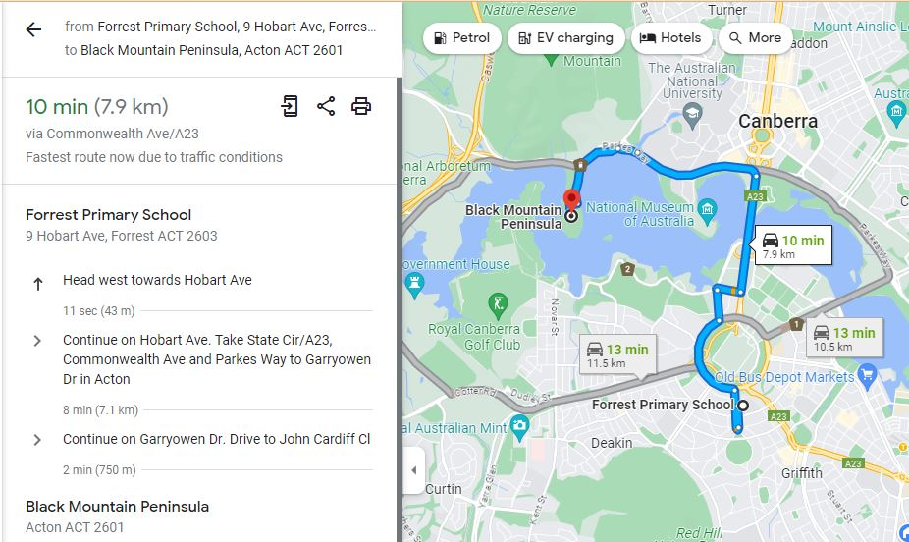

Weston Creek Indoor Sports
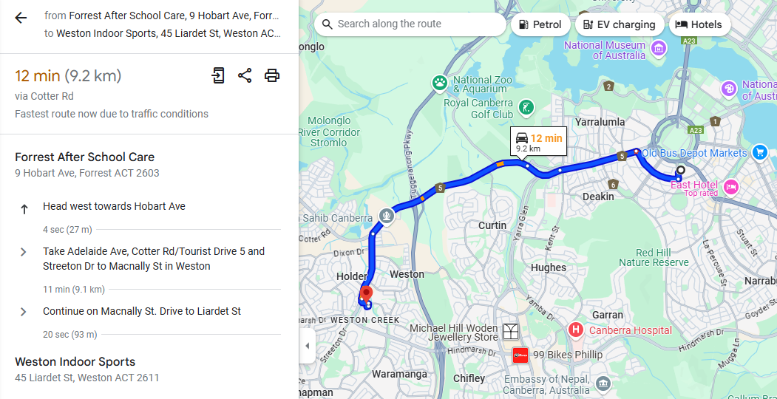

Ninja Parc Fyshwick
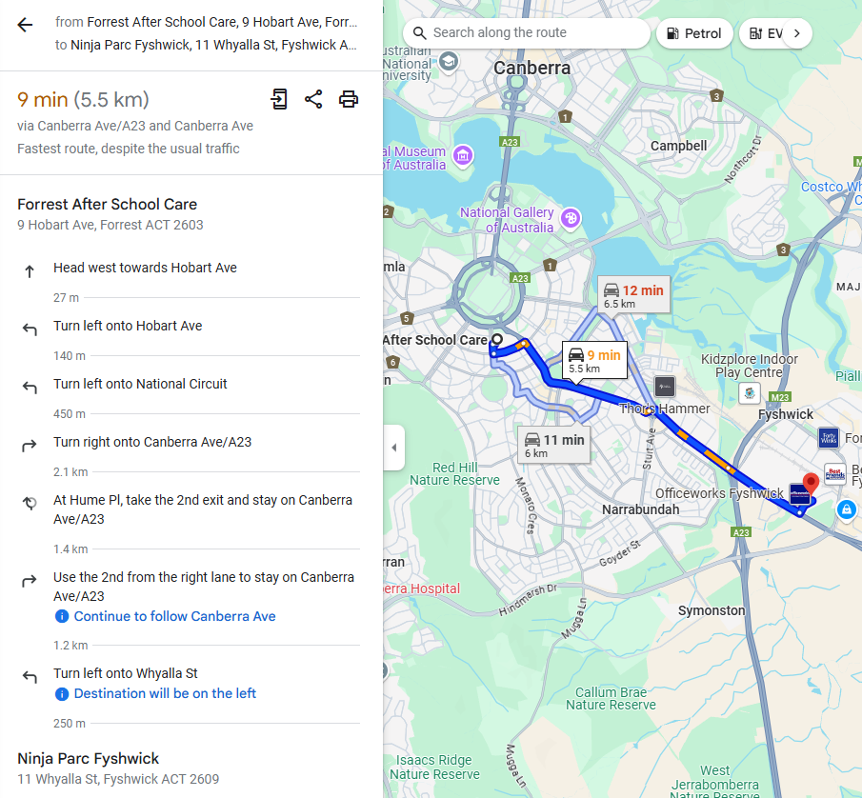

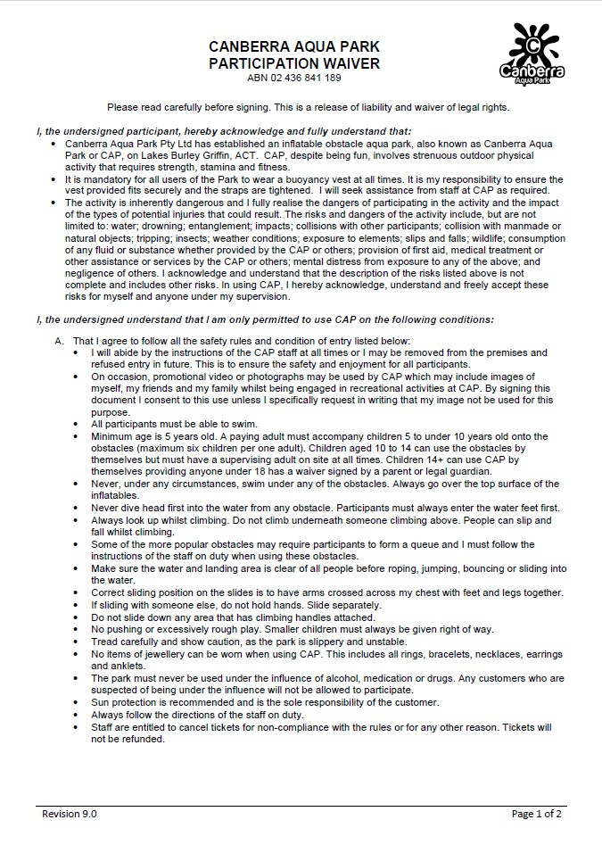

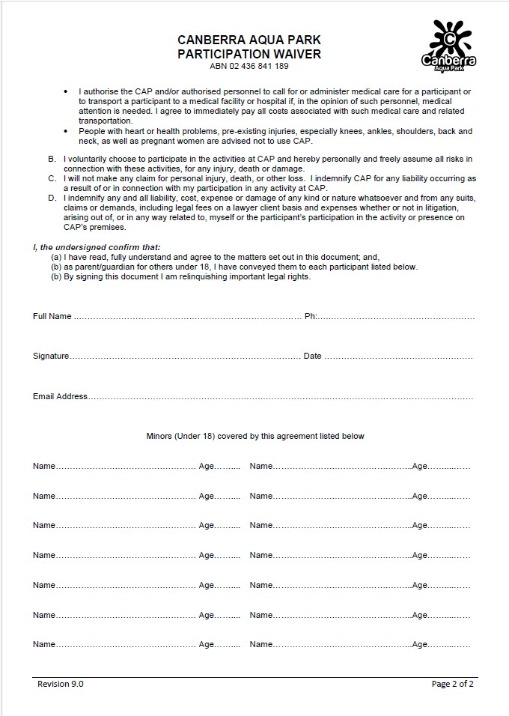

END OF PAPER

