FORREST OUT OF SCHOOL HOURS CARE
2025 APRIL SCHOOL HOLIDAY PROGRAM

Monday 14th April  $125 | Tuesday 15th April  $130 | Wednesday 16th April  $110 | Thursday 17th April  $95 | Friday 18th April
Minecraft Day!  Tool crafting    Cave exploring  External workshop:  Coding and Robotics  10:00am – 12:00pm | Excursion:  Bounce Belconnen  Indoor Trampolines, Rock Climbing & Dodgeball  9:00am – 1:00pm  Salt Art | Lava Madness  External workshop:  Aaron from Dreamtime Connections  Native planting, Boomerang throwing & Games  1:00pm – 3:00pm | 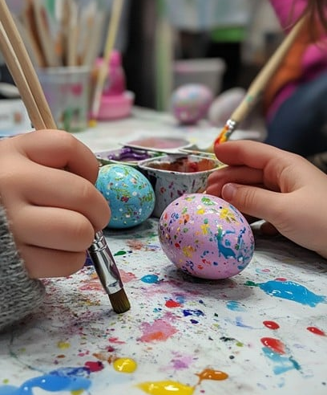  Orthodox Easter Decorative Eggs  Cooking: Maznik Puff Pastry | CLOSED FOR PUBLIC HOLIDAY
Screen Time: 3:30-5:30 | Screen Time: 3:30-5:30 | Screen Time: 3:30-5:30 | Screen Time: 3:30 – 5:30 | CLOSED FOR PUBLIC HOLIDAY

Monday 21st April | Tuesday 22nd April  $100 | Wednesday 23rd April  $120 | Thursday 24th April  $110 | Friday 25th April | Monday 28th April $110
CLOSED FOR PUBLIC HOLIDAY | Oval Campground & Fort Building  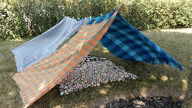    Cooking: Make your own Pizza! |   Excursion:  Pine Island  9:00am - 1:00pm    Karaoke | Celebrating World Art Day!  Paint activity stations    Polymer clay miniatures | CLOSED FOR PUBLIC HOLIDAY | FORREST PRIMARY  PUPIL FREE DAY  External workshop:  Circus Workshop  10am – 11:30am  Cooking: Chocolate dipped fruits
CLOSED FOR PUBLIC HOLIDAY | Screen Time: 3:30 – 5:30 | Screen Time: 3:30-5:30 | Screen Time: 3:30-5:30 | CLOSED FOR PUBLIC HOLIDAY | Screen Time: 3:30-5:30

About the Program
Forrest Out of School Hours Care (FOOSHC) provides a safe and welcoming environment for the children and their families. We believe children are capable, competent, and creative learners that are entitled to participate in a program that facilitates their engagement in risk-taking, experimentation and exploration of indoor and outdoor spaces.
Our program is child led with a play-focused environment which is reflective of the children’s needs and interests. Children will have the opportunity for rest and relaxation and can move freely between activities and inside and outside environments. In addition to the experiences detailed on the cover page, all the fabulous FOOSHC resources will be available daily.

Our Philosophy
Everything we do is in the best interests of the child. We advocate for children’s voices to be heard and we honour and respect their rights, views and ‘being’, as the foundation of our program.
Relationships
We seek to build and nurture trusting, reciprocal relationships with children, families, and each other. We firmly believe that these connections enable children to form secure attachments -to each other, to educators, and our environments, whilst honouring the relationships with their families.
We honour their individuality and acknowledge them as capable and competent individuals. We value and respect the members of the FOOSHC community in all of their diversities, recognising how their involvement greatly enriches our service. Using culturally responsive approaches, we actively advocate for Aboriginal and Torres Strait Islanders in our community, embedding their perspectives into our practice. Operating without bias, we endeavour to create an environment where every child feels a sense of belonging and ownership, empowering them to become confident decision-makers. We believe that children who experience kindness, trust, and respect will, in turn, embrace these values within themselves and towards others.

Play
FOOSHC prioritises play as an essential right for all children and our program is planned for the possibilities to play. Guided by a Playwork approach, we perceive children as the architects of their own experiences, thriving within an environment where they are supported and encouraged to flourish and grow. Our practice ensures that educators maintain the necessary physical and psychological conditions conducive to play—a process we believe is characterised by personal choice, self-direction, and intrinsic motivation. Through this approach we move with intentionality to positively affect the environment in support of the children’s well-being and ability to play.

Professional Development
We hold our educators at FOOSHC to high standards and expectations. We embrace opportunities for innovative practice, critical reflection, and embed professional development into our everyday practice. FOOSHC strives to create a culture of professional inquiry, in which educators are encouraged to engage in robust discussion, self-reflection, and critical reflection. Our educators operate with integrity, compassion, respect, and kindness, embodying the values we demonstrate to the children.

Advocacy and Leadership
We are committed advocates for the children of FOOSHC, advocating for their right to a childhood rich in play, freedom, exploration, and growth. We provide opportunities for children to take risks and develop their abilities to help navigate their world. By sharing our practices with the wider community and inspiring innovation, we champion the cause of all children, ensuring they too have access to these opportunities.

GENERAL INFORMATION

Open 8am – 6pm Monday 14th April 2025 – Monday 28th April 2025
CLOSED Friday 18th April, Monday 21st April & Thursday 25th April 2025 - PUBLIC HOLIDAYS

ENROLEMENT
Step 1 – All families must complete a 2025 enrolment form which can be found on our website www.forrestpandc.com.au
Step 2 - Complete the attendance/booking sheet for this holiday period & permission notes attached for the relevant days

Enrolments close Midnight 6th April , 2025 (Sunday, Week 9). Bookings received after this date will incur a $25 surcharge per family.

Fees and Childcare Subsidy (CCS)
- Cancellation must be in writing, TWO weeks in advance for no charges to apply.
- To obtain CCS you must have registered your details with Centrelink or Mygov and have provided us with your child’s date of birth and Customer Reference Number for the parent registered for CCS and each child on the enrolment form.

Arrival and Departure
- Always access the service via Children’s Services Office entrance (FOOSHC Office).
- Children MUST be signed in and out of the program each day by a parent or guardian.

Food
- Children are required to provide their own lunch and snacks each day. Children often get hungry in the holidays, please consider this when packing their daily food.
- Afternoon tea will be provided each day around 3:30pm.
- We encourage snacks with healthy high nutritional content to meet the growing needs of children.
- Breakfast is NOT provided during holiday care. We apologise for any inconvenience this may cause.
- Children should also bring a refillable water bottle. PLEASE NOTE ON EXCURSION DAYS, CHILDREN WITHOUT DRINK BOTTLES WILL BE GIVEN A WATER BOTTLE TO KEEP AND A CHARGE OF $10 WILL BE ADDED TO YOUR ACCOUNT.
- We promote healthy eating at FOOSHC so No soft-drinks or juices are permitted. We encourage the children to drink water which will be readily available.
- As we are an allergy aware centre please no nuts/nut products or eggs.

Clothing
Please label / name all your child’s clothing
- Closed in shoes are required on Excursion days
- No singlets or sleeveless tops please as these are not sunsafe
- Children MUST have a rash shirt for ALL water based excursions
- As children engage in all sorts of adventurous play a change of clothes is recommended
- Children are required to bring a sun smart hat that protects the face, back of the neck, eyes and ears. Broad-brimmed, bucket NO CAPS PLEASE.
- PLEASE NOTE ON EXCURSION DAYS, CHILDREN WITHOUT A SUNSAFE HAT WILL BE GIVEN A HAT AND A CHARGE OF $15 or WATER BOTTLES ($10) WILL BE ADDED TO YOUR ACCOUNT.

Sun Safety
We actively promote children to be sunsafe and as the UV index rating will be high, we encourage children to be proactive in their approach to sun safe practices. Please encourage your child to apply sunscreen prior to their arrival. Sunscreen will be available throughout the day but please feel free to bring your own if you prefer. Please ensure your children wear sunsafe clothing – no singlets, thin straps or baseball type caps. Sunsafe Rashie tops are required for swimming excursions.
Lost property
After the holiday period, all lost property will be donated to charity or recycled as appropriate.

Screen Time
Children will have access our electronic devices for 2-hour periods during the program. This means there will be NO BYO Device day. This decision was reached after lengthy consultation with families, children, and educators.
We hope that the way screen time has been structured these holidays will assist families in regulating screen time at home.

The FOOSHC laptop may be utilised for active and non-competitive group games, such as the “Just Dance” videos that were extremely popular in previous holidays. In unfavourable weather conditions, such as extreme heat or storms, a movie may be used depending on the needs of the children.

Wheels
- Children are welcome to bring their bikes, scooters, skateboards, rollerblades etc. to the program.
- Children MUST have their own fitted helmet (In line with Australian standards) to participate.
- Children are not allowed to share wheels. Each child will use their own wheels.
- Wheels may be left at FOOSHC overnight; however, all wheels must be taken home at the end of the holiday period unless Ali will try and sell them on ebay 😊.

DAY SPECIFIC INFORMATION
Monday 14th April 2025 – Minecraft Day and External Workshop: Lego-Robotics Coding!
Ever wondered what it would be like to spend your days crafting tools, exploring caves, and building awesome houses, just like Alex and Steve from Minecraft? Join us for our FOOSHC Minecraft day and develop your favourite Minecraft skills in REAL LIFE!
In the afternoon, we are excited to welcome back and external provider - Young Engineers Canberra. Their exciting workshop gives you the chance to play with Lego like never before as you start to think like an engineer. Build robots, develop and test computer algorithms, and learn how to code to get your robot to move around its environment. This unique opportunity is sure to be just as challenging as it is fun! A different program from the last time.

Tuesday 15th April 2025 – Excursion: Bounce Belconnen and Salt Art
Hop, skip, and jump your way over to Bounce in Belconnen. This high energy indoor trampoline park provides countless possibilities for the children to explore and master skills like never before. To ensure they are ready for a day full of adventure we suggest children wear loose, comfortable clothing that they can move freely in. Bounce Socks are included in the price.
Enclosed flat-soled shoes are required for Rock Climbing and the X-Park Adventure Challenge Course (excluding gumboots), please note that the rock-climbing section has a minimum height of 110cm and the X-Park has a minimum height of 125cm.
Please ensure your child/ren come prepared for a day of adventure and play with the following items:
- Filled water bottle and snacks
- Enclosed flat-soled shoes (gumboots not permitted)
Afterwards, wind down with us for a creative afternoon as we experiment with a classic household ingredient… salt! We will have the chance to make our very own colourful salt jars, watercolour salt art and salt play dough. Let your creativity run wild as we explore what else we can make!

Wednesday 16th April 2025 – Lava Madness and External Workshop: With our Indigenous guide Aaron from Dreamtime Connections -Native Planting / Boomerang Throwing
Get ready for an explosive day of lava-filled fun! Begin your fiery adventure by making your own bubbly lava lamp then build and erupt your own volcano before dodging molten lava in a big game the floor is lava.
Bring out your green thumb as Aaron Chatfield from Dreamtime Connections joins us for a hands-on native plant-use and gardening workshop. Children will then have the opportunity to master the art of boomerang throwing and get involved in some Indigenous games on the oval.

Thursday 17th April 2025 – Celebrate Orthodox Easter with Decorative Egg Art and Cooking: Maznik Pastries
Decorative eggs hold rich and varied cultural significance across our world, dating as far back as ancient Egypt and Persia! Seek your inner artist as we explore ancient and modern egg decorating practices and techniques. We will express our lives, wishes, victories or favourite patterns and designs on keepsake paper eggs.
Later, join us as we make delicious Macedonian Maznik pastries for afternoon tea and pick a sweet or savoury filling. A staple in Orthodox New Year celebrations, this swirled pastry symbolises unity and the joy of sharing food with loved ones.

Friday 18th April 2025 – CLOSED FOR PUBLIC HOLIDAY

Monday 21st April 2025 – CLOSED FOR PUBLIC HOLIDAY

Tuesday 22nd April 2025 – FOOSHC Campground / Fort Building and Pizzeria
Pitch your tent for a day of camping fun at FOOSHC! In the morning, transform the oval into a buzzing campsite by bringing along your own tent from home. Let your imagination run wild as we work together to construct loose-parts forts across our OSHC spaces—Who will build the ultimate camping space?
After lunch, we will come together inside junior hall to construct a giant tent masterpiece, play group games and complete campground challenges. It's a day of teamwork, excitement, and outdoor adventure that you won't want to miss!

Throughout the afternoon, our FOOSHC kitchen will also become a Pizzeria as children create their perfect pizza, choosing from a diverse range of toppings.

Wednesday 23rd April 2025 – Excursion: Pine Island Adventures and Karaoke
We will head to Pine Island for a day of adventure, complete with of all our favourite beach games and a dip in the river. Children will get to connect with nature, dip their toes in the cool, relaxing water, build in the sand, or challenge each other to a game of beach cricket / soccer. We are honoured to have Aaron join us for the first time at Pine Island and help guide us to further embed Aboriginal and Torres Strait Islander perspectives into our thinking and practice as we spend the day connecting to country.
Please ensure your child/ren come prepared for a day of adventure and play with the following items:
- Sun smart Swimming attire - Children are required to wear a rash vest /sun smart shirt and hat while at the water.
- Change of clothes
- Towel
- Sun smart hat
- Filled water bottle and lunch
- A Jumper

Ready to hit that high note? Join us for a fun-filled Karaoke session where YOU are the star! Sing your favourite tunes, show off your moves, and bask in that audience applause! Show off your talents in a solo, duet or group performance and let’s see which next Australian Idol is already among us.

Thursday 24th April 2025 – Celebrating Art Day: Paint Activities and Polymer Clay Miniatures
To kick things off for Art Day, visit our paint activity stations around FOOSHC! Test your aim with a paint balloon popping challenge and watch colours explode on a backdrop. Leave your painted mark as you wind along a walking trail and explore geometric painting. Gather your friends for kaleidoscopic paint throwing or let your imagination soar on blank canvases!
In the afternoon, design your own itty-bitty charms, monsters, trinkets or pocket pets with colourful, easy-to-mould polymer clay. Make it a keychain to display on your schoolbag, a gift for someone special, or keep it for play! With this workshop, you are the master creator of your own tiny world.

Friday 25th April 2025 – CLOSED FOR PUBLIC HOLIDAY

Monday 28th April 2025 – PUPIL FREE DAY : Circus Workshop and Cooking:
Come one, come all! Today we bring a piece of the circus to FOOSHC with the external provider Fun Incursions Circus workshop. Learn from the very best as you tumble, catch, and amaze with a range of circus tricks and skills. We are very excited to have them join us at FOOSHC for the first time.
Finally, join us as we design and decorate chocolate dipped fruits as a sweet treat in the afternoon!

FORREST OUT OF SCHOOL HOURS CARE
2025 APRIL SCHOOL HOLIDAY PROGRAM
BOOKING FORM:
Please complete the details below to enrol your child.

Account Name: Current Email Address:

Child’s name | Mon  14/4  $125 | Tue 15/4 $130 | Wed 16/4  $110 | Thu 17/4  $95 |  | Tue  22/4 $100 | Wed  23/4 $120 | Thu 24/4 $110 |  | Mon 28/4 $110

Important Information | Please sign below to acknowledge that you have read and understood this important information
I understand that children need to bring lunch, snacks and a refillable drink bottle each day. We are an Allergy Aware Centre – no nuts/nut products or eggs.
These holidays we may be using both still and movie cameras to record the children’s adventures. Please advise in writing if you do not want your child to participate in this part of the program. We may use the photos/footage to promote our program and to screen with families/friends of the service
I understand that children need to be signed in and out of the program each day. This will occur by entering through the Children’s Services Office
If I wish to cancel days’ requests must be made in writing and for no charge to apply and must be received at least TWO WEEKS prior to the cancelled day.
Outstanding fees will incur a late payment fee unless arrangements are made on enrolment. Payment plans are available. Bookings submitted after 6th April 2025 (Sunday, Week 9 ) will incur a $25 late booking fee per child.
I give permission for my child to view suitable PG movies and play some electronic games that are also rated PG (older games originally rated G that today are rated PG but deemed suitable by Educators) during the program.
I understand that FOOSHC uses a charter bus without seatbelts for excursions and if my child is not signed in prior to the advertised departure time that I will need to drop my child at the excursion.
I understand that if I do not bring a sunsafe hat or drink bottle for my child then my child will be given a new hat or drink bottle at the cost of $15 (hat) or $10(bottle) which will then be charged to my account.
I give permission for my child to use their own wheels (e.g. bike, scooter), and I understand they are required wear to a well fitted helmet that meets Australian Standards that could be used in multiple play spaces with various pieces of equipment.

PLEASE SIGN THE BOX FOR EACH DAY YOUR CHILD WILL ATTEND
Date/Time | Experience | Sign
I acknowledge that the proposed routes to all excursions my child is attending are inserted as images over the page.
I understand that these are proposed routes, and the final route will be determined on the day by the driver due to a range of contributing factors.

15/04/2025 | Bounce (Trampoline Park):  I have read and understood the proposed activities for today and give permission for my child/ren to travel by charter bus to Bounce Belconnen – dropping off at Lathlain Street interchange and walking to venue.  I give permission for my child/ren to use the indoor trampolines, climbing and play equipment available at Bounce.  I understand that my child/ren MUST wear enclosed flat-soled shoes (excluding gumboots) to participate in Rock Climbing and the X-Park Adventure Challenge Course at Bounce.  I understand that my child/ren will need to meet the minimum height of 110cm to participate in Rock Climbing.  I understand that my child/ren will need to meet the minimum height of 125cm to participate in the X-Park Adventure Challenge Course.  I have read and agree to the terms and conditions (4 pages) provided by Bounce at the end of this document.  Departing FOOSHC: 9:15am Approx arrival to venue: 9:40am – entry to bounce at Belconnen Bus interchange.  Departing venue at 12:30pm, Approx. arrival to FOOSHC 1pm  Estimated number of children in attendance: 48  Ratio and estimated number of educators: 8 Educators Ratio 1:8 (raised ratio with an additional 1x educator and RP)
23/04/2025 | Pine Island:  I have read and understood the proposed activities for today and give permission for my child/ren to travel by Charter Bus to Pine Island, North entrance.  I give permission for my child/ren to swim and explore in and around the river and natural environments if the water conditions are favourable.  I understand that my child might get wet and/or dirty.  I understand that my child will need appropriate clothing and foot ware to participate.  - Sun smart Swimming attire - Children are required to wear a rash vest /sun smart shirt and hat while at the water.  - Change of clothes  - Towel  - Sun smart hat  - Filled water bottle and lunch  - A Jumper  Departing FOOSHC: 9:15am Approx arrival to venue: 9:45am  Departing venue at 12:30pm, Approx. arrival to FOOSHC 1pm  Estimated number of children in attendance: 45  Ratio and estimated number of educators: 12 Educators Ratio 1:5 (raised ratio with an additional 2x educators and RP)

MINIMUM EDUCATOR: CHILD RATIOS
1:11 at the centre, 1:8 for excursions, 1:5 for excursions in/around water.
Risk Benefit Assessments for all excursions have been completed and are available upon request.

PROPOSED ROUTES FOR EXCURSIONS
Route may vary on the day due to traffic / weather conditions - our regulations state we need to show proposed routes on excursions.
Bounce (15/04/2025) Proposed Route:
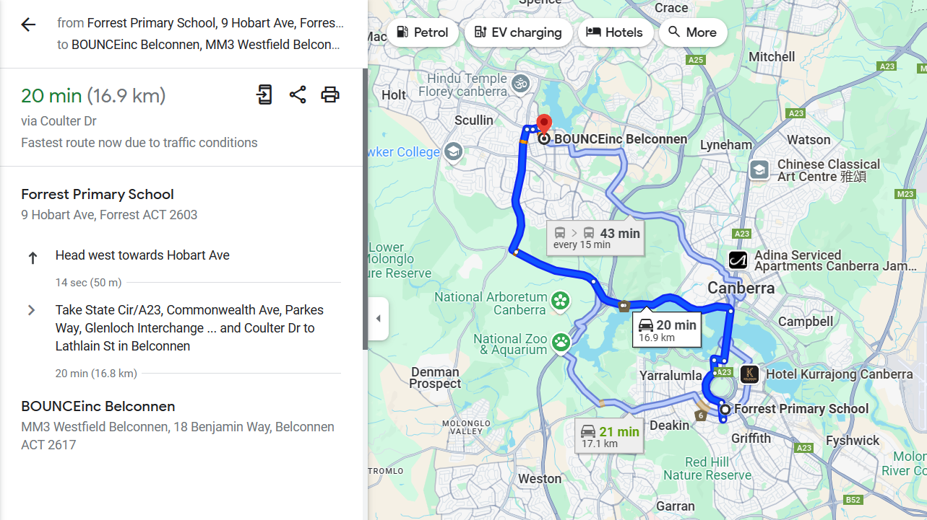

Pine Island (23/04/2025) Proposed Route:
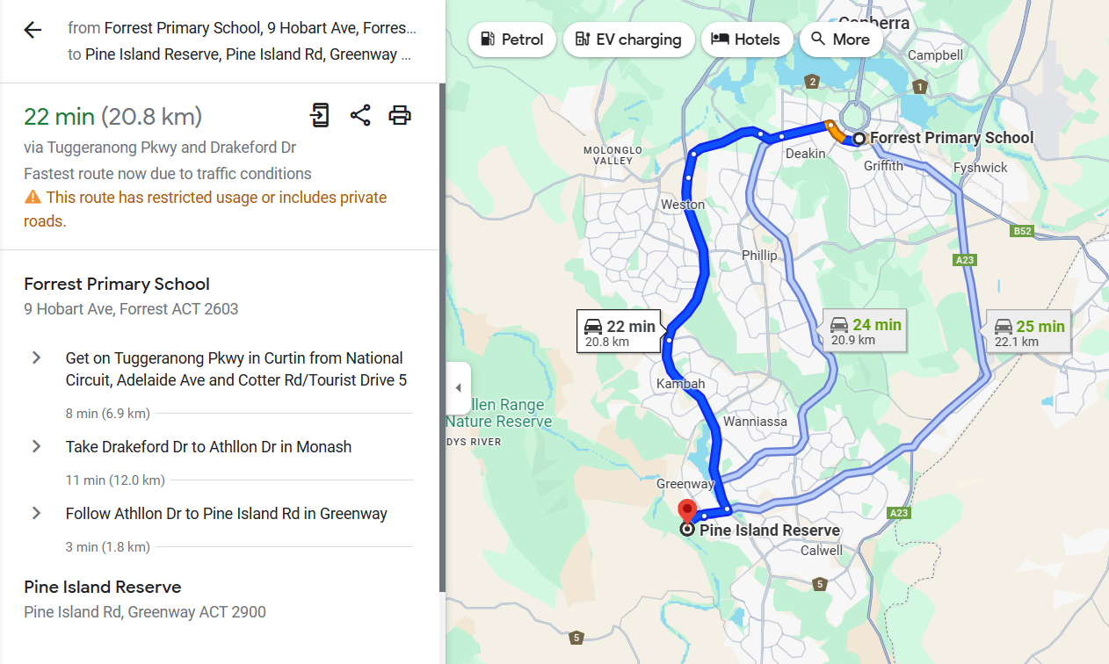
BOUNCE WAIVER – MUST BE SIGNED AND RETURNED WITH BOOKING FORM.
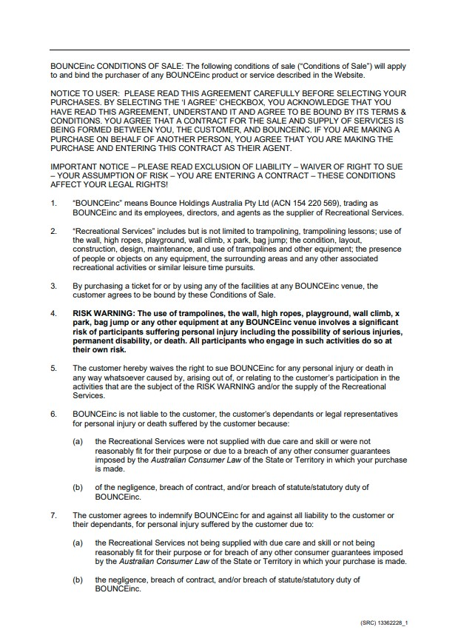
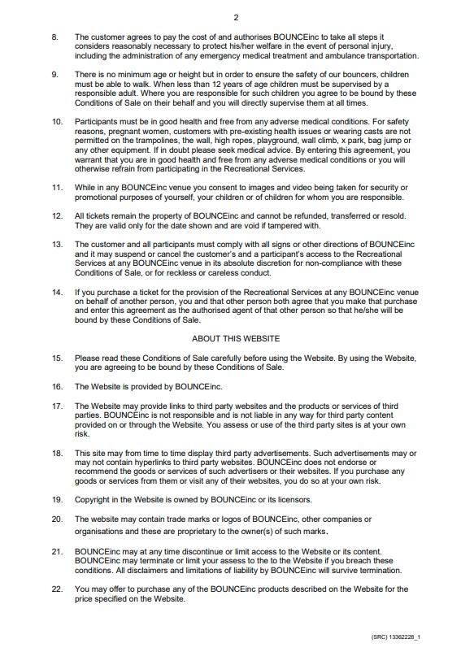

END OF FORM



